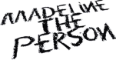

MADELINE THE PERSON TALKS TOXIC RELATIONSHIPS ON “WHY I BROKE UP WITH YOU” – LISTEN HERE
FORTHCOMING EP CHAPTER 3: THE BURNING DUE JULY 15 – PRE-SAVE HERE

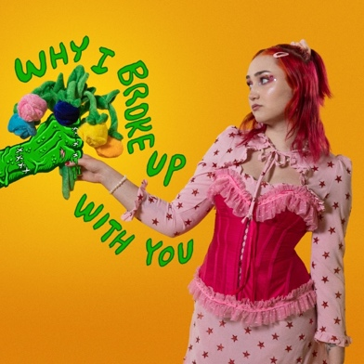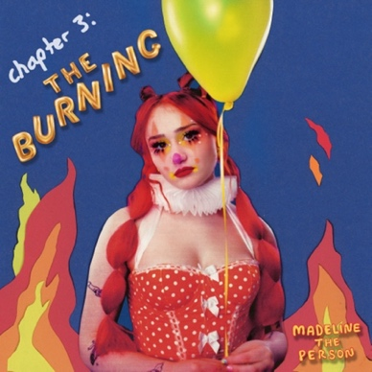

July 8, 2022 (Los Angeles, CA) – Today, rising alt-pop artist Madeline The Person releases “Why I Broke Up With You,” an endearingly honest peek at a relationship going down in flames. Listen HERE via Warner Records. The accompanying video finds Madeline reflecting on her past relationship through a doll-like lens, frustratingly watching as the zombified version of her ex-partner tears down the house they built together. Watch the video HERE. “Why I Broke Up With You” is the second cut from Madeline’s forthcoming EP CHAPTER 3: The Burning, due July 15 – pre-save HERE.

The title is quite literal. “Why I Broke Up With You” is a Dear John letter set to music. “I kinda got the warning when I saw my dad in your eyes / I’m comfortable without your handy dandy herbal disguise,” she croons, hinting at her lover’s vice. “This is why I broke up with you / Do you realize you’re too high to care?” Madeline sings over sparse production on the chorus, “I’m saying this with nothing to lose / ‘cause I know that you’re not really there.”

On the song, Madeline focuses on the liberation that can come from a particularly painful breakup. “Growing up, I dealt with my father’s addiction, so I have known from a really young age what an absent mind looks like. I knew how it felt to be talking to a completely different person, who you knew wouldn’t even remember what you were saying. My ex’s dependence on a substance uprooted the trauma of having to take care of an addicted adult as a little girl. I just couldn’t be that little girl again, so I left. That was what was healthy for me.”

“Why I Broke Up With You” follows “MEAN!” – the moody anthem that has been a run-away success on TikTok, landing on the app’s Top Sounds for six consecutive week, garnering over 909K creates and is approaching 50 million global streams. Two weeks ago, the singer released an alternate version of the track, featuring her co-writer Noah Kahan.
2021 was pivotal for Madeline as a performer. She hit the road for the very first time, supporting The Aces on their headline tour. The rising songstress also delivered an electrifying set at Los Angeles’ OUTLOUD Music Festival. This year, she is performing at the Wonderbus Music & Arts Festival, the perfect venue for her vulnerable brand of pop. With her new EP on the way featuring the intensely relatable “Why I Broke Up With You,” Madeline is poised to become a pop sensation.
About Madeline The Person:
Music is therapy for Madeline The Person. The alt-pop newcomer uses songwriting to process trauma, triumph, and every confounding feeling in-between. Complete transparency is a compulsion for her, a trait that characterized the 20-year-old’s 2021 debut project, Chapter 1: The Longing. Like old diary entries, those four songs document the highs and lows that forged Madeline’s outlook on life. Unfiltered and unflinching, the EP immediately struck a chord with fans and critics, amassing more than 2 million audio and video streams, and winning recognition from Billboard and People magazine, who included her in their Emerging Artists roundup. While Chapter 1 looked to the past, Chapter 2: The Shedding, also released in 2021, was a snapshot of the present. The second of a planned quartet of EPs, it tackles themes such as sexuality, identity, and growth. The lead single “Haunted” is a perfect example: the acoustic-pop anthem doubled as the Houston, Texas, native’s coming-out statement. Like many pop prodigies, Madeline grew up in a house filled with music. Her talent was nurtured from an early age and she was discovered by Warner Records after posting a series of viral covers on TikTok that garnered her 942,000 followers. Madeline’s star will, no doubt, continue to rise as she adds chapters to her story. But as the moniker she’s chosen suggests, the breakout artist plans to keep her feet firmly on the ground. “I have lots of flaws, faults, and feelings that hurt,” she says, “but also all the good stuff. I'm just a person.”
# # #
For further information, please contact:
Darren Baber | Warner Records
Darren.Baber@warnerrecords.com

Follow Madeline the Person:
TikTok | Instagram | Twitter | YouTube | Press Materials

