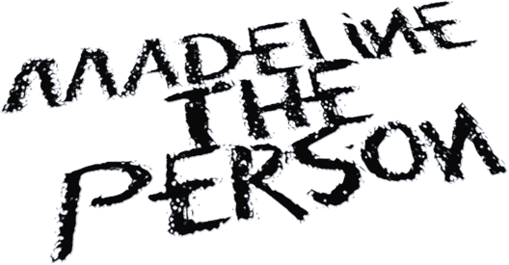

BOILER

Music is therapy for Madeline The Person. The alt-pop newcomer uses songwriting to process trauma, triumph, and every confounding feeling in-between. Complete transparency is a compulsion for her, a trait that characterized the 19-year-old’s 2021 debut project, Chapter 1: The Longing. Like old diary entries, those four songs document the highs and lows that forged Madeline’s outlook on life. If Chapter 1 looked to the past, then Chapter 2: The Shedding is a snapshot of the here and now. The second EP, tackles themes such as sexuality, identity, and growth. The lead single is a perfect example: “Haunted,” an acoustic-pop anthem about a doomed romance, doubled as the Houston, Texas, native’s coming-out statement. “August,” featuring friend Adam Melchor, is about a flourishing long-distance relationship. And, yes, it’s autobiographical. Madeline promises additional revealing Chapters are on the horizon. Like many pop prodigies, Madeline grew up in a house filled with music. Her talent was nurtured from an early age and she was discovered by Warner Records after posting a series of viral covers on TikTok. Madeline’s star will, no doubt, continue to rise as she adds chapters to her story. But as the moniker she’s chosen suggests, the breakout artist plans to keep her feet firmly on the ground. “I have lots of flaws, faults, and feelings that hurt,” she says, “but also all the good stuff. I'm just a person.”

