MAC MILLER SHARES NEW TRACK FEATURING CEELO GREEN

DETAILS TRACK LISTING FEATURING BILAL, ANDERSON .PAAK, TY DOLLA $IGN, NJOMZA, CEELO GREEN, ARIANA GRANDE & KENDRICK LAMAR

THE DIVINE FEMININE DUE SEPTEMBER 16TH VIA WARNER BROS. RECORDS

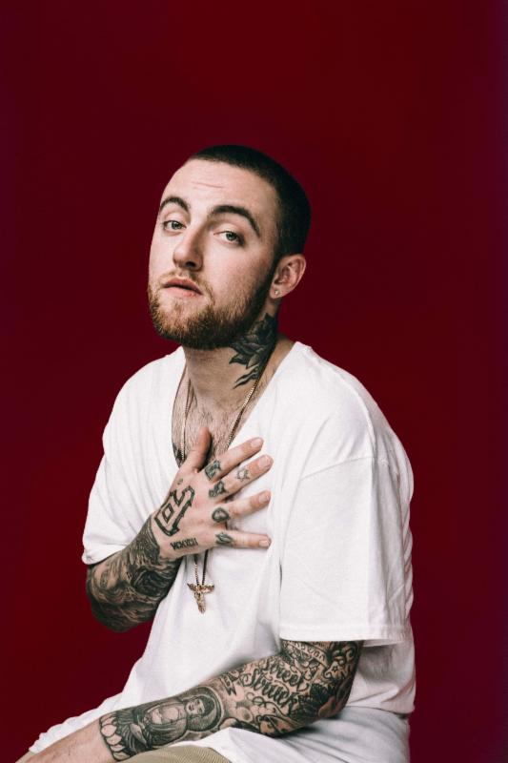

STREAM: "We (feat. CeeLo Green) - https://youtu.be/XL--KSNxfy8

WATCH: "DANG! (feat. Anderson .Paak)" - https://youtu.be/LR3GQfryp9M

PRE-ORDER: The Divine Feminine - http://smarturl.it/MM.TDF

After announcing his forthcoming album The Divine Feminine and its September 16th release with "Dang!", the uptempo Anderson .Paak-assisted cut (and its appropriately summery Rex Arrow-directed video), Mac Miller is back today to share the second taste from the LP. New track "We" features the previously-reported album guest CeeLo Green and shows a different side of the album's survey of the journey that is love.

In conjunction with the song's release, Miller is sharing The Divine Feminine's track listing in its entirety and detailing its featured guests, which include Ariana Grande, Kendrick Lamar, Ty Dolla $ign and more, in addition to CeeLo and Anderson .Paak.

Both "Dang!" and "We" are available for immediate download when you pre-order The Divine Feminine. Tickets and exclusive VIP Meet & Greet packages for Mac's fall headlining tour that launches following his hometown Pittsburgh show, headlining performance at this year's Fool's Gold Day Off and appearance at the inaugural Meadows Music & Arts Festival in New York are available for fans to purchase on Mac's website now.

Stream "We" above now, see below for all The Divine Feminine details and stay tuned for more Mac Miller news soon.

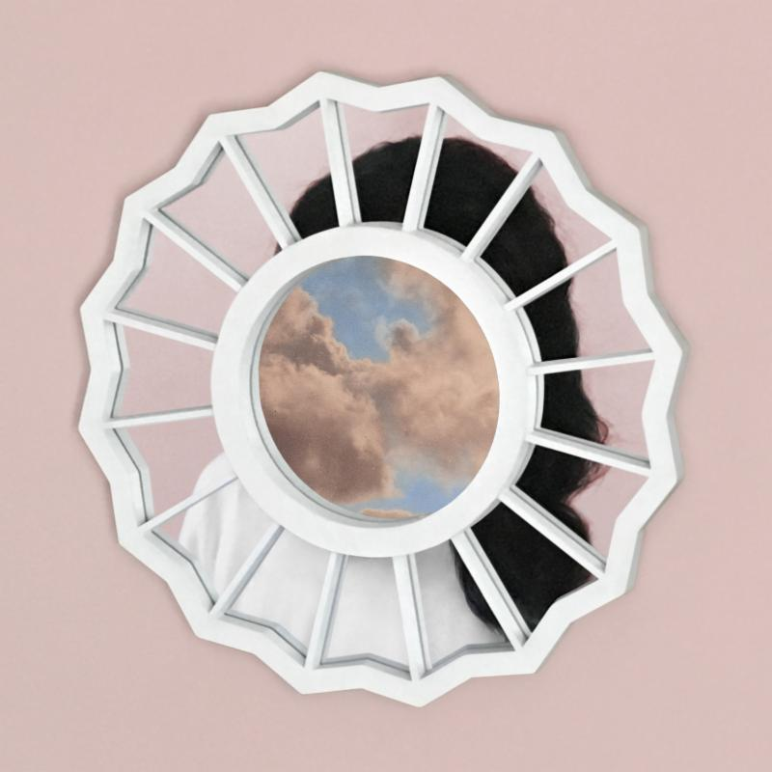

Mac Miller
The Divine Feminine
(Warner Bros. Records)
September 16, 2016

1. Congratulations (feat. Bilal)
2. Dang! (feat. Anderson .Paak)
3. Stay
4. Skin
5. Cinderella (feat. Ty Dolla $ign)
6. Planet God Damn (feat. Njomza)
7. Soulmate
8. We (feat. CeeLo Green)
9. My Favorite Part (feat. Ariana Grande)
10. God Is Fair, Sexy, Nasty (feat. Kendrick Lamar)

Tour Dates:
9/18 Pittsburgh, PA - Stage AE
9/25 Los Angeles, CA - Fool's Gold Day Off
10/02 New York, NY - The Meadows Music & Arts Festival
10/07 Capetown, South Africa - Superbalist Festival (Rocking the Daisies)
10/09 Johannesburg, South Africa - Superbalist Festival (In the City)
10/13 Indiana, PA - The Kovalchick Complex - Ed Fry Arena
10/15 Orlando, FL - Carnage Festival
10/17 Atlanta, GA - Tabernacle
10/18 Birmingham, AL - Iron City
10/19 Louisville, KY - Palace Theatre
10/21 Memphis, TN - Minglewood Hall
10/22 Nashville, TN - War Memorial Auditorium
10/23 St. Louis, MO - The Pageant
10/25 Minneapolis, MN - First Avenue
10/26 Madison, WI - Orpheum Theatre
10/27 Milwaukee, WI - The Rave
10/29 Omaha, NE - Sokol Auditorium
10/31 Morrison, CO - Red Rocks Ampitheater
11/01 Magna, UT - The Great Saltair
11/02 Boise, ID - Revolution Center
11/04 Seattle, WA - Showbox SoDo
11/06 Vancouver, BC - Vogue Theatre
11/07 Portland, OR - Crystal Ballroom
11/09 Oakland, CA - Fox Theater
11/15 Tucson, AZ - The Rialto Theatre
11/16 Tempe, AZ - The Marquee
11/19 Dallas, TX - Bomb Factory
11/20 Houston, TX - Revention Music Center
11/21 Austin, TX - Emo's
11/28 Tulsa, OK - Cain's Ballroom
11/29 Kansas City, MO - Uptown Theater
12/01 Indianapolis, IN - Egyptian Ballroom
12/02 Grand Rapids, MI - Orbit Room
12/03 Royal Oak, MI - Royal Oak Music Theatre
12/05 Columbus, OH - Express Live Indoor Pavilion
12/06 Cleveland, OH - House of Blues
12/08 Toronto, ON - Sound Academy
12/09 Montreal, QC - Metropolis
12/11 Boston, MA - House of Blues
12/13 Silver Spring, MD - The Fillmore
12/16 Charlotte, NC - The Fillmore
12/17 Raleigh, NC - The Ritz
12/18 Baltimore, MD - Baltimore Sound Stage

For tools and Mac Miller inquiries, please visit http://press.wbr.com/macmiller

