GRAMMY® AWARD-WINNING MASTODON ANNOUNCE SECOND LEG OF
CO-HEADLINE TOUR WITH OPETH

NOMINATED FOR “BEST METAL PERFORMANCE” AT 2022 GRAMMY® AWARDS

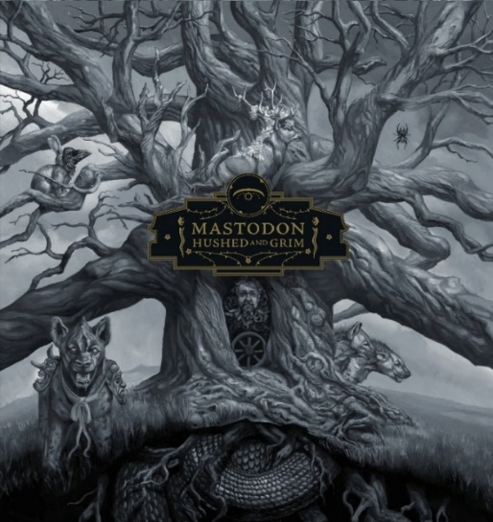

(Hi-res cover image by Paul Romano here)

February 7, 2022 (Los Angeles, CA) – GRAMMY® Award winners Mastodon will return to the road for the second leg of their acclaimed co-headline tour with Opeth this Spring. The North American jaunt resumes on April 21 at Place Bell in Montreal, QC, stops in major markets coast-to-coast, and comes to a close on May 11 at Municipal Auditorium in Riverside, CA. Special Blabbermouth.net and Knotfest.com presales go live on February 8 at 10am local time through February 9 at 10pm local time. Local, promoter, radio, and venue presales open Thursday February 10 at 10am-10pm local time. General on-sale begins this Friday February 11 at 10am local time. Mastodon will hit the trail once again in support of their unanimously applauded 2021 epic, HUSHED AND GRIM.

Of the first leg, Consequence of Sound wrote, “The crowd swayed and sang the new tunes as loud as they could, as the band shook all 12,000 square feet of the ballroom with their tremendous sound, which was accompanied by psychedelic visuals being displayed on a huge LED wall, plus gnarly lasers shooting high above past the balcony.”

Next up, Mastodon are nominated at the 2022 GRAMMY® Awards in the category of Best Metal Performance for “Pushing The Tides.” This marks the band’s sixth career nomination at the ceremony.

Most recently, Mastodon took the #1 position on the Billboard Hard Rock Album Chart with double album HUSHED AND GRIM. Mastodon achieved the same feat with their last studio album Emperor Of Sand in 2017. Concurrently, HUSHED AND GRIM also topped the official Rock and Metal Chart in the U.K. They also notably performed “Teardrinker” on Late Night with Seth Meyers! Watch the performance here.

Upon release, Mastodon’s ninth full-length album has garnered critical praise for all corners of the media including NPR Music, Rolling Stone, MOJO, Metal Hammer, and many more!

“Riffs escalate and clang with a swaggering bombast, but are grounded by the soaring vocal hooks… arena-sized rock” – NPR

“…their weightiest, most majestic opus yet”. - MOJO (UK)

“Mastodon are still exceedingly adept at the ageless art of kicking ass. Brent Hinds, Troy Sanders, Bill Kelliher, and Brann Dailor are now legends in heavy music.” – Rolling Stone

HUSHED AND GRIM was recorded in their hometown of Atlanta over the past year and produced by David Bottrill (Tool, Rush, Muse, Peter Gabriel) Their most ambitious body of work to date, the 15 disparate tracks cover a wide confluence of textures that include rock, psychedelia, punk, metal, alternative, and prog interwoven by their innately expressive musical interplay of these virtuosic musicians. An atmospheric canvas of very real of loss, loneliness, and longing permeates through the trio of cathartic vocals as they musically say goodbye to old friend, confidant, and longtime manager the late Nick John. Always pushing their creative process to greater expanse, the ever-evolving music of Mastodon cannot fit into any simple, single style or category. This is Mastodon music. Click here to view and share their mindset behind this 15-song body of work.

MASTODON TOUR DATES
Apr 21 Montreal, QC Place Bell
Apr 22 Toronto, ON Queen Elizabeth Theatre
Apr 23 Cleveland, OH The Agora
Apr 24 Pittsburgh, PA Stage AE
Apr 26 Philadelphia, PA The Met
Apr 28 Chicago, IL Aragon Ballroom
Apr 29 Detroit, MI The Masonic
Apr 30 Milwaukee, WI Eagles Ballroom
May 01 St. Paul, MN The Myth
May 03 Saskatoon, SK TCU Place
May 04 Calgary, AB Grey Eagle Events Centre
May 05 Edmonton, AB EDM Expo Center
May 07 Vancouver, BC Thunderbird Sports Centre
May 08 Seattle, WA Paramount Theater
May 09 Portland, OR Keller Auditorium
May 11 Riverside, CA Municipal Auditorium

# # #

Mastodon Contacts:
Rick Gershon at Warner Records / Reprise Records
rick.gershon@warnerrecords.com

Regional Press: Jenny Huynh at Warner Records / Reprise Records
jenny.huynh@warnerrecords.com

Follow Mastodon:
Website | Facebook | YouTube | Twitter | Instagram | Spotify | Press Materials

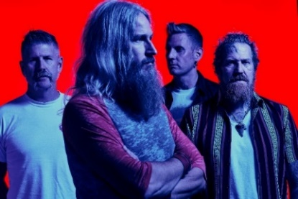

(Click here for Hi-res image by Clay McBride)

