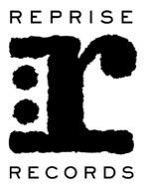

MASTODON PAY HOMAGE TO LATE, LONGTIME MANAGER NICK JOHN WITH THEIR COVER OF “STAIRWAY TO HEAVEN” ENTITLED
STAIRWAY TO NICK JOHN

Includes Studio and Live Versions of the Iconic Led Zeppelin Anthem Exclusively For Record Store Day 2019

All Of Proceeds To Benefit Hirschberg Foundation For Pancreatic Cancer Research

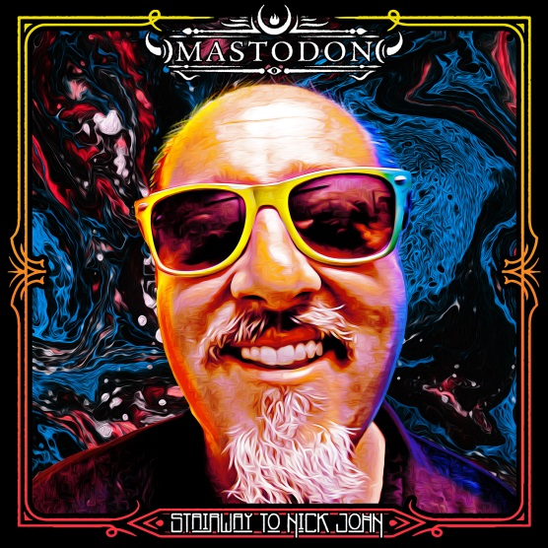
February 28, 2019 (Burbank, CA) – As the ultimate rock ‘n’ roll goodbye to longtime manager, trusted advisor, confidant, and close friend Nick John, GRAMMY® Award-winning Atlanta hard rock juggernaut Mastodon reveal the details for Stairway To Nick John.

For this very special release, the quartet cut a cover of “Stairway To Heaven” by Led Zeppelin—who their late manager professed a lifetime of fandom for as his favorite band. For the first time, Mastodon will uncover their take on this classic as a permanent Record Store Day exclusive vinyl, featuring the Studio Version on Side A and a Live Version on Side B.

Only 1,500 copies pressed to 10-inch vinyl will be available in participating independent retailers during the 12th annual Record Store Day on Saturday April 13, 2019. Poised to sell out fast, fans are encouraged to get one as soon as possible.

All of the proceeds benefit the Hirshberg Foundation for Pancreatic Cancer Research. Click here for further information.

Mastodon has issued the following statement: “In early September 2018 we lost one of our closest friends and our biggest fan, our manager Nick John. He was essentially the band’s Dad. From our highest highs to our lowest lows he was always there. Every single move we made went through him first as our trust in him was marrow deep. His favorite band besides us and Gojira, was Led Zeppelin. We were asked to perform “Stairway to Heaven” at his funeral. Afterwards, finding out that someone had recorded it, we figured we should record a studio version and release it on RSD as a tribute to Nick with all the proceeds to be donated to pancreatic cancer research. We would not be the band we are today without the help of Nick John. We miss him dearly and think of him always. We love you buddy!”

Stairway To Nick John arrives on all DSP’s this May.

Mastodon have just announced a co-headline U.S. tour with Coheed and Cambria under the banner of “The Unheavenly Skye Tour” with special guests Every Time I Die. Each night Mastodon will perform their 2009 groundbreaking album Crack The Skye in its entirety. The album remains one of the most critically revered albums of its time:

"Ambitious vision and vivid execution." – The New York Times

“Mastodon is the greatest metal band of their generation – no one else comes close.” – Rolling Stone

“Thunderous, disciplined and expansive…the ambition and tenacity of Mastodon’s music makes Crack The Skye sonically unforgettable.” – Time Magazine

Tickets are on sale now. For additional ticket information go to: mastodonrocks.com and www.livenationentertainment.com.

About Record Store Day:
Record Store Day is managed by the Department of Record Stores and organized in partnership with the Alliance of Independent Media Stores (AIMS), the Coalition of Independent Music Stores (CIMS), celebrating the culture of independent record stores by playing host to in-store events/performances, signings and special product releases on a global scale.

# # #

For all Mastodon inquiries, please contact:
Rick Gershon at Warner Bros. / Reprise Records
818-953-3473 / rick.gershon@wbr.com

Follow Mastodon:
Website: mastodonrocks.com
Facebook: facebook.com/Mastodon
YouTube: youtube.com/mastodonmusic
Twitter: @mastodonmusic
Instagram: @mastodonrocks

Press materials:
http://press.wbr.com/mastodon

