GRAMMY® AWARD-WINNING MASTODON UNVEIL EMOTIONALLY CHARGED NEW SINGLE & CINEMATIC MUSIC VIDEO “TEARDRINKER”

HUSHED AND GRIM OUT OCTOBER 29 VIA REPRISE RECORDS

TICKETS ON SALE NOW FOR MASTODON AND OPETH CO-HEADLINE FALL TOUR

LISTEN HERE / WATCH HERE

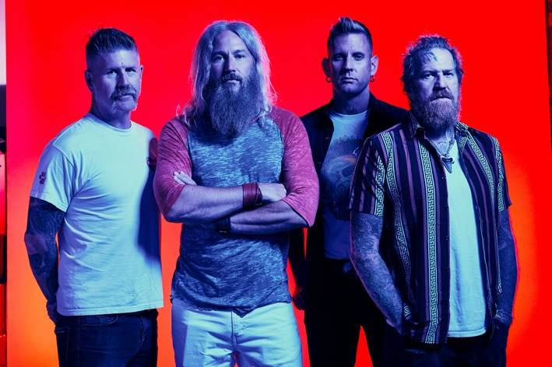
(Click here for Hi-res image by Clay Patrick McBride)

October 1, 2021 (Los Angeles, CA) – Today, GRAMMY® Award-winning Atlanta heavy rock quartet Mastodon present a brand new single and music video entitled “Teardrinker.” Click here to stream and here to view/share the new video. It stands out as the first official single from their anxiously awaited ninth full-length album, HUSHED AND GRIM, arriving on October 29, 2021 via Reprise Records. It is available for pre-order at all digital retailers and in vinyl and physical configurations here.
Invoking their evolution again, the elegiac track’s melodic riff cuts through a steady groove before a haunting hook takes hold, “I can see your face, and I feel the pain, and I feel the shame that I have let you down again.” The vocal call-and-response spirals into warbling guitar leads, and one last cathartic blast of distortion and drums. In the accompanying clip directed by Lorenzo Diego Carrera, the band enters an empty warehouse before being immersed into four uniquely curated mini universes, each of them feeding tears to a greater deity filling it with more life and power.

It arrives on the heels of the previously released track “Pushing The Tides.” The latter has already amassed 2 million-plus total streams and counting in addition to 808K YouTube views on the music video. Inciting critical applause, NPR noted, “Riffs escalate and clang with a swaggering bombast, but are grounded by the soaring vocal hook from drummer Brann Dailor,” before adding “count me in for the upcoming double-album Hushed and Grim.” Brooklyn Vegan hailed it as “a fired-up rager” and “a promising first taste.” Music Radar wrote, “‘Pushing The Tides’ has an intensity that recalls earlier Mastodon but with a typically widescreen approach to melodies and textures,” and Consequence of Sound highlighted its “dark riffs, mountainous rhythms and an eerie melody.”

Making a grand return to the road this fall, Mastodon will co-headline a massive North American tour with Opeth. It stands out as the band’s first full-scale North American run since 2019. Zeal & Ardor open all shows as the evening’s special guest. Click here for ticket and tour information.

Their first full-length studio work in four years, HUSHED AND GRIM was recorded in their hometown of Atlanta, over the course of the past 12 months with producer David Bottrill (Tool, Rush, Muse, Peter Gabriel). Their most ambitious body of work to date, each of 15 tracks, survey the sonic landscapes of the band’s vast confluence of influences and inspirations. An atmosphere of very real loss, loneliness, and longing permeates through the trio of cathartic vocals as they musically say goodbye to old friend, confidant, and longtime manager the late Nick John by architecting an affecting, intense body of work that bears the influence of his eternal memory. HUSHED AND GRIM represents the next step on Mastodon’s endless path of natural evolution. By removing boundaries and creating in a free form they evolved with a combination of newfound melodic confidence and their signature musical intricacy intact. In the end, HUSHED AND GRIM is hard-hitting, hypnotic, and heart-wrenching. More than ever before, Mastodon continue to be one of the most influential forces in modern rock music.

# indicates festival appearance – not part of co-headline dates:
#Oct 10 Sacramento, CA Aftershock
#Nov 14 Daytona Beach, FL Welcome to Rockville

Mastodon Co-headline w/ Opeth:
Nov 16 Asheville, NC ExploreAsheville.com Arena
Nov 18 Boston, MA Wang Theater
Nov 19 Albany, NY Palace Theatre
Nov 20 New York City Hammerstein Ballroom
Nov 21 Washington, DC Anthem
Nov 23 Nashville, TN The Ryman Auditorium
Nov 24 Atlanta, GA The Eastern
Nov 26 Austin, TX ACL Live
Nov 27 Dallas, TX Southside Music Hall
Nov 28 Houston, TX Smart Financial Centre @ Sugarland
Nov 30 Mesa, AZ Mesa Amphitheater
Dec 01 Los Angeles, CA Hollywood Palladium
Dec 02 Oakland, CA Fox Theater
Dec 04 Salt Lake City, UT Union
Dec 05 Denver, CO Mission Ballroom

HUSHED AND GRIM Tracklisting:
- Pain With An Anchor
- The Crux
- Sickle And Peace
- More Than I Could Chew
- The Beast
- Skeleton Of Splendor
- Teardrinker
- Pushing The Tides
- Peace And Tranquility
- Dagger
- Had It All
- Savage Lands
- Gobblers Of Dregs
- Eyes Of Serpents
- Gigantium

About Mastodon:
GRAMMY® Award-winning band Mastodon continue to chart their own course through their highly successful music career. Founded in Atlanta, GA during 2000 by Troy Sanders (bass/vocals), Brent Hinds (guitar/vocals), Bill Kelliher (guitar) and Brann Dailor (drums/vocals), the group have unleashed a series of influential albums. Rolling Stone notably cited 2004’s Leviathan on its coveted The 100 Greatest Metal Albums of All Time. Meanwhile, Crack The Skye closed out 2009 on year-end lists by everyone from TIME to SPIN. They delivered three consecutive Top 10 debuts on the Billboard Top 200 with The Hunter [2011], Once More ‘Round the Sun [2014], and Emperor of Sand [2017]. “Sultan’s Curse” notably garnered their first GRAMMY® Award in the category of Best Metal Performance. Mastodon have been nominated for GRAMMY’S® five times to date. The group commemorated their late manager Nick John with their 2019 take on “Stairway To Heaven,” affectionately entitled “Stairway To Nick John.” Initially released for Record Store Day, all proceeds benefit the Hirschberg Foundation For Pancreatic Cancer Research. Their evolution continues later this year, with their ninth full-length offering for Reprise Records produced by David Bottrill [Tool, Rush], HUSHED AND GRIM.

# # #

Contact:
National: Rick Gershon at Warner Records / Reprise Records
rick.gershon@warnerrecords.com

Regional: Jenny Huynh at Warner Records / Reprise Records
Jenny.huynh@warnerrecords.com

Follow Mastodon:
Website | Facebook | YouTube | Twitter | Instagram | Spotify | Press Materials

