“Lorde-like vocals” – NPR

“pop-perfect sound” – Rolling Stone

Named in Variety’s “Artists to Watch for the GRAMMYs”

“Maude Latour is quickly becoming the indie-pop girl to know.” – V Magazine

“An intergalactic pop odyssey” – The FADER

“Disco-infused pop” – NYLON

May 16, 2022 (Los Angeles, CA) – Continuing on a momentous past year, rising alt-pop star Maude Latour announces her Fall 2022 North American headline tour, kicking off September 29th in Boston, MA. The 16-date run – which follows her completely sold-out spring tour – will make stops across the country, including debut festival performances at Austin City Limits, Lollapalooza, and All Things Go Music Festival. Tickets go on-sale to the general public this Friday, May 20th at 11am local time at www.maudelatour.com/live. See a full list of dates below!

Additionally, Maude’s latest track “Trees” just premiered last week on Zane Lowe’s Apple Music 1 New Music Daily show alongside an official video set in Central Park that feels like a sun-dappled, summer daydream. Check it out HERE and listen to “Trees” HERE.

Following recent singles “Lola” and “Headphones,” the new song doubles as a love letter to nature and an exploration of grief. “Suddenly the trees are breathing like my lungs,” the 22-year-old sings on the ethereal chorus. “It occurs to me that I'm forever changed by you, even though you're not here by my side — maybe you'll be listening and understand.” The inspiration for the track was losing a loved one, who feels nearby during moments of transcendent beauty. As Maude explains, “It is about missing the one person I wish I had, and in some magnificent moments, looking at trees, feeling her still.”

With a knack for crafting melodic tracks centered on healing and friendship, Maude has established herself as a pop force, amassing more than 62 million streams on Spotify alone. With the poignant, inward-looking “Trees,” she unveils yet another vibrant side of her colorful approach to pop. Stay tuned for more announcements coming soon!

FALL 2022 TOUR DATES
July 28 Chicago, IL Lollapalooza
September 29 Boston, MA Paradise Rock Club
October 1 Washington, DC All Things Go Music Festival
October 2 Philadelphia, PA The Foundry
October 4 Atlanta, GA Terminal West
October 5 Nashville, TN The End
October 7-9 Austin, TX Austin City Limits
October 11 Houston, TX The Bronze Peacock at House of Blues
October 12 Dallas, TX The Cambridge Room at House of Blues
October 14 Denver, CO Globe Hall
October 15 Salt Lake City, UT Kilby Court
October 17 Phoenix, AZ The Rebel Lounge
October 18 Los Angeles, CA El Rey Theatre
October 20 Sacramento, CA Harlow's
October 21 San Francisco, CA The Chapel
October 23 Seattle, WA Neumos
November 2 New York, NY Irving Plaza

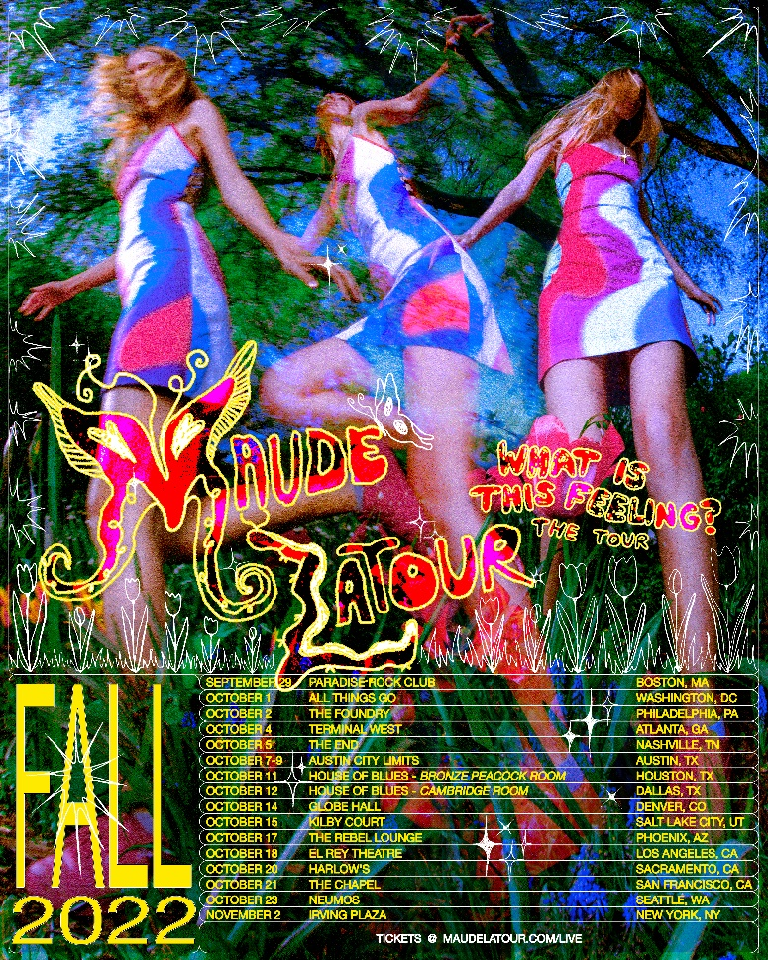
High-res photos + admat available here

FOLLOW MAUDE LATOUR:
TikTok | Instagram | Twitter | Facebook | YouTube | Press Materials

For more information, please contact:
Patrice Compere | Patrice.Compere@warnerrecords.com

