MAUDE LATOUR DROPS SPARKLING SUMMER ANTHEM “PROBABILITIES”
LISTEN HERE

MAKING FESTIVAL DEBUT AT LOLLAPALOOZA NEXT WEEK
AHEAD OF FALL 2022 HEADLINE TOUR

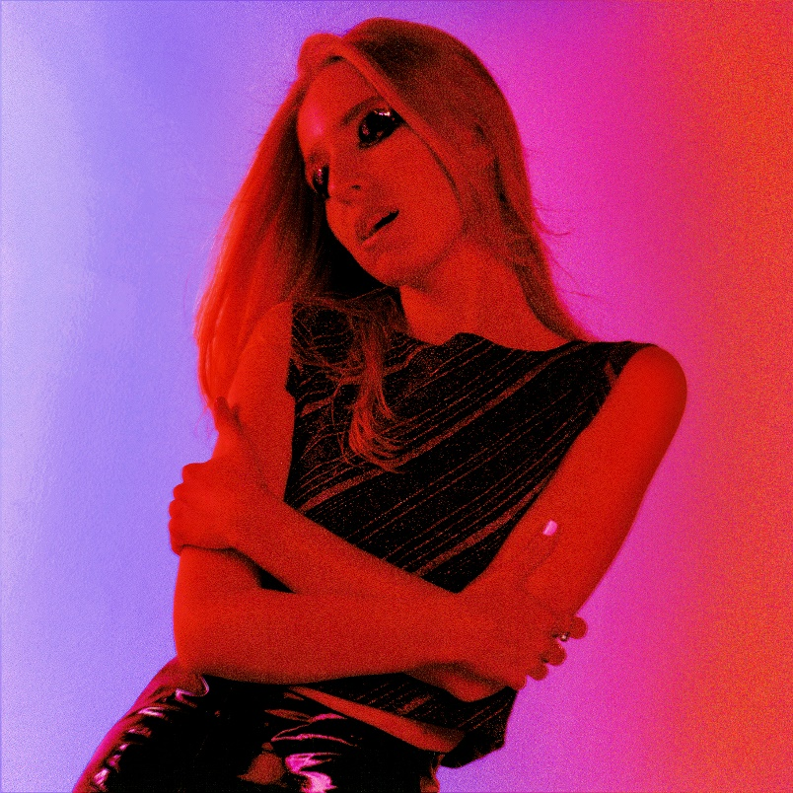

“plush indie pop” – The New York Times

“Lorde-like vocals” – NPR

“pop-perfect sound” – Rolling Stone

“Maude Latour is quickly becoming the indie-pop girl to know.” – V Magazine

July 22, 2022 (Los Angeles, CA) - Rising alt-pop artist Maude Latour returns today with “Probabilities,” a euphoric new single with ethereal arrangements, heartwarming nostalgia, and her signature sunny charm. Listen HERE via Warner Records. The new track arrives just days after the 22 year-old Columbia grad was featured in The New York Times, and next week, she’s set to continue her momentum as she embarks upon the festival circuit with Lollapalooza, Austin City Limits, All Things Go, and Music Midtown, followed by a fall headlining tour.
Maude looks for meaning in the chaos on “Probabilities,” a topic that informs much of her songwriting. “Are we where we are meant to be, or is this everything we know because of chance?” she says. “Thinking about the effect of chance in our lives can be nauseating.” While the subject matter is weighty, the production of “Probabilities” is light and feathery. Over glinting synths, she sings optimistically about the future. “All we have are these chances,” she sings. “I want something to believe.”

“Probabilities” is the latest blissful indie-pop song from the NYC-based singer after “Trees,” “Lola,” and “Headphones.” Now that she’s graduated from college, she’s able to focus on putting the finishing touches on even more new music—and singles like “Probabilities” are already starting to show the depth and joy that she’s able to unearth through her textured and vulnerable pop songs.

UPCOMING TOUR DATES
July 28 Chicago, IL Lollapalooza
September 17-18 Atlanta, GA Music Midtown
September 29 Boston, MA Paradise Rock Club
October 1 Columbia, MD All Things Go Music Festival
October 2 Philadelphia, PA The Foundry
October 4 Atlanta, GA Terminal West
October 5 Nashville, TN The End
October 7-9 Austin, TX Austin City Limits
October 11 Houston, TX The Bronze Peacock at House of Blues
October 12 Dallas, TX The Cambridge Room at House of Blues
October 14 Denver, CO Globe Hall
October 15 Salt Lake City, UT Kilby Court
October 17 Phoenix, AZ The Rebel Lounge
October 18 Los Angeles, CA El Rey Theatre
October 20 Sacramento, CA Harlow's
October 21 San Francisco, CA The Chapel
October 23 Seattle, WA Neumos
November 2 New York, NY Irving Plaza

Photo by Anna Koblish. Download hi-res here

###
FOLLOW MAUDE LATOUR:
TikTok | Instagram | Twitter | Facebook | YouTube | Press Materials

For more information, please contact:
Patrice Compere | Patrice.Compere@warnerrecords.com

