ALT-POP BREAKOUT MAUDE LATOUR DROPS COLORFUL STRANGERS FOREVER EP

STREAM HERE – WATCH “STRANGERS FOREVER” VIDEO HERE

SOLD-OUT RUN OF INTIMATE LIVE SHOWS KICKS OFF NEXT MONTH

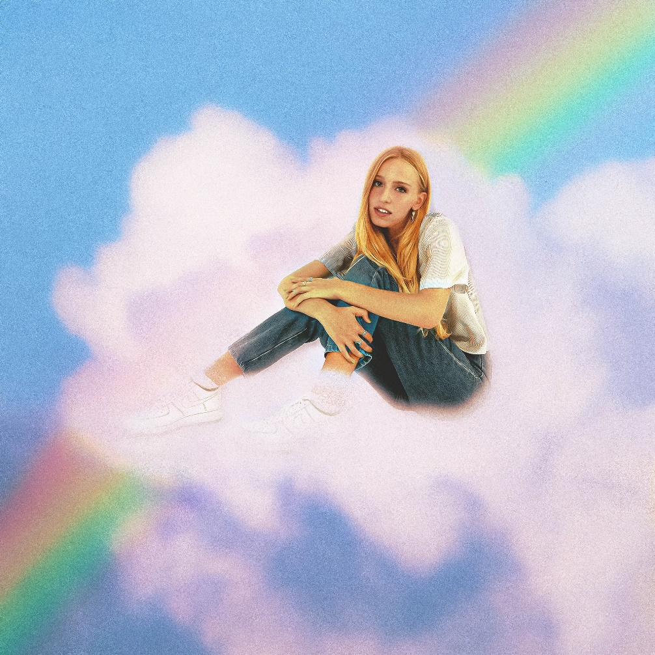

October 29, 2021 (Los Angeles, CA) – Rising alt-pop star Maude Latour’s breakthrough year continues today with the arrival of her much anticipated major-label debut EP, Strangers Forever. The irresistible six-track set is a showcase of the newcomer’s evocative, colorful brand of pop, and it includes viral hits “Clean,” “One More Weekend,” and “Furniture,” as well as the standout title track. Listen to Strangers Forever HERE.

“Strangers Forever” is the kind of unfiltered diary entry set to music that makes Latour one of alt-pop’s most exciting new talents. The emotional pop track finds the 21-year-old trying and failing to come to grips with a breakup. “I love you but you wanna be somebody else’s baby,” Latour sings. “You love me but you’re over it and you start to hate me.” The pain of a one-sided split is aptly conveyed in the Tess Lafia-directed official video, in which Latour watches home movies and interacts with the literal ghost of her ex. Watch it HERE.

Kicking off next month, Maude will embark on a sold out, four-date run of intimate live shows to celebrate the release of Strangers Forever, making stops in NYC, Chicago, Washington, DC, and Los Angeles. Check out full dates below.

The breakout artist—who hails from New York City (by way of London, Hong Kong, and Sweden)—first made waves back in 2019 with an independently released EP called Starsick. Her authenticity and emotionally nuanced lyrics immediately resonated with listeners, and she joined the Warner Records family in 2021. With a steady stream of viral hits, five of which are housed on Strangers Forever, Latour has amassed more than 30 million streams and appeared on prestigious playlists including Spotify’s New Music Friday, Lorem, and Indie Pop. The rising hitmaker has also earned critical acclaim from the likes of The FADER, NYLON, Billboard, Refinery29, and FLAUNT Magazine. With Strangers Forever, she takes another bold, yet introspective step towards stardom.

STRANGERS FOREVER EP TRACKLIST:
1. Furniture
2. One More Weekend
3. Block Your Number
4. Walk Backwards
5. Clean
6. Strangers Forever

UPCOMING TOUR DATES:
November 21 Brooklyn, NY Baby’s All Right
December 5 Chicago, IL Schuba’s
December 12 Washington, DC Songbyrd Music House
December 16 Los Angeles, CA Moroccan Lounge

ABOUT MAUDE LATOUR:
The New Yorker spent a lot of time growing and learning from the city, which has influenced the music she makes. "This city is what taught me independence, expression, creativity," she shares. "It's where I first truly stepped into myself. Since I was 13, this city has been my playground, and that has completely shaped who I am. I grew up fast and I grew up creating my own world with the paintbrushes and magic this city provides. I know it better than I know myself." From exploring personal growth, to pondering existential dread to dealing with love, heart break, and all the in-betweens, what began as an act of personal freedom, created a community of followers who revel in speaking out and thus a revolution of support was born.

FOLLOW MAUDE LATOUR:
Press Assets | Website | TikTok | Twitter | Instagram | YouTube

For more information, please contact:
Patrice Compere | Patrice.Compere@warnerrecords.com
Darren Baber | Darren.Baber@warnerrecords.com
Ceri Roberts | Ceri.Roberts@warnerrecords.com
