MAUDE LATOUR KEEPS HER GIRLS PROTECTED ON BIG-HEARTED NEW SINGLE “LOLA”

LISTEN HERE – WATCH VIDEO HERE

SOLD-OUT U.S. HEADLINE TOUR UNDERWAY +
LOLLAPALOOZA JUST ANNOUNCED

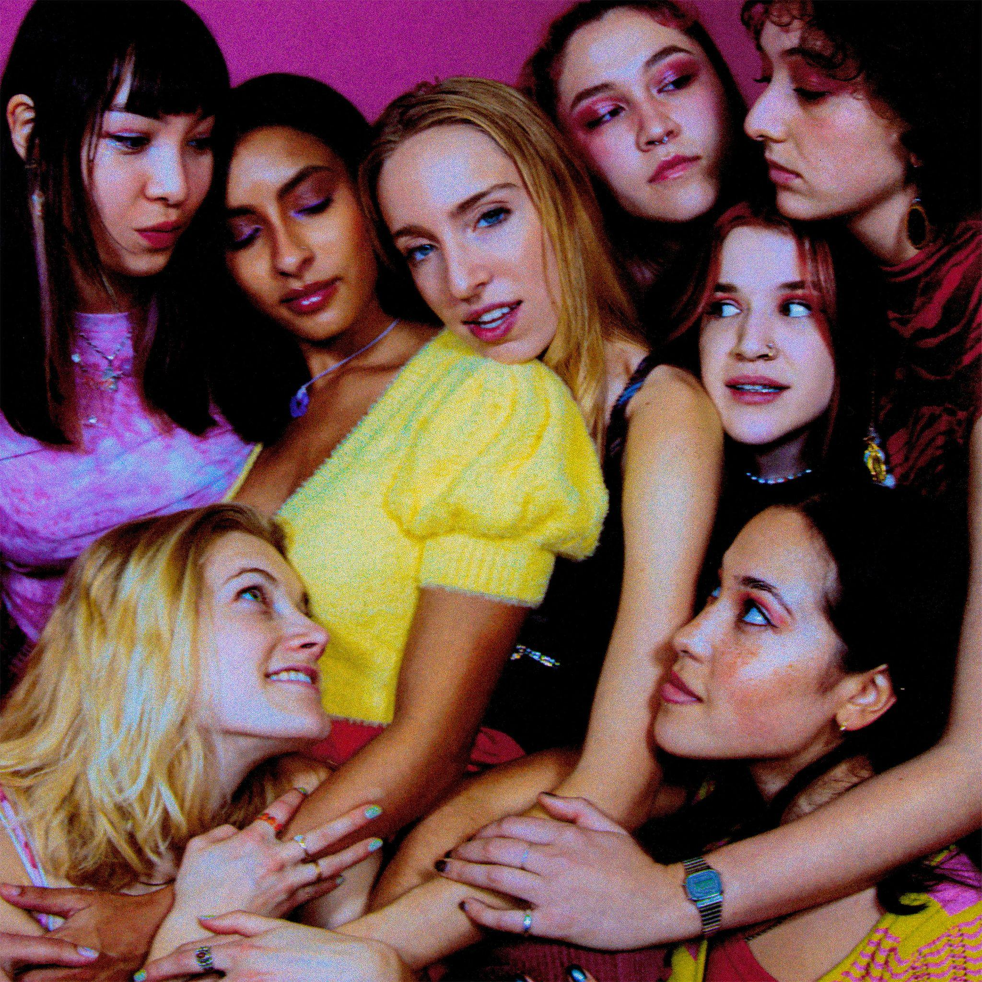

“Lorde-like vocals” – NPR

“pop-perfect sound” – Rolling Stone

Named in Variety’s “Artists to Watch for the 2022 GRAMMYs”

“An intergalactic pop odyssey” – The FADER

“Disco-infused pop” – NYLON

April 8, 2022 (Los Angeles, CA) - Today, rising alt-pop star Maude Latour releases her new single, “Lola,” a sonic avalanche of serene beats, ethereal keys, and heartwarming hopes for a better, safer world. The new track follows Maude’s latest pop gem “Headphones,” which has been widely embraced by outlets such as Rolling Stone and NPR, finding the soon-to-be Columbia University grad at the height of her abilities – raw, insightful, and brimming with infectious optimism – as she wraps up her completely sold-out U.S. headline tour before making her festival debut at Lollapalooza this summer.

“Keep my girls protected, I'm turned on when I'm respected,” Maude sings. “For my planet, for my daughters, make my music, drink my water.” Love is clearly in the air for the singer — who hails from New York City (by way of London, Hong Kong, and Sweden) — but it’s no fledgling crush. Instead, it’s a love letter to both the bustling world around her, and her closest friends.

“Sharing this song feels like being in love,” Maude says of her new release. “‘Lola’ is about the desire to protect my friends, for a dream of a better planet, for healing, for keeping queer people protected, women protected, for my sister, and the air that I’m breathing. This song is also dedicated to one of my best friends, Lola—she is a magical person.”

Pairing sparkling electronics with soaring vocals, Maude Latour has already established herself as a pop force, amassing more than 50 million streams on Spotify alone. With intimate, kinetic tracks like “Lola,” “Headphones,” and breakout hits “One More Weekend,” “Furniture,” and “Clean,” she is sharing her journey — and inviting everyone to come along for the ride.

Stay tuned for much more to come from Maude Latour in 2022.

Download hi-res photos + artwork here

UPCOMING TOUR DATES:
April 8 Toronto, ON The Garrison
April 9 Detroit, MI The Shelter
April 15 Cambridge, MA Sonia Live Music Venue
April 16 Cambridge, MA Sonia Live Music Venue
April 17 Washington, DC Black Cat
April 22 Atlanta, GA Center Stage Theater
April 23 Charlotte, NC Neighborhood Theatre
July 28-31 Chicago, IL Lollapalooza

###

FOLLOW MAUDE LATOUR:
TikTok | Instagram | Twitter | Facebook | YouTube | Press Materials

For more information, please contact:
Patrice Compere | Patrice.Compere@warnerrecords.com
Darren Baber | Darren.Baber@warnerrecords.com
Ceri Roberts | Ceri.Roberts@warnerrecords.com

