ADAM MELCHOR UNVEILS DEBUT MIXTAPE
MELCHOR LULLABY HOTLINE, VOL. 1

LISTEN HERE

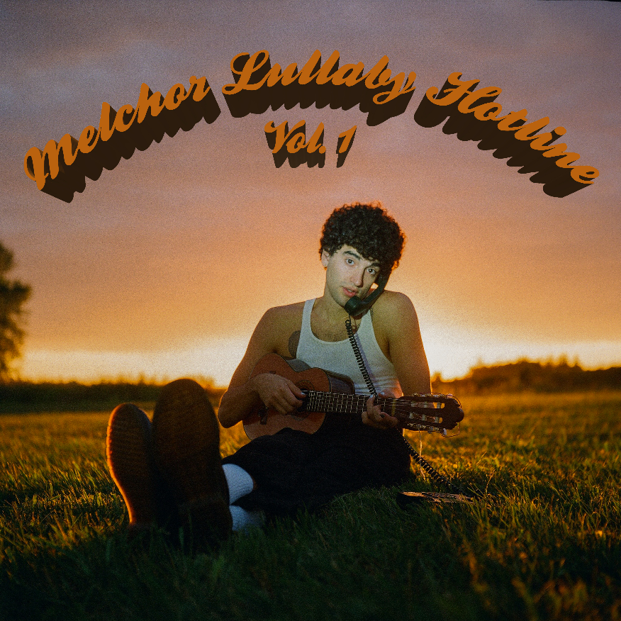

“Adam Melchor is a singer-songwriter from New Jersey with the acoustic chops of an angel.” – Esquire

“Adam Melchor is One To Watch in 2021.” – Idolator

“A strong start for Melchor, who no doubt has an exciting year ahead.” – Ones To Watch

March 19, 2021 (Los Angeles, CA) – New Jersey-born and Los Angeles-based singer, songwriter, and producer Adam Melchor unveils his debut mixtape, Melchor Lullaby Hotline, Vol. 1, today via Warner Records/R&R Records. Heralded by newly-dropped singles “Begin Again” “Last Time,” and My Chemical Romance cover “I’m not okay,” the 12-track record is made up of both brand new material, plus a selection of songs he’s personally sent out to fans via the Melchor Lullaby Hotline every Sunday since the COVID lockdown began. As a result, the Melchor Lullaby Hotline, Vol. 1 serves as a soothing balm after a dark past year for the world, earning early acclaim from the likes of Esquire, SPIN, Billboard, Idolator, and more for his dreamy and nostalgic melodies. Listen to it HERE.

“I’m not sure what I would’ve done without the Hotline this past year – it led me to have one of the most unexpectedly rewarding years of my creative life,” Adam says. “I wanted this to encompass the reasons I make music, whether it’s a voice memo or a cassette demo or a reimagining of a song or a brand new studio recording. All of these things have a home on the Lullaby Hotline Vol. 1, and I want the people listening to feel like all of the sketches of themselves are equally as valid as the more polished versions of themselves.”

Adam first introduced the Melchor Lullaby Hotline last year, urging fans to text or email him every Sunday to hear a new song. By the end of the year, he personally sent 44 songs to a rapidly growing list of almost 10,000. Last month, the rising troubadour elevated the hotline to the next level, launching The Lullaby Hotline Podcast, a weekly podcast designed to help fans relax, unwind and fall asleep to the sound of his latest tunes.

To celebrate the mixtape release, Adam will embark on a 10-date socially-distanced tour with Flipturn this spring, making stops at small capacity, outdoor venues across the southern US. Tickets are available for purchase here.

Tracklisting:
- Lullaby Hotline Theme
- Moon In The Morning
- Last Time
- Begin Again
- Start Forgetting Death
- i’m not okay
- Lateral Move
- Best Problem
- I Choose You (Wedding Edition)
- No Way of Knowing
- Itsjustmyheart
- Times Square

More about Adam Melchor:
Adam Melchor’s journey thus far has been far from conventional. Long story short, this proud Jersey boy picked up a guitar and eventually fulfilled his lifelong dream of becoming a musician in Los Angeles. But in reality, he got there by singing for mobsters “well-suited insurance guys” at pizza parlors, getting an Opera degree, playing thousands of hours in various dives, churches, and restaurants (sometimes in the same day), and driving across the country to the West Coast in an old Toyota Camry (twice). Moving to Los Angeles during 2018, he had sessions with everyone from Charlie Puth to The Chainsmokers, and has also toured alongside Mt. Joy, Dodie, Rodrigo Y Gabriela, and JS Ondara. Picking up steam, his single “Real Estate” gained impressive traction leading up to the 2020 SUMMER CAMP EP. After racking up more than 40 million streams and garnering acclaim from NPR, Wonderland Magazine, Billboard, Atwood Magazine, and more, he properly introduces himself and shares the juicy details of this story on Melchor Lullaby Hotline, Vol. 1.

###

For more information, contact:
Darren Baber, Darren.Baber@warnerrecords.com
Ceri Roberts, Ceri.Roberts@warnerrecords.com

Press Materials:
press.warnerrecords.com/adam-melchor

Follow Adam Melchor:
Instagram | TikTok | YouTube

