MIKE SHINODA OF LINKIN PARK SHARES KALEIDOSCOPIC MUSIC VIDEO FOR NEW SINGLE “HAPPY ENDINGS” FEAT. IANN DIOR & UPSAHL
WATCH HERE

#1 Most Added At Alternative Radio Now

Shinoda Becomes First-Ever Major Label Artist to Successfully Launch Single via NFT Auction

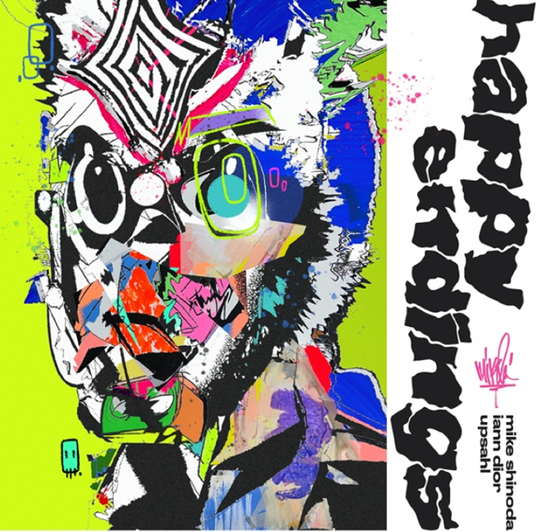
Click here for hi-res image

March 11, 2021 (Los Angeles, CA) - Today, Linkin Park’s multi-platinum GRAMMY® Award-winning singer, songwriter, and producer Mike Shinoda reveals the music video for his new single “Happy Endings” featuring genre-bending, platinum-selling artist iann dior & Arizona pop disruptor UPSAHL. Watch it HERE. “Happy Endings” is available HERE via Warner Records.

Directed by PIX3LFACE [A$AP Rocky, PARTYNEXTDOOR, Saint JHN], the video oozes with throwback vibes and nineties-style cartoon animation, some hand drawn by Shinoda himself. Against its sunny Downtown Los Angeles backdrop, Shinoda rhymes with hunger and heart as UPSAHL sings the unshakable hook between emotive bars from iann dior. With its kinetic editing and intimate closeups, the visual bottles the song’s upbeat spirit with just the right amount of tension and release.

“Happy Endings” took flight right out of the gate. Impacting major markets coast-to-coast, it stands out as the #1 Most Added Song at Alternative Radio. Making headlines, Shinoda recently spoke to Input Magazine about the groundbreaking launch of “Happy Endings” through an NFT on Zora. Additionally, he sat down with frequent collaborator, longtime friend, and legendary producer Rick Rubin for an episode of the “Broken Record” podcast. Listen HERE.

Last month, Shinoda paved the way for “Happy Endings” via social media, Twitch, and cryptocurrency authorities. Teasing out its impending arrival in groundbreaking fashion, he became “the first major label artist to launch a single via NFT auction.” The 75-second clip immediately piqued interest among fans and tastemakers; the final top 10 bidders each received an original print of the single artwork signed by Shinoda and contemporary artist Cain Caser. Proceeds from the auction benefitted ArtCenter College of Design. Coin Telegraph and Musicxtechxfuture discussed Shinoda’s embrace of NFTs and was the featured interview on The Needle Drop’s Twitch channel with Anthony Fantano. In case you missed it, watch it HERE.

Shinoda has spent the better part of the past year creating brand new music with fans and teaching production live each morning on Twitch, and, in recent weeks, producing tracks by fans—a dream come true for the artists, mostly found on social media. Both Spin and Forbes chronicled his “Dropped Frames” series; Alt Press described it as “unlike anything he’s ever done" and mxdwn added, “The album is unique and definitely stands on its own.”

Stay tuned for a lot more from Mike Shinoda very soon.

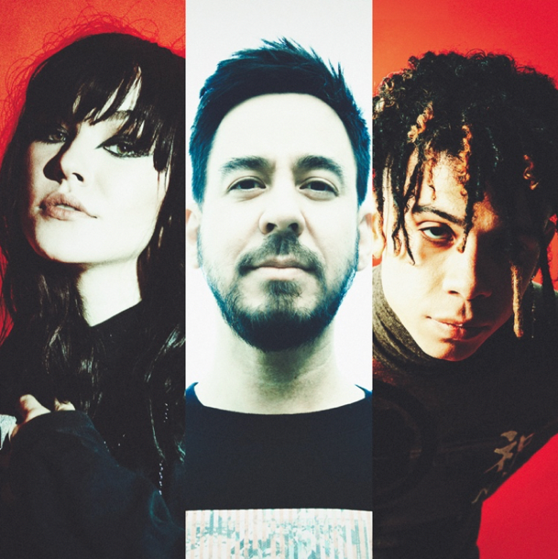
Click here for hi-res image

About Mike Shinoda:
Mike Shinoda is a songwriter, performer, record producer, film composer and visual artist with a B.A. in illustration and Doctorate of Humane Letters from ArtCenter College of Design. He is best known as co-lead vocalist for multi-platinum GRAMMY® Award-winning rock band, Linkin Park, who has sold over 55 million albums worldwide and commanded a massive fan following, holding the title as the most-liked band on Facebook and amassing over 7.7 billion YouTube views. Shinoda is the founding member of the group, which achieved the best-selling debut of this century with their Diamond-certified album, Hybrid Theory, selling over 10 million copies in the U.S. alone. Collectively, they sold out stadiums around the globe and earned a multitude of accolades including 2 Grammy Awards, 5 American Music Awards, 4 MTV VMA Awards, 10 MTV Europe Music Awards, 3 World Music Awards, and most recently, “Rock Album of the Year” at the 2018 iHeartRadio Music Awards for their seventh studio album, One More Light. In 2005, Shinoda launched his first solo project, Fort Minor, releasing The Rising Tied to critical acclaim and the every-sport anthem “Remember The Name.” In June 2018, Shinoda released his second solo effort, Post Traumatic. The deeply personal 16-track album garnered critical raves and unanimous acclaim, earning praise from the likes of NME, Variety, NPR, GQ, Forbes, Billboard, Rolling Stone, Complex, The New York Times, The Los Angeles Times, Associated Press, The Daily Show with Trevor Noah, and The Tonight Show Starring Jimmy Fallon. Shinoda toured across the globe, including festival sets at Reading and Leeds (UK) and Summer Sonic (Japan).

About iann dior:
Puerto Rican-born, Corpus Christi-raised Michael Iann Olmo (also known as “iann dior”) found success with the first song he ever wrote. After uploading to SoundCloud, the song gained 10,000 plays in its first week and caught the ear of Internet Money founder Taz Taylor who invited the budding songwriter to work with him in LA. Shortly afterwards, iann dior inked a deal with Elliot Grainge’s label 10K Projects in April 2019. Iann has since become one of the industry’s fastest growing new artists, something he joked about with the naming of his 2019 record Industry Plant. He has 3 RIAA-certified Gold records, 1 Platinum record for his feature on the Billboard #1 hit “Mood” with 24KGoldn, reaching 1 billion+ streams and counting today, and has released songs with acts like Lil Baby, Machine Gun Kelly, Travis Barker, Clean Bandit, Trippie Redd and more. Known as a highly versatile talent, iann’s work has charted in Alternative, Pop, Rap and Electronic/Dance genres and has earned him the #1 spot on Billboard’s Emerging Artists chart. As he prepares to release new music in 2021, iann dior assures his fans this is only the beginning. “A number one album is up next… I want to become the Number One artist in the world, and I am fully determined and obsessed with being the greatest.”

About UPSAHL:
Early in her career, UPSAHL released songs which gained much-deserved recognition throughout the Phoenix music scene. As a graduate of the Arizona School for the Arts, she went on to ignite a groundswell of fan adoration and tastemaker praise by way of numerous indie alternative gems. “Can You Hear Me Now” achieved a palpable viral buzz followed by the widely praised single “Drugs”, which was featured on her debut Hindsight 20/20 EP via Arista Records, and has been used in nearly 2,000,000 TikTok videos, reaching #6 on the TikTok Viral Chart and #1 Sound on the TikTok Trends Chart. “Drugs” led to a momentous year for the “up-and-coming indie-pop queen”—according to Alternative Press. 2019 saw UPSAHL take the stage at Lollapalooza and support acts including PVRIS, Joywave, BROODS, Max Frost, and Young the Giant. Additionally, “Smile For The Camera” hit Top 40 on Alternative Radio as it attracted glowing critical acclaim and YouTube claimed UPSAHL as their ‘Artist on the Rise’. Nylon proclaimed, “She’s on her rock star ish,” and American Songwriter labeled the track, “intelligently written.” 2020 was a standout year for UPSAHL, releasing her second EP Young Life Crisis, which Billboard crowned as one of the top 25 pop albums of 2020. Earlier in 2020, UPSAHL undertook her first co-write on “Good in Bed” for Dua Lipa’s Grammy-nominated chart-topping blockbuster, Future Nostalgia, and recently lent her pen to Madison Beer on her fiery single “BOYSHIT”. UPSAHL's rise to pop ubiquity (on her own terms) has only just begun.

###

Follow Mike Shinoda:
Instagram | Twitch | YouTube | Twitter | Facebook | Website

