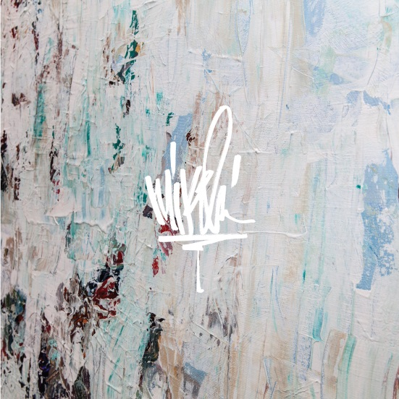

February 22, 2019 (Los Angeles, CA) – Today, Mike Shinoda (of Linkin Park) drops two new tracks “Prove You Wrong” and “What The Words Meant” via Warner Bros. Records. Both songs are now available on all DSPs for the very first time as part of Post Traumatic (Deluxe Edition). Take a listen below.

Listen/Share “Prove You Wrong” & “What The Words Meant” HERE

Shinoda recently teamed up with Mastercard for the launch of their first-ever Sonic Brand, a sound signature that will serve as an audio logo for the brand. Learn more here. Next month, he will embark on a European headline tour, continuing his extensive past year on the road in support of his critically-acclaimed solo debut, Post Traumatic. A full list of dates is below.

EUROPEAN TOUR DATES
March 2 – Berlin, Germany – Columbiahalle
March 3 – Bremen, Germany – Pier 2
March 5 – Hannover, Germany – Swiss Life Hall
March 6 – Oberhausen, Germany – Turbinenhalle
March 8 – Hamburg, Germany – Sporthalle
March 9 – Paris, France – Zenith
March 10 – London, UK – Roundhouse
March 12 – Budapest, Hungary – Budapest Arena
March 14 – Milan, Italy – Fabrique
March 15 – Padova, Italy – GT Geox
March 17 – Zurich, Switzerland – Halle 622
March 18 – Munich, Germany – Zenith
March 19 – Prague, Czech Republic – Forum Karlin
March 21 – Amsterdam, Netherlands – AFAS Live
March 22 – Ludwigsburg, Germany – MHP Arena
March 23 – Luxembourg City, Luxembourg – Luxexpo
March 25 – Tel Aviv, Israel – Hangar 11
March 26 – Tel Aviv, Israel – Hangar 11

###

Press Contacts:
Laura Swanson / Warner Bros. Records
(818) 953-3722/ laura.swanson@wbr.com

Patrice Compere / Warner Bros. Records
(212) 707-3450 / patrice.compere@wbr.com

