D.I.Y. SINGER/SONGWRITER MYKEY DEBUTS NEW EP
WELCOME TO THE WITCHING HOUR

LISTEN HERE

March 19, 2021 (Los Angeles, CA) – Buzzing singer, songwriter, multi-instrumentalist, producer, and all-around nice guy MyKey unveils his new EP, Welcome To The Witching Hour, today via Warner Records. Executive produced by rising producer marinelli [spill tab], the nine track record continues on a momentous past year for the indie pop auteur – earning upwards of 25 million streams – and features recently released singles “Mazda5,” “Sweet Tooth” and new track “Kneepads,” which has an accompanying lyric video also released today. Listen to Welcome To The Witching Hour HERE and watch the “Kneepads” lyric video HERE.

Predominantly crafted at the odd hours of the night, Welcome To The Witching Hour was a true labor of love for MyKey during the COVID lockdown. He explains, “My friend David [marinelli] and I trapped ourselves in a cabin in Big Bear and wrote an entire album in 4 days. Writing the album felt like a glimmer of hope in the dark abyss of 2020 and I’m really excited to be sharing it.”

MyKey resembles that friend whose idiosyncrasies and quirks teach us something about ourselves. He eats cereal with chopsticks. It’s not out of character for him to wake up at three in the morning and order a Lego set. He also presides over a handcrafted musical world entirely of his own design, singing, playing every instrument, producing, engineering, and making his own videos, including stop-motion animation. Growing up in Maryland, he worked at a recording studio and performed in various local groups. In 2017, he decided to create, record, and release his independent debut Faces, that ultimately propelled him to his signing with Warner Records last year. From there, he made his official Warner debut with standout single “Please Don’t Go” and teamed up with labelmate Cavetown on fan favorite “Was It Something I Said.”

Welcome To The Witching Hour Tracklisting
- Welcome To The Witching Hour
- Mazda5 (feat. marinelli)
- Madly (feat. Lonely God)
- Sweet Tooth
- Kneepads
- Vin Diesel
- Emily
- Graveyard Blues (feat. marinelli)
- Marshmallow Moons

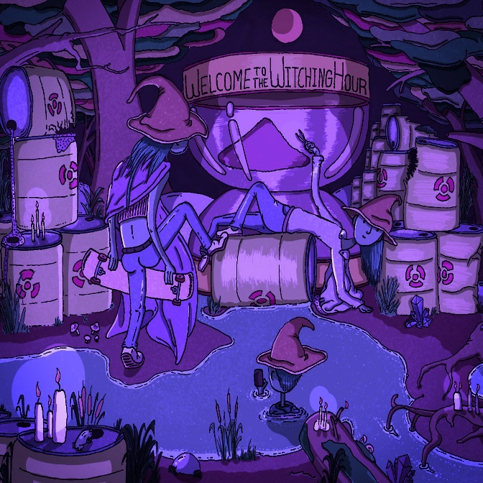
Hi-res artwork + photos available here

###
Follow MyKey:
INSTAGRAM | FACEBOOK | TWITTER | YOUTUBE | TIKTOK

For further information, contact:
Ceri Roberts, Ceri.Roberts@warnerrecords.com
Patrice Compere, Patrice.Compere@warnerrecords.com

