BUZZING DIY SINGER/SONGWRITER MYKEY ENLISTS LABELMATE CAVETOWN
FOR NEW VERSION OF “WAS IT SOMETHING I SAID”

WATCH THE MYKEY-MADE ANIMATED VIDEO HERE

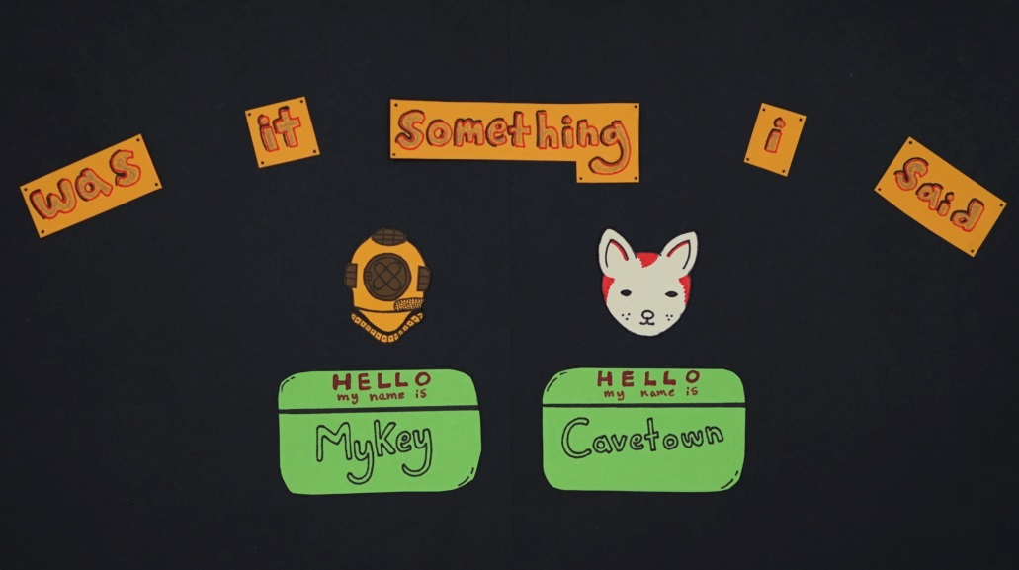

May 15, 2020 – Buzzing DIY singer/songwriter MyKey enlists labelmate Cavetown for a new version of his wistful breakout track, “Was It Something I Said,” out today via Warner Records. The fan-favorite has been streamed over 6 million times and secured coveted real estate across playlists since its original release last year. Adding to his DIY charm, MyKey made his own video for the new Cavetown-assisted version of “Was It Something I Said” using stop-motion animation.

Watch “Was It Something I Said” Video HERE
Listen “Was It Something I Said” Audio HERE

“Was It Something I Said” by MyKey and Cavetown follows the recent release of MyKey’s Warner debut “Please Don’t Go,” which doubles as something of a spiritual successor. While the former attempted to make sense of an unraveling relationship, the latter accepts the split and encourages him to start moving on. Watch the official video here.

About MyKey
MyKey resembles that friend whose idiosyncrasies and quirks teach us something about ourselves. He eats cereal with chopsticks. It’s not out of character for him to wake up at three in the morning and order a Lego set. He also presides over a handcrafted musical world entirely of his own design, singing, playing every instrument, producing, engineering, and making his own videos, including stop-motion animation. Growing up in Maryland, he accidentally ended up in the popular bluegrass outfit The Flower Hill String Band, worked at a recording studio, and performed in various local groups. In 2017, he decided to create, record, and release his independent debut Faces. It amassed nearly 10 million streams driven by the likes of “Monsters in the Dark” [1.6 million Spotify streams], “Untitled Unloved” [1.3 million Spotify streams], and “Maybe I Was the One” [1 million Spotify streams]. Along the way, he moved to LA and dropped the breakthough single “Was It Something I Said,” as he signed to Warner Records.

About Cavetown
Since launching Cavetown at age 14, the UK-based singer – real name Robin Skinner – has racked up 250 million Spotify plays and 1.3 million YouTube subscribers. He did so not with a viral hit or easy gimmicks, but rather pure heart, filling his YouTube channel with day-in-the-life, behind-the-scenes vignettes and covers. Coupled with his original, self-recorded music, Skinner’s unassuming-yet-captivating personality took the internet by storm, catapulting him to millions of streams and subscribers and stages around the world, including recent sold-out headline performances at venues like Los Angeles’ Fonda Theatre, New York City’s Webster Hall and London’s Shepherd’s Bush Empire, as well as Reading & Leeds and TRNSMT Festival. This year, he released his major label debut album, SLEEPYHEAD on Sire Records.

###

Follow MyKey:
Press Assets | Instagram | Facebook | YouTube

Follow Cavetown:
Press Assets | Website | Facebook | Twitter | Instagram | YouTube

For further information, contact:
For MyKey: Ceri Roberts / Ceri.Roberts@warnerrecords.com
For Cavetown: Jaime Rosenberg / Jaime.Rosenberg@warnerrecords.com

