NEIL YOUNG SET TO RELEASE HIS FIRST NEW ALBUM WITH CRAZY HORSE
IN SEVEN YEARS

COLORADO ARRIVES ON OCTOBER 25 VIA REPRISE RECORDS

Album Available For Pre-Order - Stream New Track “Milky Way” At
https://neilyoungarchives.com/

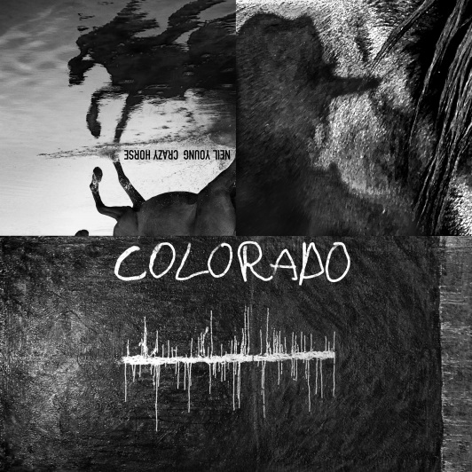
(Cover Art hi-res link here)

August 30, 2019 (Los Angeles, CA) – Neil Young with Crazy Horse have completed a brand new studio album titled COLORADO which is set for release on October 25 via Reprise Records. This is the first new music since 2012’s critically acclaimed PSYCHEDELIC PILL.

COLORADO was recorded mostly live in the studio in the Rocky Mountains of Colorado and produced by Young and John Hanlon with additional mixing at Shangri-La Studios in Malibu. Mastering by Chris Bellman at Bernie Grundman Mastering, Hollywood. As with every Young release, the resultant audio fidelity is nothing short of astonishing and sounds as if one is present on the studio floor with the band during the recording.

COLORADO will be available on high resolution digital audio through NYA, and on a three-sided, double vinyl album set with a bonus 7” vinyl single as well as CD and digitally at all streaming and digital outlets. The bonus single contains two non-album tracks, “Rainbow Of Colors,” (live) recorded live by Neil Young solo and was the first-ever public performance of this powerful new fan favorite, and “Truth Kills,” a studio track by Young with Crazy Horse.

Pre-order COLORADO now and receive and instant download of the album track “Milky Way.”
Click here to purchase and stream.

COLORADO Track listing:

Side 1
Think Of Me
She Showed Me Love

Side 2
Olden Days
Help Me Lose My Mind
Green Is Blue
Shut It Down

Side 3
Milky Way
Eternity
Rainbow Of Colors (studio version)
I Do

Side 4
Etched artwork

Bonus 7” Single:
A-Side:
Rainbow Of Colors (solo, live in Portland, OR May 17, 2019)

B-Side:
Truth Kills (Neil Young with Crazy Horse – studio)

In other Neil Young news, a book co-authored by Young and Phil Baker titled, TO FEEL THE MUSIC: A Songwriters Mission To Save High Quality Audio, will be published in September by BenBella Books. This is a memoir about Young’s single most passionate pursuit: Bringing high-quality audio back to music lovers, who have been forced to settle for compressed, digital files that rob songs of their original warmth. Click here for further information.

CRAZY HORSE:
Neil Young – guitars, vocals, piano, vibes, harmonica
Nils Lofgren – guitars, vocals, pump organ
Ralph Molina – drums, vocals
Billy Talbot – bass, vocals

# # #

For further information, contact Rick Gershon at Reprise / Warner Records Publicity:
818-953-3473 /rick.gershon@warnerrecords.com

Official Site/NYA:
neilyoungarchives.com

Press materials:
http://press.warnerrecords.com/neilyoung

