

**NEIL YOUNG ‘FIRESIDE SESSIONS’ PART FOUR**

**SET FOR 9AM PT TODAY @**[**NEIL YOUNG ARCHIVES**](https://nam04.safelinks.protection.outlook.com/?url=https%3A%2F%2Fneilyoungarchives.com%2F&data=02%7C01%7CRick.Gershon%40warnerrecords.com%7C7bf813b2c62c48d2dde108d7f1fdd038%7C8367939002ec4ba1ad3d69da3fdd637e%7C0%7C0%7C637243944724967993&sdata=istv3TyPHVp5RYOxlhaF9XRq4XEIVyUdw0sXLj0Gkzw%3D&reserved=0)

**A Downhome Production Directed by dhlovelife**

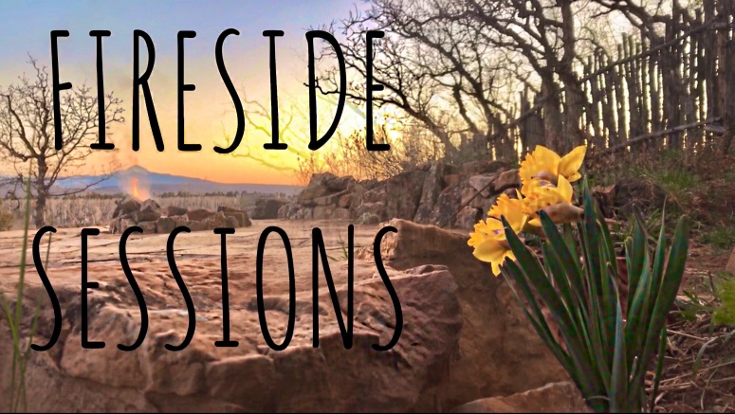

**May 7, 2020 – (Los Angeles, CA)** Today, Neil Young and Daryl Hannah launch their fourth and longest, highly anticipated **Fireside Sessions**. The session is set for 9:00AM PT today. Click here to view. Click [**here**](https://neilyoungarchives.com/news/1)to view. Click [**here**](https://neilyoungarchives.com/) for further details. Neil’s innovative, comprehensive website [**neilyoungarchives.com**](https://neilyoungarchives.com/) is free for all to explore and enjoy during these unusual and challenging times. The previous three, warm and intimate **Fireside Sessions** have been featured some surprising set lists.

The ***Rolling Stone*** article - Quarentee Comfort: “The Best Livestreamed Performances So Far” - said of a previous session “the intimate show featured…wonderfully obscure tunes from his vast catalog.  It set the bar very high…”

“Neil Young is helping us get through this trying time with a little music and the magic of the internet.” –***Stereogum***

“Nothing can stop Neil Young from playing music; not even coronavirus. Young is back at it again today, this time with a Fireside Session featuring some unexpected deep cuts (!) and gorgeous footage of the snow.” – ***Consequence Of Sound***

 As previously announced Young has recently released a new mix of “Shut It Down” titled **“Shut It Down 2020**” from his current album with**Crazy Horse**, ***COLORADO*.**  Click [**here**](https://NeilYoung.lnk.to/ShutItDownVideo)to view and share **“Shut It Down 2020”** video and [**here**](https://neilyoung.lnk.to/ShutItDown) for the audio.

For all information on Neil Young, Fireside Sessions, NYA Times-Contrarian, Hearse Theatre and so much more, go to: [**https://neilyoungarchives.com/**](https://neilyoungarchives.com/)

Contact **Rick Gershon** at Reprise / Warner Records Publicity:

818-953-3473 [/ **rick.gershon@warnerrecords.com**](mailto:/%20rick.gershon@warnerrecords.com)

**/var/folders/kf/v6dntks955j4xr91961zp0200000gp/T/com.microsoft.Word/WebArchiveCopyPasteTempFiles/cidimage003.jpg@01D4F910.A5DA5810** 