NEIL YOUNG + PROMISE OF THE REAL
ANNOUNCE NOISE & FLOWERS LIVE ALBUM AND CONCERT FILM
AVAILABLE AUGUST 5 VIA REPRISE RECORDS
The Emotional Project Documents 2019’s European Shows Performed In Tribute To His Late Manager Elliot Roberts
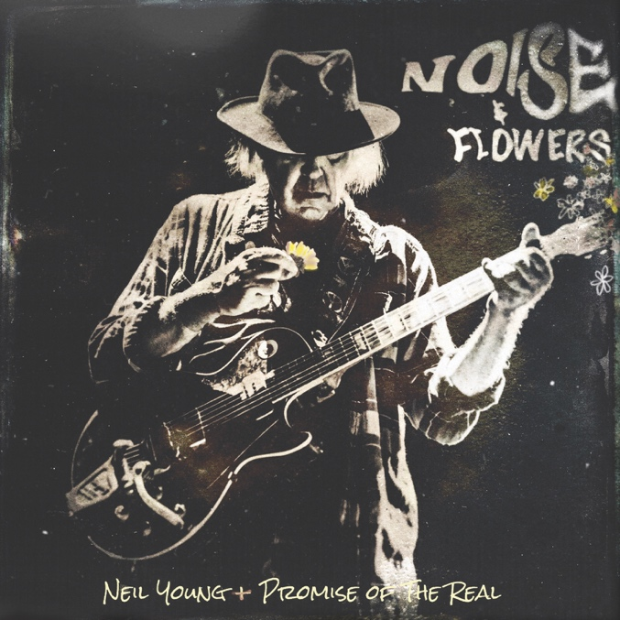
(Hi-res artwork HERE)
June 24, 2022 — (Los Angeles, CA) Today, Neil Young + Promise Of The Real announce a new live album, Noise & Flowers, that captures the group in all their glory on their 2019 European tour. The release will be accompanied by a similarly titled concert film that’s included in the album’s 2xLP+CD+Blu-ray Deluxe Edition. Noise & Flowers is available for pre-order now and is out August 5 via Reprise Records. Click HERE to pre-order/pre-save. Click HERE to stream “From Hank To Hendrix.”
Noise & Flowers documents a 9-date tour that began just two weeks after Young’s lifetime friend and manager of more than 50 years, Elliot Roberts, passed away at age 76. Performing alongside a photograph of Roberts taped to his road case, Young approached each show as a celebratory memorial service to honor his late friend. It’s a trek the legendary singer/songwriter describes as “wondrous.”
“Playing in his memory [made it] one of the most special tours ever,” Young says in the album’s liner notes. “We hit the road and took his great spirit with us into every song. This music belongs to no one. It’s in the air. Every note was played for music’s great friend, Elliot.” In paying tribute to the manager who guided Young’s career for over a half-century, Noise & Flowers explores all corners of his vast discography.
It balances all-timer anthems (“Mr. Soul,” “Helpless,” “Rockin’ in the Free World”) with rarely aired ‘70s deep cuts (“Field of Opportunity,” “On the Beach”) and ’90s gems (“From Hank to Hendrix,” “Throw Your Hatred Down”). His frequent backing band since 2015, Promise of the Real effectively bridges the extremes in Young’s sound, infusing his raging rockers and country serenades with their casual brilliance and telepathic intuition.
Noise & Flowers’ companion film (directed by Bernard Shakey and dhlovelife) emphasizes both the intimacy and ecstasy of these performances. Noise & Flowers will be available on double vinyl, CD, Deluxe Edition at The Greedy Hand Store through Neil Young Archives (NYA), and music retailers everywhere. Find Noise & Flowers digitally at the Xstream Store at NYA and most DSP’s including Atmos/Spatial. Purchasers of Vinyl and CD at The Greedy Hand Store will receive the hi-res digital download from the Xstream Store at NYA. The Blu-ray edition of the concert film will be available exclusively at The Greedy Hand Store.
Noise & Flowers is entry No. PS 21 in the Neil Young Archives Performance Series of live releases—a special addition to a robust, and still-growing catalog.

Noise & Flowers track list:
1. Mr. Soul
2. Everybody Knows This Is Nowhere
3. Helpless
4. Field Of Opportunity
5. Alabama
6. Throw Your Hatred Down
7. Rockin’ In The Free World
8. Comes A Time
9. From Hank to Hendrix
10. On The Beach
11. Are You Ready For The Country
12. I’ve Been Waiting For You
13. Winterlong
14. F***in’ Up

# # #

For further information, contact Rick Gershon at Warner Records:
818-953-3473 / Rick.Gershon@warnerrecords.com

Official Site/NYA:
neilyoungarchives.com

Press Materials:
https://press.warnerrecords.com/neilyoung/

