NEIL YOUNG TO RELEASE TUSCALOOSA VIA REPRISE RECORDS ON JUNE 7

PREVIOUSLY UNRELEASED ALBUM FEATURES YOUNG &
STRAY GATORS RECORDED LIVE IN ALABAMA 1973

Album Available For Pre-Order

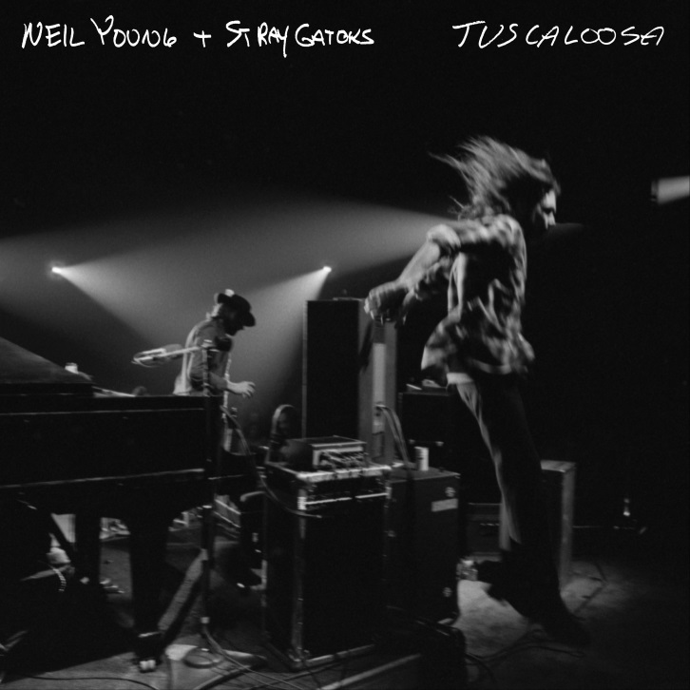
(Photo Credit: Joel Bernstein - Click HERE for hi-res)

May 13, 2019 (Los Angeles, CA) – Neil Young will release TUSCALOOSA, from his ongoing live archival series, on June 7th. The previously unreleased, 11-track recording features Neil Young & Stray Gators recorded live at the University of Alabama, Tuscaloosa on February 5, 1973. The album can be pre-ordered now and will be available as a double album over 3-sides with etched artwork on side 4. TUSCALOOSA will also be available on single disc CD and on high resolution digital audio via NYA. Young performs the first two songs solo before being joined by the band.

A very limited edition bundle will also be available through NYA only and will contain the album along with a Joel Bernstein autographed color litho print of the band live on stage. Click here to pre-order. Those who pre-order the album will receive an instant download of album track “Don’t Be Denied.” Click here to listen and share the song.

During 1971 – 1973, between solo shows and dates with Crazy Horse, Young would switch up his sound to suit the material he would focus on when touring with Stray Gators. Comprised of Tim Drummond (bass), Kenny Buttrey (drums), Jack Nitzsche (piano) and Ben Keith (steel guitar) this lineup, most notably, would record Harvest and Times Fades Away with Young. Tuscaloosa features live versions of songs from Young’s self-titled 1969 debut (“Here We Are In The Years”) plus classic songs from his two most commercially successful albums of his early career, After The Goldrush (1970) and Harvest (1972).

The album also contains a stunning version of the title track from the live album Time Fades Away that would not surface until later in 1973, as well as songs from the seminal classic Tonight’s The Night that would eventually be released in 1975. TUSCALOOSA is essentially a live greatest hits package with a stellar set comprised of some of Young’s best-loved classic songs.

TUSCALOOSA was produced by Neil Young, Elliot Mazer and mixed by John Hanlon and mastered by Chris Bellman at Bernie Grundman from the original analogue tapes. The resultant audio sounds as immediate and present as it did the moment it was performed as you hear it. The sonic quality of these tracks is nothing short of astonishing making this document an essential part of any Neil Young collection. Photographs by Joel Bernstein complete the packaging.

Tuscaloosa Track listing below:

A side:
Here We Are In The Years (3:56)
After The Gold Rush (4:42)
Out On The Weekend (5:29)
Harvest (4:14)
B side:
Old Man (4:17)
Heart Of Gold (3:48)
Time Fades Away (6:10)
Lookout Joe (4:59)
C side:
New Mama (3:01)
Alabama (3:50)
Don’t Be Denied (8:09)
D-side:
Etched artwork

# # #

For further information, contact Rick Gershon at Reprise/Warner Bros. Records Publicity:
818-953-3473 / rick.gershon@wbr.com

Official Site/NYA:
neilyoungarchives.com

Press materials:
http://press.wbr.com/neilyoung

