NEIL YOUNG ANNOUNCES INTIMATE 1971 SOLO LIVE ALBUM AND CONCERT FILM YOUNG SHAKESPEARE SET FOR MARCH 26TH RELEASE VIA REPRISE RECORDS – INCLUDES EARLIEST LIVE FOOTAGE OF YOUNG KNOWN TO EXIST

LISTEN HERE
WATCH HERE

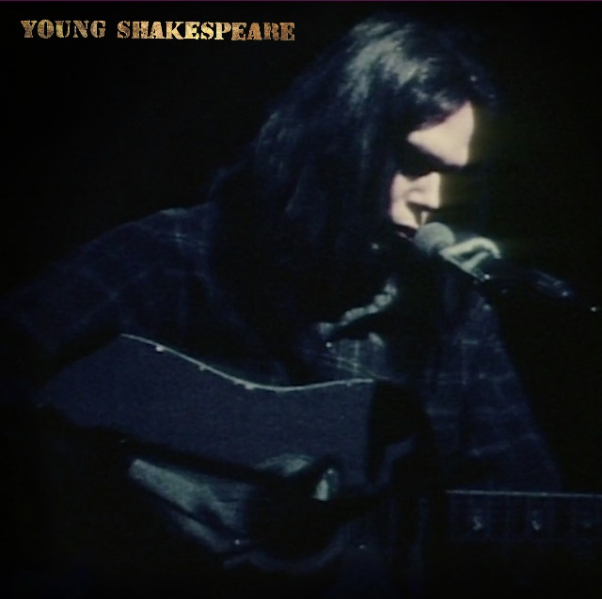
(Click here for hi-res artwork)

February 12, 2021 (Los Angeles, CA) — Fifty years after the original performance, NEIL YOUNG announces Young Shakespeare, an as-yet unreleased 1971 live recording and concert film which contains the earliest known live performance footage of Young known to exist. The 1971 Stratford, CT show captures the artists stripped down to the bare essentials—acoustic guitar, piano, and harmonica.
Available for pre-order today and out on March 26, 2021, Young Shakespeare features early recordings of “Old Man,” “The Needle and the Damage Done,” “A Man Needs a Maid,” and “Heart Of Gold” which were then over a year away from being released on Young’s classic 1972 record Harvest. Available for pre-order now, the album will be available on vinyl, CD via The Greedy Hand Store at Neil Young Archives (NYA) and music retailers everywhere. A stand-alone DVD of the concert will be available exclusively through The Greedy Hand Store at NYA.
A Deluxe Box Set Edition is also available and will include vinyl, CD, and the DVD and will be available through the NYA Greedy Hand Store and all retailers. Those who purchase the CD, LP or Box set from the NYA Greedy Hand Store will also receive free hi-res digital audio downloads from the Xstream Store © at NYA. Order today and receive an instant download of “Tell Me Why.” Click here to view & share the video and here for the album trailer. Additional Instant Download tracks will follow prior to release date.
Just two months after the release of Young’s seminal After the Gold Rush, he sat down for a performance at The Shakespeare Theater on January 22, 1971. The concert was recorded for presentation on German TV later that year but was not publicly available until now. The original 50 year-old analog tapes have been lovingly restored, making available early acoustic recordings of two After the Gold Rush songs, early Harvest tunes, and beloved favorites such as “Ohio,” “Cowgirl in the Sand,” “Helpless,” “Down by the River,” and “Sugar Mountain.”
Young wrote on NYA that Young Shakespeare is, “a more calm performance, without the celebratory atmosphere of Massey Hall, captured live on 16mm. Young Shakespeare is a very special event. To my fans, I say this is the best ever…one of the most pure-sounding acoustic performances we have in the Archive.”

NYA is the first totally immersive fan-experience website and remains the only portal for all things Neil Young. Only at NYA can you find Young’s music in the highest possible digital audio resolution alongside a seemingly infinite store of archival files. It’s also the home of Young’s virtual daily newspaper, The Times Contrarian, and The Hearse Theater, home to rare footage and live-streamed shows. NYA is a fittingly sprawling repository for Young; few artists—perhaps none—have explored such a vast spectrum of sounds and styles. Young Shakespeare is a raw reminder of his roots.

Young Shakespeare track listing:
1. Tell Me Why
2. Old Man
3. The Needle and the Damage Done
4. Ohio
5. Dance Dance Dance
6. Cowgirl in the Sand
7. A Man Needs a Maid/Heart Of Gold
8. Journey Through the Past
9. Don’t Let It Bring You Down
10. Helpless
11. Down by the River
12. Sugar Mountain

# # #

For further information, contact Rick Gershon at Warner/Reprise Records:
Rick.Gershon@warnerrecords.com

Official Site/NYA:
neilyoungarchives.com

Press materials:
https://press.warnerrecords.com/neilyoung/

