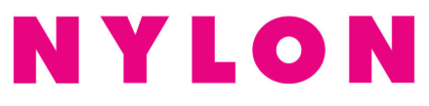

November 11, 2019

https://nylon.com/soundcheck-11-9-2019

