**NEIL YOUNG OFFICIAL BOOTLEG SERIES (OBS) LAUNCHES TODAY WITH THE RELEASE OF *CARNEGIE HALL 1970* VIA SHAKEY PICTURES RECORDS**

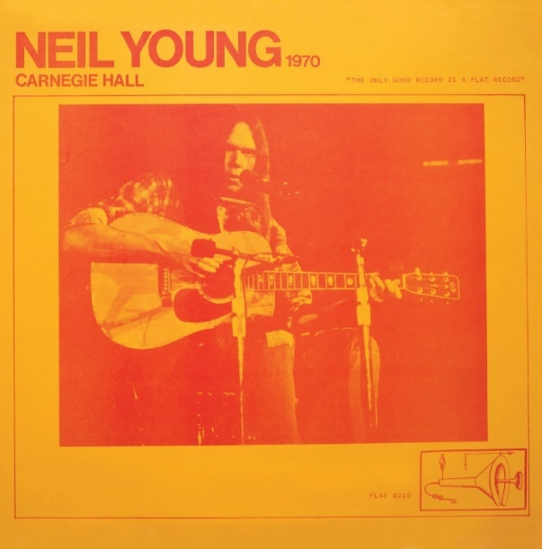

(Click [**here**](https://wmg.sharepoint.com/:i:/s/US.WBR.Publicity/EcI66MPVd7ZDtXNw3jOeb_IBhXwaqb6-uWsBkjA_mXa2Tg?e=42PHgT)for Hi-Res link)

**October 1, 2021 – (Los Angeles, CA)** – **Shakey Pictures Records** and **Reprise Records** are now happy to release the first title of a new series - **The Neil Young Official Bootleg Series** – starting today with ***Carnegie Hall 1970***, available on double vinyl, and double CD via [**The Greedy Hand Store**](https://neilyoung.warnerrecords.com/) at [**Neil Young Archives**](https://neilyoungarchives.com/) (**NYA**) and at music retailers everywhere and digitally at all DSP’s including hi-res audio at [**NYA**](https://neilyoungarchives.com/). **Greedy Hand Store** purchases of ***Carnegie Hall 1970*** come with a free hi-res digital audio downloads from the [**Xstream Store ©**](https://store.neilyoungarchives.com/) at **NYA**.

Five more series selections will become available in 2022. Click [**here**](https://neilyoung.lnk.to/FlyingOnTheGroundIsWrong) to stream **“Flying On The Ground Is Wrong”** now.

***Carnegie Hall*** was recorded on original analog multitrack and was mixed by**“The Volume Dealers”** *--* Neil Young and Niko Bolas. This recording was made from the show on December 4th, 1970 and it was the first time Neil ever walked onstage at Carnegie Hall. There were two shows at Carnegie Hall, one on the 4th and one followed at midnight the next morning. No bootleggers ever captured this first show, and it was, by far, a much superior show according to NY.

The concert’s generous setlist covers one of the most revered eras of Young’s career, with stripped-down versions of the tunes ***“Down By the River,” “Helpless,”*** and***“Sugar Mountain,”*** plus *“****After The Gold Rush****”* from the album of the same name, released only nine weeks prior to the Carnegie Hall show. Neil even played the poignant songs **“*Bad Fog of Loneliness,”******“Old Man,”***and ***“See the Sky About to Rain”*** before they were recorded and released. ***Carnegie Hall*** is an album full of gems.

**Neil Young Official Bootleg Seriestrack listing:**

**OBS 1: Carnegie Hall 1970**

**(NYC: December 4, 1970 – Early show)**

1. Down by the River
2. Cinnamon Girl
3. I Am a Child
4. Expecting to Fly
5. The Loner
6. Wonderin'
7. Helpless
8. Southern Man
9. Nowadays Clancy Can't Even Sing
10. Sugar Mountain
11. On the Way Home
12. Tell Me Why
13. Only Love Can Break Your Heart
14. Old Man
15. After the Gold Rush
16. Flying on the Ground Is Wrong
17. Cowgirl in the Sand
18. Don't Let It Bring You Down
19. Birds
20. Bad Fog of Loneliness
21. Ohio
22. See the Sky About to Rain
23. Dance Dance Dance

**# # #**

For further information, contact **Rick Gershon** at Warner Records:

[**Rick.Gershon@warnerrecords.com**](mailto:Rick.Gershon@warnerrecords.com)

**Follow Neil Young:**

**Official Site/NYA** **|** [**Press Materials**](https://press.warnerrecords.com/neilyoung/)

