

**NEIL YOUNG**

**" FIRESIDE SESSIONS"**

***PORCH EPISODE***

**NOW ON**[**NEIL YOUNG ARCHIVES**](https://nam04.safelinks.protection.outlook.com/?url=https%3A%2F%2Fneilyoungarchives.com%2F&data=02%7C01%7CRick.Gershon%40warnerrecords.com%7C7bf813b2c62c48d2dde108d7f1fdd038%7C8367939002ec4ba1ad3d69da3fdd637e%7C0%7C0%7C637243944724967993&sdata=istv3TyPHVp5RYOxlhaF9XRq4XEIVyUdw0sXLj0Gkzw%3D&reserved=0)

**Another Downhome Production Directed by dhlovelife**

**Click** [**HERE**](https://neilyoungarchives.com/)

**PREVIOUSLY UNRELEASED STUDIO ALBUM *HOMEGROWN* FROM 1974**

**AVAILABLE NOW VIA REPRISE RECORDS**

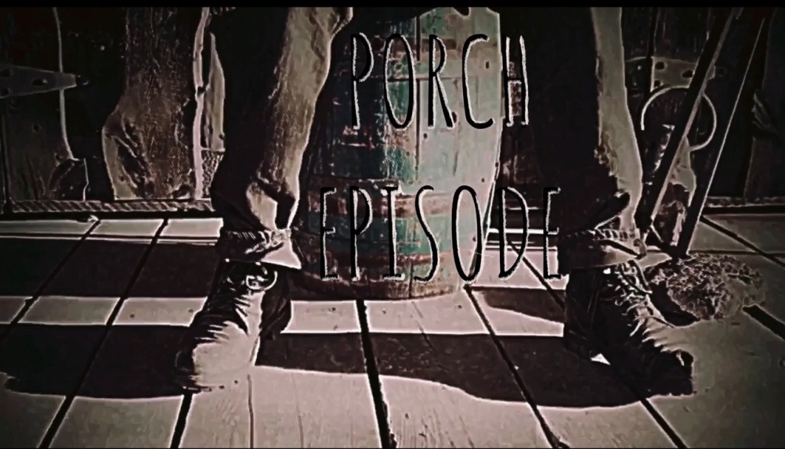

**July 1, 2020 (Los Angeles, CA**) **–** Today, **Neil Young’s** “**Fireside Sessions”** returns with the launchof the ***Porch Episode***. Go to <https://neilyoungarchives.com/> to stream the sixth session in his ongoing series of intimate livestreams.

All previous **Fireside Sessions**are viewable only at **NYA.** These highly anticipated sessions continue to garner universal praise:

“Neil Young’s website, neilyoungarchives.com offers up a plethora of material in his ‘Hearse Theater’ [which] offers a welter of different material from throughout his long career recorded in lockdown.” –***The Arts Desk* (UK)**

“There's still good news out there, even as the coronavirus has us sheltering in place. Neil Young is playing fireside shows which you can watch free in the ‘[Hearse Theater](https://neilyoungarchives.com/movie-night).’" – ***Newsweek***

Neil Young’s long awaited album ***HOMEGROWN*** is available now. Click [**here**](https://RepriseRecords.lnk.to/Homegrown) to listen.

“Neil Young’s *Homegrown*, is one of the great ‘Holy Grails’ of his unreleased catalogue.” – ***Pitchfork***

*“Homegrown*is a whole other kind of miracle. It’s all here, and yet somehow it all feels new and fresh.”

– ***Uproxx***

“Neil Young’s 45-year-old new album, *Homegrown*, is a rare missing link that actually lives up to its legend…one of the best albums from his 1970’s golden era. *Homegrown* is an essential addition to the Young catalog and the best of his many archival releases.” – ***Variety***

**# # #**

**Follow Neil Young**

[**NYA**](https://neilyoungarchives.com/) **|** [**Facebook**](http://www.Facebook.com/NeilYoungRepriseRecords)

Contact **Rick Gershon** at Reprise / Warner Records Publicity:

818-953-3473 [/ **rick.gershon@warnerrecords.com**](mailto:/%20rick.gershon@warnerrecords.com)

**/var/folders/kf/v6dntks955j4xr91961zp0200000gp/T/com.microsoft.Word/WebArchiveCopyPasteTempFiles/cidimage003.jpg@01D4F910.A5DA5810**