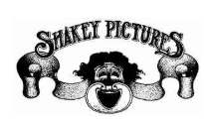

**NEIL YOUNG**

**‘FIRESIDE SESSIONS’**

**BARNYARD EDITION**

**NOW ON @**[**NEIL YOUNG ARCHIVES**](https://nam04.safelinks.protection.outlook.com/?url=https%3A%2F%2Fneilyoungarchives.com%2F&data=02%7C01%7CRick.Gershon%40warnerrecords.com%7C7bf813b2c62c48d2dde108d7f1fdd038%7C8367939002ec4ba1ad3d69da3fdd637e%7C0%7C0%7C637243944724967993&sdata=istv3TyPHVp5RYOxlhaF9XRq4XEIVyUdw0sXLj0Gkzw%3D&reserved=0)

**Another Downhome Production Directed by dhlovelife**

**Click** [**HERE**](https://neilyoungarchives.com/)

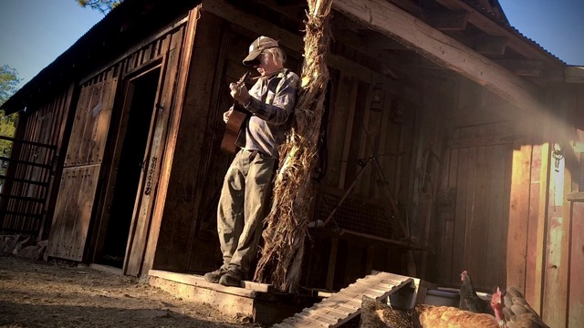

**May 20, 2020 (Los Angeles, CA**) **–**  **Fireside Sessions - Barnyard Edition** was not scheduled for today, but it’s here anyway…”Yer Welcome!”

Go to <https://neilyoungarchives.com/> to stream the **Barnyard Edition** as well as the previous four **Fireside Sessions**. **NYA** is currently free for all.

“There's still good news out there, even as the coronavirus has us sheltering in place. Neil Young is playing fireside shows which you can watch free in the "[Hearse Theater](https://neilyoungarchives.com/movie-night)." – ***Newsweek***

“In his previous livestreams, Young went deep into his extensive catalog, performing rarities or solo versions of his classic songs. Young’s *Fireside Sessions* has been one of the best livestreams due to their unpredictable nature that showcases him at his most freewheeling. The stripped-down songs show Young’s warmth and comfort, especially in this intimate setting.” –***Spin***

**# # #**

**Follow Neil Young**

[**NYA**](https://neilyoungarchives.com/) **|** [**Facebook**](http://www.Facebook.com/NeilYoungRepriseRecords)

Contact **Rick Gershon** at Reprise / Warner Records Publicity:

818-953-3473 [/ **rick.gershon@warnerrecords.com**](mailto:/%20rick.gershon@warnerrecords.com)

