NEIL YOUNG TO RELEASE HOMEGROWN ON JUNE 19 VIA REPRISE RECORDS
PREVIOUSLY UNRELEASED STUDIO ALBUM FROM 1974

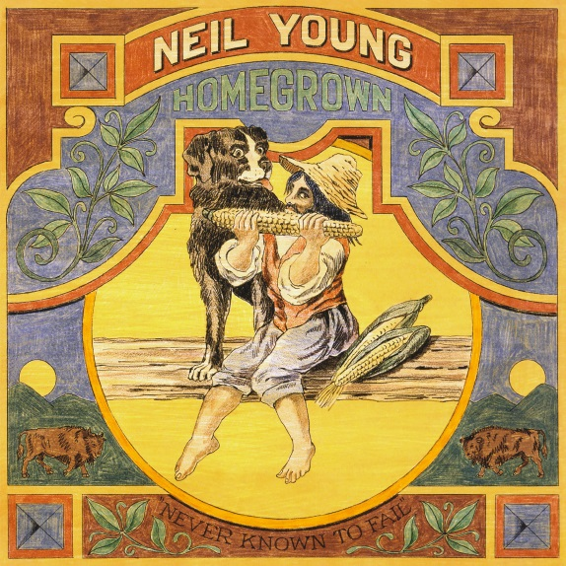

(Click here for album artwork)

May 18, 2020 (Los Angeles, CA) – Roughly forty-six years after its original recording, Neil Young announces the release of one his most storied and sought-after albums ever, Homegrown. Often referred to by fans as one of Young’s mysterious, great “lost albums,” the twelve studio tracks will be released on all formats on June 19th, via Reprise Records. Album pre-orders begin today and will include an instant download of previously unreleased album track “Try.” Click here to pre-order.

Neil Young describes Homegrown as “The One That Got Away,” and posted the following letter on Neil Young Archives below:

“I apologize. This album Homegrown should have been there for you a couple of years after Harvest. It’s the sad side of a love affair. The damage done. The heartache. I just couldn’t listen to it. I wanted to move on. So I kept it to myself, hidden away in the vault, on the shelf, in the back of my mind….but I should have shared it. It’s actually beautiful. That’s why I made it in the first place. Sometimes life hurts. You know what I mean. This is the one that got away.

Recorded in analog in 1974 and early 1975, Homegrown was mixed at that time to original stereo analog master tapes. These original mixes have been restored with love and care by John Hanlon, and mastered by Chris Bellman at Bernie Grundman Mastering, making Homegrown a completely original album.

Levon Helm is drumming on some tracks, Karl T Himmel on others, Emmylou Harris singing on one, Robbie Robertson plays on one. Homegrown contains a narration, several acoustic solo songs never even published or heard until this release and some great songs played with a band of my friends, including Ben Keith – steel and slide – Tim Drummond – bass and Stan Szelest – piano. Anyway, it’s coming your way in 2020, the first release from our archive in this new decade. Come with us into 2020 as we bring you the past.” – Neil Young

Neil Young puts it best, “This album is the unheard bridge between Harvest and Comes A Time.” Recorded between June 1974 and January 1975, Homegrown was intended to come out in 1975 before Young cancelled the release. The album has remained unreleased until now, achieving a legendary status among Neil Young fans in the process.

The album is made up of twelve Neil Young songs, of which seven are previously unreleased - “Separate Ways,” “Try,” “Mexico,” “Kansas,” We Don’t Smoke It No More,” “Vacancy” and “Florida” (a spoken word narration). Also included are the first recordings of “Homegrown,” “White Line,” and “Star Of Bethlehem” – different versions of which would all later appear on other Neil Young albums. The versions of “Love Is A Rose” and “Little Wing” have been previously released on the 1977 compilation Decade.

Young plays solo on some tracks (guitar, piano and harmonica), and is joined by a band of friends on other tracks, including Levon Helm, Ben Keith, Karl T Himmel, Tim Drummond, Emmylou Harris and Robbie Robertson.

Recorded in analog, and mastered from the original master tapes, this long-lost album is a wonderful addition to Young’s incomparable catalog.

HOMEGROWN Track Listing:
Separate Ways
Try
Mexico
Love Is A Rose
Homegrown
Florida
Kansas
We Don’t Smoke It No More
White Line
Vacancy
Little Wing
Star of Bethlehem

# # #

Contact Rick Gershon at Reprise / Warner Records Publicity:
818-953-3473 / rick.gershon@warnerrecords.com

Follow Neil Young:
NYA | Facebook

Press Materials:
http://press.warnerrecords.com/neilyoung

