Nessa Barrett Unleashes Haunting Debut Single, ‘Pain’
Listen HERE Watch HERE

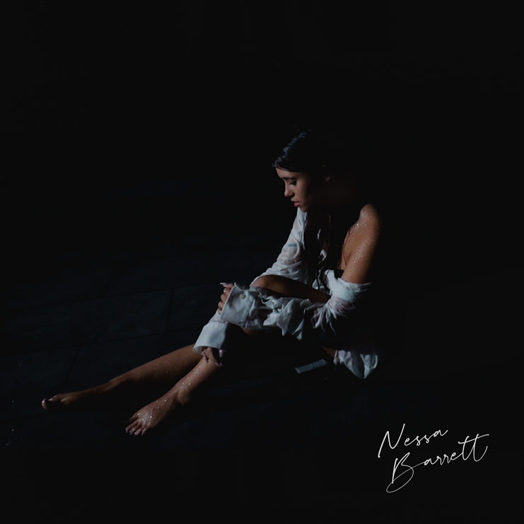

Click here for hi-res single art

July 31, 2020 (Los Angeles, CA) - Known for her wildly popular dancing and her exhilarating and engaging videos, social media phenom Nessa Barrett is finding her own musical voice. Now, Barrett unveils “Pain,” her debut single and video. Written and arranged by the artist herself, “Pain” is Barrett’s first music project released on Warner Records.

Barrett, a Puerto Rican-American influencer originally from New Jersey, joined social media in March 2019. Barrett quickly went viral, garnering nearly 10 million followers on TikTok and over 2.7 million followers on Instagram. Eager to engage with the 17-year-old star, her fans have viewed her recent TikTok videos over 5 million times, with many videos receiving over 10 million views. Barrett, who moved to Los Angeles this summer, also launched a line of merchandise – a selection of hoodies and sweatshirts highlighting her position as one of social media’s reigning queens.
Music has always been Barrett’s passion, and upon moving to L.A., she went straight into the studio, sat down at a piano, and poured her heart out into "Pain." In her soul-stirring debut, Barrett lays bare her feelings of heartbreak, emotional tumult, and the growth she's experienced since bursting into the limelight and living life under a microscope. “Pain” pulls back the curtain on the person behind the social media persona, deftly showcasing the kind of sound fans can expect from the artist as her natural musical talents continue to evolve.

Apart from her music and social media content, Barrett is also actively involved in supporting anti-bullying and mental health outreach. In June, she made a video for the Child Mind Institute discussing mental health support available for families during the COVID-19 crisis. As someone who has come of age (Barrett turns 18 in August) in the often harsh glare of the social media spotlight, the musician and influencer has been working to use her platform to raise awareness to help other young people who are struggling.

Check out “Pain” and stay tuned for much more music to come from Nessa Barrett.

# # #

For media inquiries, please contact:
Darren Baber | Warner Records
Darren.Baber@warnerrecords.com

Follow Nessa Barrett:
Official | Instagram | Twitter | Facebook | YouTube | Press Materials

