JOJO ANNOUNCES 2020 HEADLINE TOUR + NEW ALBUM good to know

Tour Kicks Off April 21, Tickets on Sale Next Week

Photo credit: Dennis Leupold (hi-res here)

February 21, 2020 (Los Angeles, CA) – JoJo has announced her 2020 headline tour – the good to know Tour – making 20+ stops across North America this spring with additional dates confirmed in the U.K./Europe this fall. The tour marks JoJo’s first headline tour since 2017 and is in support of her highly-anticipated new album good to know, set for release this spring on Clover Music/Warner Records.

Alongside producers Doc McKinney [The Weeknd, Santigold], Lido [Halsey, Chance The Rapper], and 30 Roc [Roddy Ricch, Kendrick Lamar, Cardi B], JoJo has honed together an R&B-infused, emotionally honest body of work centered around her new-found confidence, both musically and personally.

JoJo explains, “I called the album good to know because of everything I’ve learned in the past few years – every piece of feedback, criticism (internal or external), whatever it is – it’s all just information. And it’s all good! I’ve been lucky to have the space to reflect on my own journey up to now, and I hope people can take comfort in the fact that I am not anywhere near perfect, and I will never sugarcoat anything. We are all constantly living and learning, and that’s what makes this life so fun.”

Tickets for the tour will be available HERE, with pre-sales beginning Monday, February 24 and general on-sale Friday, February 28 at 10am local. Every ticket purchased online includes a choice of a CD or a digital copy of the new album good to know upon release. Fans will receive instructions via email on how to redeem the album after ticket purchase. Fans may also purchase the Q&A VIP Experience, which will include one ticket to the show, pre-show acoustic performance and Q&A with JoJo, priority entry, and exclusive merchandise items. See full details HERE and dates below.

“The renaissance of JoJo continues.”
THE FADER

“Now that JoJo has stepped back into the spotlight, prepare to be totally steamrolled by her perfect runs on a weekly basis.”
NYLON

“[JoJo is] reclaiming her seat at the table of this century's top R&B talents”
HotNewHipHop

“refreshingly intimate…while not sacrificing the sultry, powerhouse vocals she’s been owning her entire career.”
Teen VOGUE

North American Headline Tour Dates
April 21 Seattle, WA The Showbox
April 22 Portland, OR Wonder Ballroom
April 25 San Francisco, CA The Regency Ballroom
April 27 Los Angeles, CA The Novo
April 28 Santa Ana, CA The Observatory
April 30 San Diego, CA House of Blues
May 1 Tucson, AZ Rialto Theatre
May 4 Dallas, TX Canton Hall
May 5 Houston, TX House of Blues
May 8 Nashville, TN Cannery Ballroom
May 10 Atlanta, GA Variety Playhouse
May 12 Carrboro, NC Cat’s Cradle
May 14 New York, NY Terminal 5
May 15 New Haven, CT College Street Music Hall
May 17 Silver Spring, MD The Fillmore Silver Spring
May 19 Boston, MA Royale
May 20 Philadelphia, PA Union Transfer
May 22 Cincinnati, OH Bogarts
May 23 Cleveland, OH House of Blues
May 27 Chicago, IL Vic Theatre
May 28 Detroit, MI St. Andrew’s Hall
May 30 Minneapolis, MN First Avenue

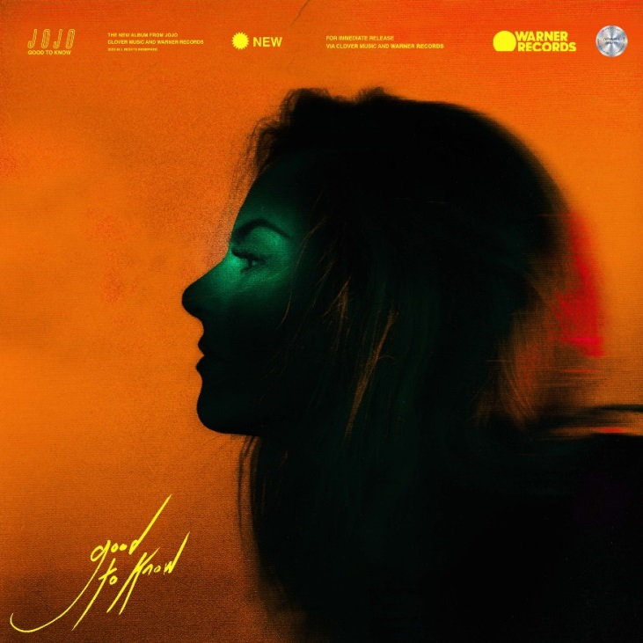
good to know Cover Art (hi-res here)

ABOUT JOJO:
JoJo [born Joanna Levesque] is a chart-topping, award-winning singer, songwriter, and actress who, at just 29 years old, is already a veteran of the music industry, having released her self-titled debut album when she was just 13. JoJo’s breakout smash “Leave (Get Out)” rocketed to the top of the charts, making JoJo the youngest-ever solo artist to have a debut #1 single in the U.S. The album went on to sell over four million copies and became the singer’s first Platinum record, which she followed with a string of additional hits, most notably the Top 3 single “Too Little Too Late.” In 2016, JoJo made a heralded return to music with her first new album in 10 years, Mad Love. – debuting Top 10 on the Billboard 200 and earning her unanimous critical acclaim from the likes of TIME, Pitchfork, Rolling Stone, Cosmo, Entertainment Weekly and more. Most recently, JoJo re-recorded and re-released her first two albums (JoJo and The High Road) under her own label Clover Music, not wanting anyone to erase her legacy and story. She took back ownership and was able to give fans the nostalgia that they missed during her years of legal battles with her former label that prevented the albums from existing on digital platforms. She has also pushed herself outside the confines of genre, in the past year alone collaborating with artists ranging from Jacob Collier and Tank to PJ Morton, on the GRAMMY-winning R&B hit “Say So.” Now signed to Warner Records as a joint venture with her own Clover Music, JoJo is a self-made, authoritative and impassioned 29-year-old woman who is ready to write her next chapter.

###

For further information, please contact Warner Records Publicity:
National: Ceri Roberts | 212-707-2259
Ceri.Roberts@warnerrecords.com

Regional: Patrice Compere | 212-707-3450
Patrice.Compere@warnerrecords.com

Follow JoJo:
Instagram | YouTube | Twitter | Facebook | Website

Press Materials:
press.warnerrecords.com/jojo

