BRITISH BREAKTHROUGH NICK MONO SHARES NEW SINGLE + VIDEO
“ALL THE MONEY”
LISTEN HERE – WATCH VIDEO HERE

DEBUT EP THE SUN WON’T STAY AFTER SUMMER OUT MARCH 11TH

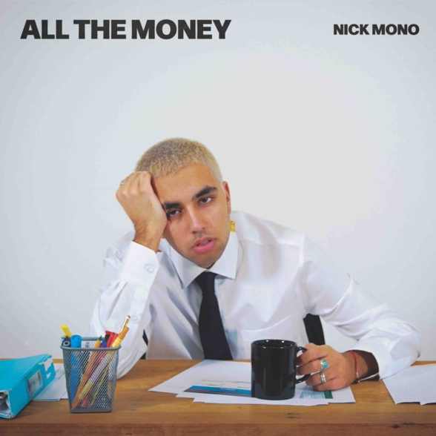

January 28, 2022 (Los Angeles, CA) – 19-year-old London producer, songwriter, and multi-instrumentalist Nick Mono further solidifies his status as a breakthrough artist to watch with his hazy, sun-soaked new single and video “All The Money,” off his upcoming debut EP The Sun Won’t Stay After Summer, out March 11th on Warner Records.

About the new single, Nick explains, "I wrote and produced it in my room during the first lockdown. During that time, I was making a whole lot of songs and missing a whole lot of online classes in the process. I really want this song to become an indie classic that plays at parties in 10 years and gives people that sense of nostalgia that I get listening to ‘Teenage Dirtbag’ or ‘All The Small Things.’ How catchy the hook is gives me hope it can go on to be one of those songs.”

Following his recently-released single “Anywhere In The World,” “All The Money” is the sound of an artist making the kind of genre-defying music that he loves. Nick is preparing to release his upcoming debut EP The Sun Won’t Stay After Summer, which he almost entirely self-produced. Merging his London stylings with alternative hip hop influences, his sound is rich with hazy soundscapes, woozy guitars, and an ability to craft tight, memorable melodies.

Growing up in West London with Punjabi-Indian parents, Nick was a music obsessive from an early age - writing and releasing music all through high school. The song that propelled him to that next level is “Effy Stonem” - named after a character from the iconic U.K. teen drama Skins, the track began to blow up on TikTok, with creators like Bella Poarch and the Skins actor April Pearson using the song in their videos. On only his second single, Nick secured the support of BBC Radio 1 (who premiered “Rusty” as Jack Saunders’ Next Wave) and was just named as one of NME’s “Emerging Artists for 2022.” The release of “All The Money” is a stunning preview of his debut EP and a taster of the exciting future that’s in store for this talented artist.

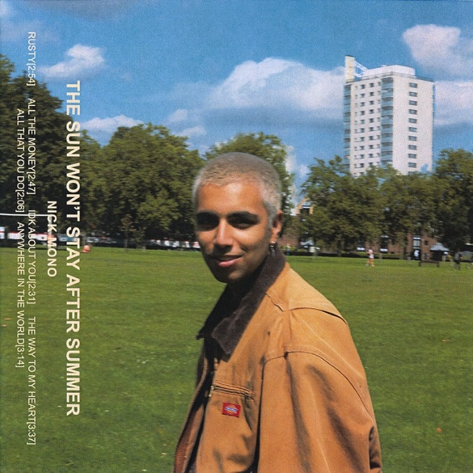

The Sun Won’t Stay After Summer

1. Rusty
2. All The Money
3. IDK Bout You
4. The Way To My Heart
5. All That You Do.
6. Anywhere In The World

Follow Nick Mono:
Instagram | Twitter | TikTok | YouTube

For more information, please contact:
Ceri Roberts | Warner Records
Ceri.Roberts@warnerrecords.com

