BRITISH BREAKTHROUGH NICK MONO UNVEILS DEBUT EP
THE SUN WON’T STAY AFTER SUMMER
LISTEN HERE

FEATURING NEW SINGLE “IDK ABOUT YOU”
WATCH VIDEO HERE

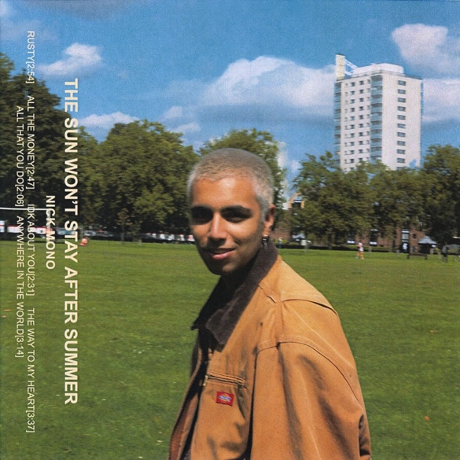

March 11, 2022 (Los Angeles, CA) – 19-year-old London producer, songwriter, and multi-instrumentalist Nick Mono continues to solidify himself as a breakthrough artist to watch with the release of his debut sun-soaked EP The Sun Won’t Stay After Summer, out today via Warner Records. Listen to it HERE.

Featuring new single “IDK About You,” plus recently-released standouts “Anywhere In The World” and “All The Money,” the 6-track record is the sound of an artist making the kind of genre-defying music that he loves – with the majority of the tracks being entirely self-produced. Merging the London stylings of people like Blur, King Krule and Jamie T with the experimental spirit of US artists like Omar Apollo and Dijon, his sound is rich with hazy soundscapes, woozy guitars and Nick’s ability to craft tight, memorable melodies.

Nick describes The Sun Won’t Stay After Summer as a coming-of-age EP, explaining, “these were all songs written at the age of 17/18 around the time of leaving school and moving onto the next phase of life. The songs are mainly about dealing with feelings of confusion, uncertainty, and hopefulness. The title is a reflection of the impermanence of everything which can be seen as a good or bad thing depending on your own relationship with the current moment. I know it’s easy to say your music includes different genres and merges them together so it’s more for the listener to decide what they hear in it, but I’m following in the footsteps of my idols such as Prince, Childish Gambino and Kevin Abstract so while I’m not tryna sound like any of those artists specifically I’m influenced by the way they create. This EP is just the first step in fulfilling a much larger vision of who I want to be as an artist and how I want to be remembered.”

Growing up in West London with Punjabi-Indian parents, Nick was a music obsessive from an early age - writing and releasing music all through high school. The song that propelled him to that next level is “Effy Stonem” - named after a character from the iconic U.K. teen drama Skins, the track began to blow up on TikTok, with creators like Bella Poarch and the Skins actor April Pearson using the song in their videos. On only his second single, Nick secured the support of BBC Radio 1 (who premiered “Rusty” as Jack Saunders’ Next Wave) and was just named as one of NME’s “Emerging Artists for 2022.” The Sun Won’t Stay After Summer is a stunning taster of the exciting future that’s in store for this talented artist.

The Sun Won’t Stay After Summer

1. Rusty
2. All The Money
3. IDK Bout You
4. The Way To My Heart
5. All That You Do.
6. Anywhere In The World

Follow Nick Mono:
Instagram | Twitter | TikTok | YouTube

For more information, please contact:
Ceri Roberts | Warner Records
Ceri.Roberts@warnerrecords.com

