GREEN DAY’S BILLIE JOE ARMSTRONG RELEASES QUARANTINE COVERS ALBUM,
NO FUN MONDAYS

No Fun Mondays is available on vinyl, CD, and digitally

Billie Joe confirms he is not in masked synth wave band,
The Network, who have an album out Dec 4th

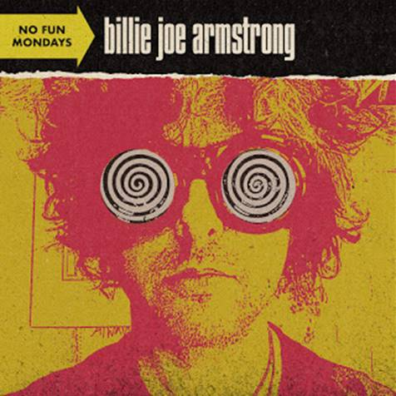

November 27, 2020 (Los Angeles, CA) – Green Day frontman Billie Joe Armstrong releases his YouTube covers series No Fun Mondays as a 14-song collection today via Reprise/Warner Records – available now on vinyl, CD, and digitally. No Fun Mondays sees Armstrong putting his signature melodic-punk spin on the songs that have formed the soundtrack to his life, including classics by John Lennon, Billy Bragg, and Johnny Thunders. Additionally, limited baby blue colored vinyl will be available at U.S. independent music retailers. Listen to No Fun Mondays HERE.

The No Fun Mondays series launched in March on Green Day’s YouTube channel. Like many musicians, Armstrong expected to spend much of this year on the road, touring in support of Green Day’s chart-topping February album, Father of All… However, once the COVID-19 pandemic forced him to put those plans on pause, Armstrong got busy with a different kind of work. "While we’ve all been in quarantine I’ve been reflecting on the things that matter the most in my life: family, friends, and, of course, music,” he says. “I figure if we have to spend this time in isolation at least we can be alone together."

Kicking things off with his perfectly on-trend cover of Tommy James and the Shondells’ golden oldie, “I Think We’re Alone Now,” Armstrong treated fans to a new home-recorded cover song each Monday, accompanied by a DIY video. Armstrong performed his first quarantine cover on The Late Late Show with James Corden accompanied by his two sons as well as The Tonight Show Starring Jimmy Fallon. Beyond paying respects to his punk-rock forefathers (The Avengers’ “Corpus Christi,” Dead Boy Stiv Bators’ “Not That Way Anymore”) and working-class heroes (John Lennon’s “Gimme Some Truth,” Billy Bragg’s “A New England”), Armstrong also indulged his love of sugary pop through reverent versions of The Bangles’ “Manic Monday” and the Beatlesque theme to Tom Hanks’ 1995 film That Thing You Do! The latter was performed in tribute to the song’s writer, Adam Schlesinger, who passed away from COVID-19 complications in April.

While the project’s inspiration was solemn at times, these songs are here to uplift. Home-recorded though it may be, No Fun Mondays is as revved-up as any of Green Day’s arena-ready anthems, a masterclass in punky power-pop from a true connoisseur of the form.

Green Day will embark on a nearly sold-out global stadium tour with Fall Out Boy and Weezer next summer. The Hella Mega Tour kicks off June 9th in Vienna, Austria and will visit cities throughout Europe, the U.K. and North America. Green Day will also perform a series of solo shows. Click here for all dates. Additionally, Billie Joe’s Instagram was hacked recently by Fink, lead singer of the masked synth wave band The Network, who recently released the Trans Am EP and have an album out December 4th. Fink is a mysterious figure whose identity is unknown, except for that it’s definitely not Billie Joe Armstrong.

NO FUN MONDAYS tracklisting
SIDE A
- I Think We’re Alone Now
- War Stories
- Manic Monday
- Corpus Christi
- That Thing You Do!
- Amico
- You Can’t Put Your Arms Round A Memory
SIDE B
- Kids in America
- Not That Way Anymore
- That’s Rock ‘N’ Roll
- Gimme Some Truth
- Whole Wide World
- Police On My Back
- A New England

About Green Day:
Green Day released their thirteenth studio album Father of All… earlier this year via Reprise/Warner Records. It debuted at #1 on the UK Albums Chart while also hitting #1 on the Billboard Top Rock Albums and #4 on the Billboard 200, resulting in the band’s 11th US Top-10 album. It was met with widespread critical acclaim from Pitchfork, Consequence of Sound, Noisey, Stereogum, and Rolling Stone who called it “one of their most fun ever.” They performed on The Ellen DeGeneres Show, The Late Late Show with James Corden, Good Morning America, and the American Music Awards. Green Day will embark on a global stadium tour, The Hella Mega Tour with Fall Out Boy and Weezer kicking off June 9th, 2021.

