THE HEAD AND THE HEART CLAIM #1
POSITION AT ALTERNATIVE RADIO FOR LEAD SINGLE
“MISSED CONNECTION”

Rocked Two Sold Out Shows at Red Rocks Amphitheatre

Performing on Jimmy Kimmel Live! Aug 1

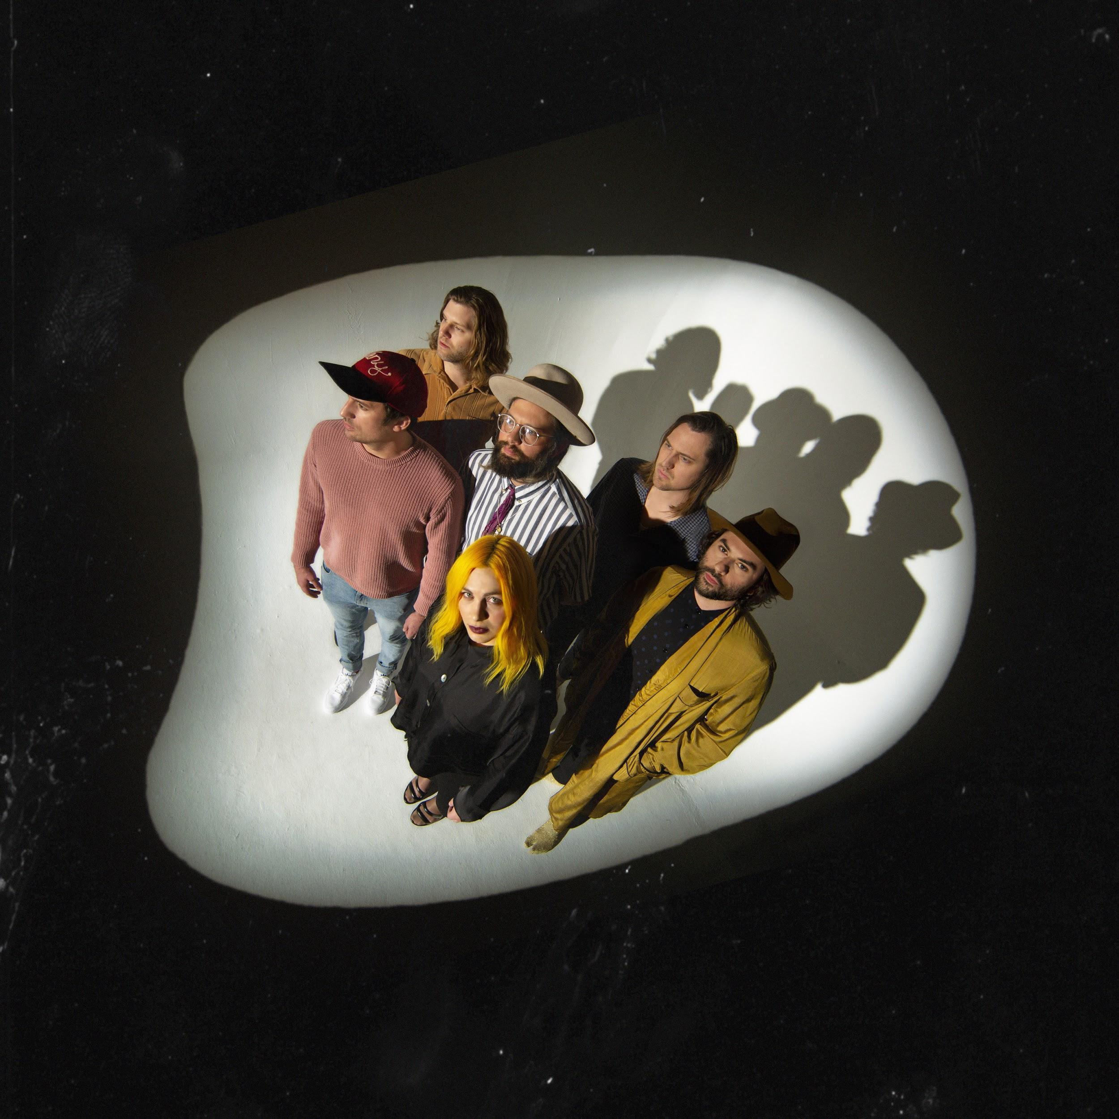

July 22, 2019 (Los Angeles, CA) - The Head and The Heart’s “Missed Connection” has secured the #1 position on the Alternative Chart and #1 at Mediabase and BDS alternative charts, already having achieved #1 on the AAA chart. “Missed Connection” is the lead single from Living Mirage, the band’s fourth full-length album, released on Reprise Records / Warner Records to critical praise earlier this year. This marks the band’s second #1 at Alternative, having previously landed the position for “All We Ever Knew” (Signs of Light), which also held the #1 spot at AAA for nine straight weeks in 2016. This win caps a monumental week including two SOLD OUT shows at the legendary Red Rocks Amphitheatre that were live streamed via nugs.tv.

The Head and The Heart have been bringing their high-energy live show out on the road for a 38-city tour. Full list of tour dates available below. The band will make their third appearance on the Jimmy Kimmel Live! outdoor concert stage Thursday, August 1, to perform their #1 hit. LA-based fans can go to 1iota for a chance to be a part of a live taping. Tickets purchased online for select tour dates (as noted below) includes your choice of a CD or digital copy of the new album, Living Mirage. Purchasers will receive instructions via email on how to redeem the album after ticket purchase. Complete list of tour dates below. Stream and purchase Living Mirage HERE.

Initially self-released in 2011, The Head and The Heart’s self-titled breakout debut produced instant classics including “Rivers and Roads,” “Down In The Valley” and “Lost In My Mind” (#1 at AAA) and is now Certified Gold. Their last two albums, 2013’s Let’s Be Still and 2016’s Signs of Light, settled into Billboard’s Top 10 albums chart, with Signs of Light securing the #1 position on Rock Album Charts. They have appeared in Cameron Crowe’s Roadies, with music featured in countless other commercials, films and TV, among them Corona, Silver Linings Playbook and more. The band has established their status as a touring power house, having landed prime time mainstage slots at Coachella, Lollapalooza and Austin City Limits. In total, the band has performed 15 times on national television including appearances on Ellen, The Tonight Show Starring Jimmy Fallon, The Late Show With Stephen Colbert, Austin City Limits with more to come in the coming months.

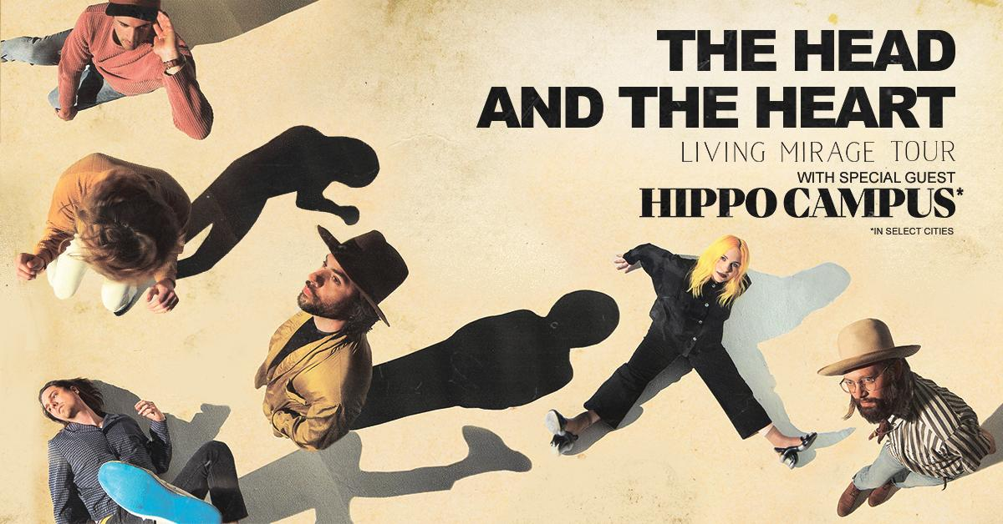

North American Tour Dates:
07/22/19 - Comerica Theatre - Phoenix, AZ *
07/23/19 - Santa Barbara Bowl - Santa Barbara, CA *+
07/25/19 - Grand Theatre at The Grand Sierra Resort - Reno, NV *
07/26/19 - Bill Graham Civic Auditorium - San Francisco, CA *
08/02/19 - The Observatory - San Diego,CA +^
08/03/19 - Alt 98.7 Summer Camp - Long Beach, CA+^
09/06/19 - Murat Theatre at Old National Centre - Indianapolis, IN
09/07/19 - Murat Theatre at Old National Centre - Indianapolis, IN
09/08/19 - PNC Pavilion at Riverbend Music Center - Cincinnati, OH
09/10/19 - Jacobs Pavilion at Nautica - Cleveland, OH
09/11/19 - 20 Monroe Live - Grand Rapids, MI
09/13/19 - Chicago Theatre - Chicago, IL
09/15/19 - The Sylvee - Madison, WI
09/16/19 - The Sylvee - Madison, WI
09/18/19 - The Armory - Minneapolis, MN
09/19/19 - Stephens Auditorium - Ames, IA
09/21/19 - Pilgrimage Music & Cultural Festival - Franklin, TN +^
09/23/19 - Avondale Brewing Company - Birmingham, AL
09/24/19 - The Fillmore - New Orleans, LA
09/26/19 - Thomas Wolfe Auditorium - Asheville, NC
09/27/19 - The Tabernacle - Atlanta, GA
09/29/19 - Charlotte Metro Credit Union Amphitheatre - Charlotte, NC
10/01/19 - Red Hat Amphitheater - Raleigh, NC
10/03/19 - The Anthem - Washington, DC
10/04/19 - Kings Theatre - Brooklyn, NY
10/05/19 - The Capitol Theatre - Port Chester, NY
10/08/19 - The MET - Philadelphia, PA
10/09/19 - Palace Theatre - Albany, NY
10/11/19 - Toyota Presents Oakdale Theatre - Wallingford, CT
10/12/19 - Agganis Arena - Boston, MA
10/14/19 - UPMC Events Center - Moon Twp., PA
10/15/19 - The Fillmore Detroit presented by Cricket Wireless - Detroit, MI
10/16/19 - Palace Theatre - Columbus, OH
10/18/19 - Algonquin Commons Theatre - Ottawa, ON
10/19/19 - MTELUS - Montreal, QC
10/20/19 - Sony Centre for the Performing Arts - Toronto, ON

*Hippo Campus
+not a Live Nation date
^ tickets purchased for this date will not include the album

For more information about The Head and The Heart, please contact:
Kate Jackson, KateJ@grandstandhq.com
Katie Nelson, KatieN@grandstandhq.com
Bobbie Gale, Bobbie.Gale@warnerrecords.com
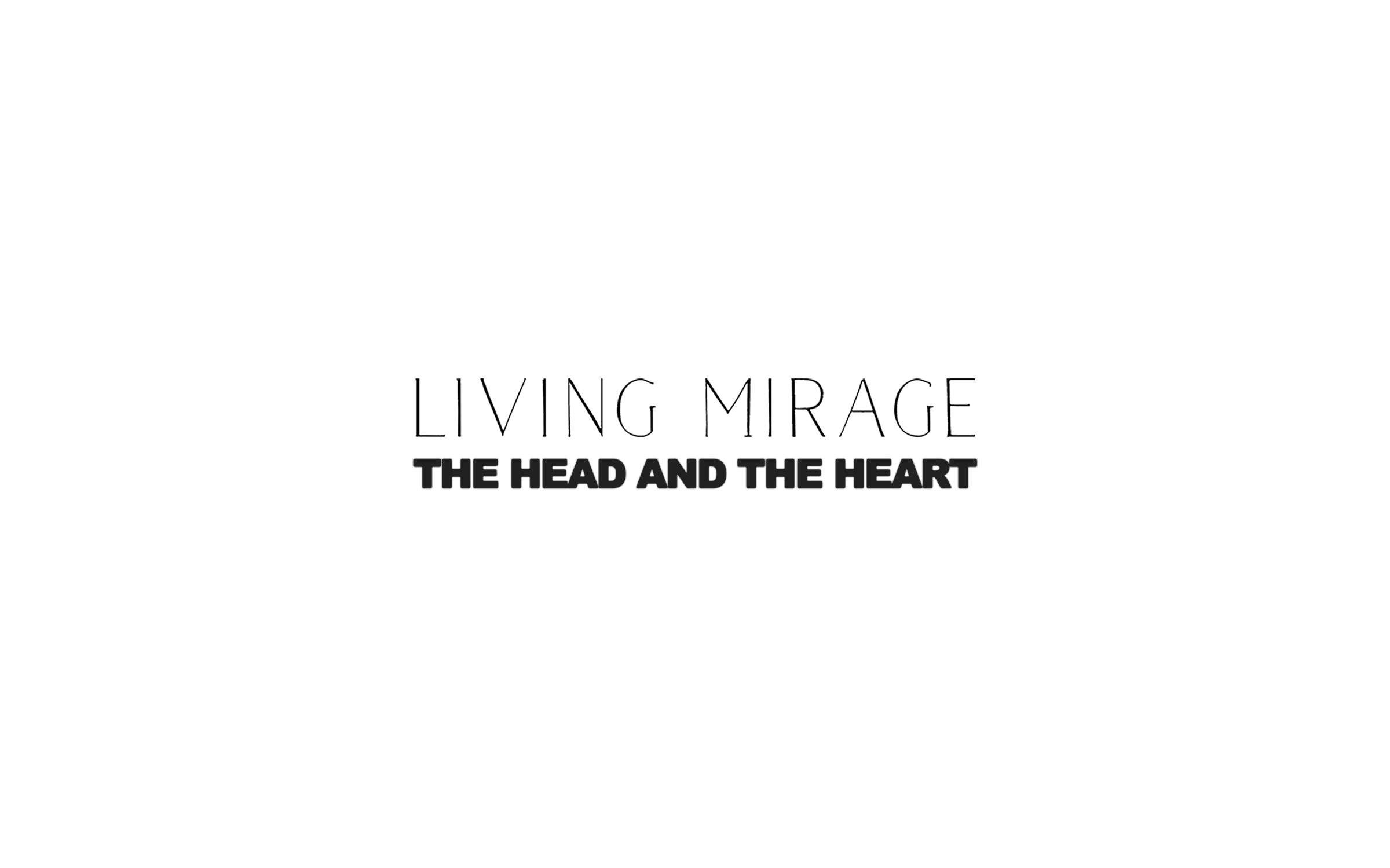

Website / Facebook / Twitter / Instagram / Youtube / Soundcloud

