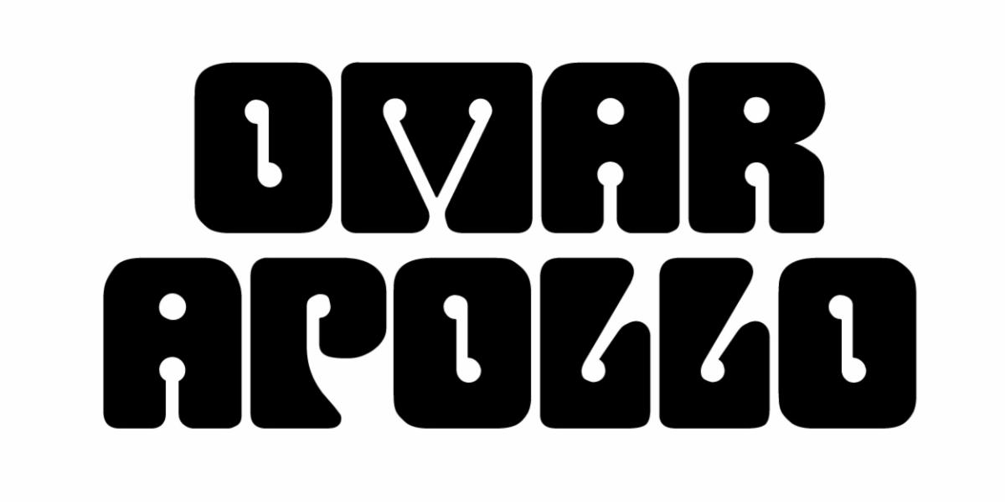
ANNOUNCES APOLONIO OUT NEXT FRIDAY, OCTOBER 16TH – PRE ORDER HERE

SET TO PERFORM AT PRINCE'S PAISLEY PARK ON 10/28

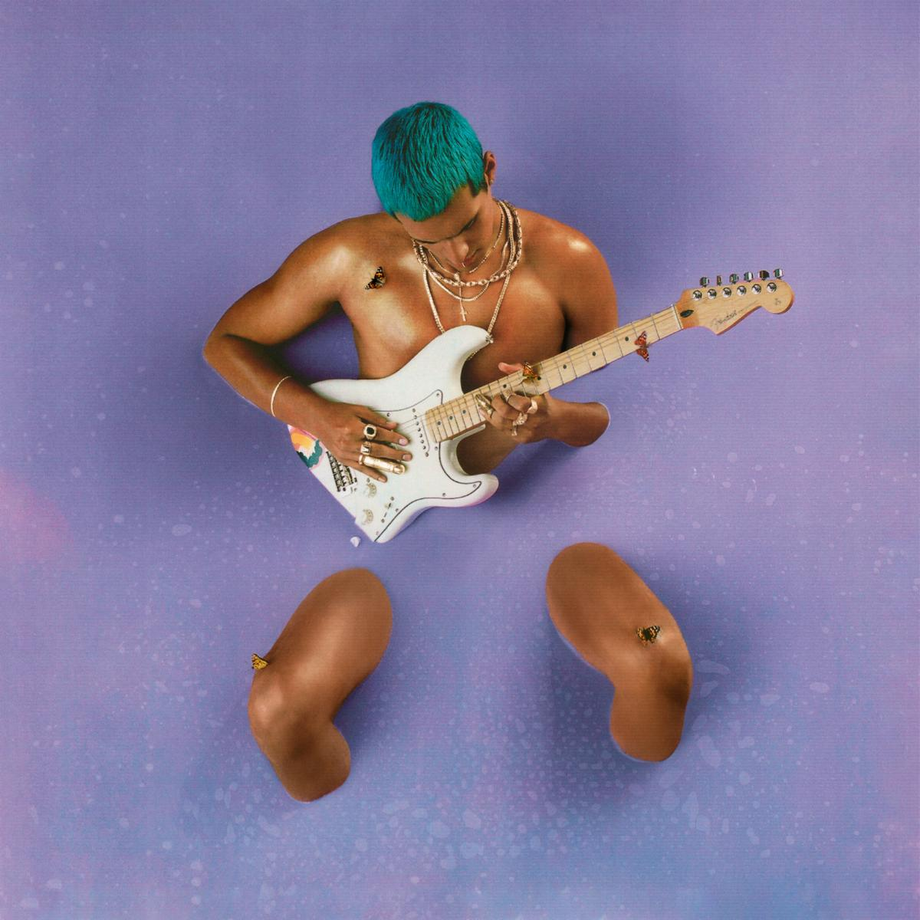
(DOWNLOAD HI-RES COVER ART HERE)

"sleek, soulful, heartache-infused love songs" - NPR

"A triple threat of an artist with plenty to offer" - Pitchfork

"lovelorn songs that reconcile the sultry sounds of D'Angelo, Prince, and Frank Ocean with Mexican soul and traditional corridos" - Rolling Stone

October 6, 2020 (Los Angeles, CA) - Today, Omar Apollo announces a new project. Apolonio is due next Friday, October 16th, and features guest appearances by Kali Uchis and Ruel and production collaborations with Albert Hammond Jr, Mk.gee, DJ Dahi, and Michael Uzowuru. It also contains previously released songs, "Kamikaze," "Dos Uno Nueve," titled 219 after the area code of his home state of Indiana, and the self-written and self-produced "Stayback," which The FADER called "his downright funkiest work to date."

Alongside the project announcement, Omar Apollo is also announcing a one-of-a-kind concert documentary live from Prince's Paisley Park in Minneapolis. Airing October 28th, the documentary will feature behind-the-scenes footage of Apollo and his band as they record and rehearse around the legendary estate alongside their performance live from the Park. Spotify pre-sale for the show begins today, Live Nation and artist pre-sale begins Wednesday, and general on-sale will begin Thursday - all at 10AM PT / 1PM ET. Get your tickets here.

Since his 2018 critically-acclaimed debut EP Stereo, Omar Apollo has continued to ascend as an undeniable talent to watch, becoming one of today's brightest breakout stars and one of the most talked about new artists of the last couple of years. Last year he released his second EP Friends, and Rolling Stone named him an Artist You Need To Know, Pitchfork featured him as a Rising artist, he made his late-night television debut on Late Night with Seth Meyers, and he had two headlining North American tours which included stops at Tyler, The Creator's Camp Flog Gnaw Carnival and Tropicalía Festival. He was also part of YouTube's Foundry International artist development program, with past alumni including Cuco, ROSALÍA, Gunna, Chloe X Halle, and Dua Lipa. In late 2019, he released a pair of singles with Kenny Beats - "Frio" and "Hit Me Up" - the former showcasing Spanish lyrics and playing off of Dembow music, the latter of which featured Dominic Fike. More recently, he released "Imagine U" which was also co-produced by Kenny Beats and was described by UPROXX as "an alluring, melodic anthem about modern heartbreak."

Pre-order Apolonio above, see project details below and stay tuned for more from Omar Apollo coming soon.

Apolonio Tracklisting:
1. I'm Amazing
2. Kamikaze
3. Want U Around (feat. Ruel)
4. Stayback
5. Hey Boy (feat. Kali Uchis)
6. Dos Uno Nueve (219)
7. Useless
8. Bi Fren
9. The Two Of Us

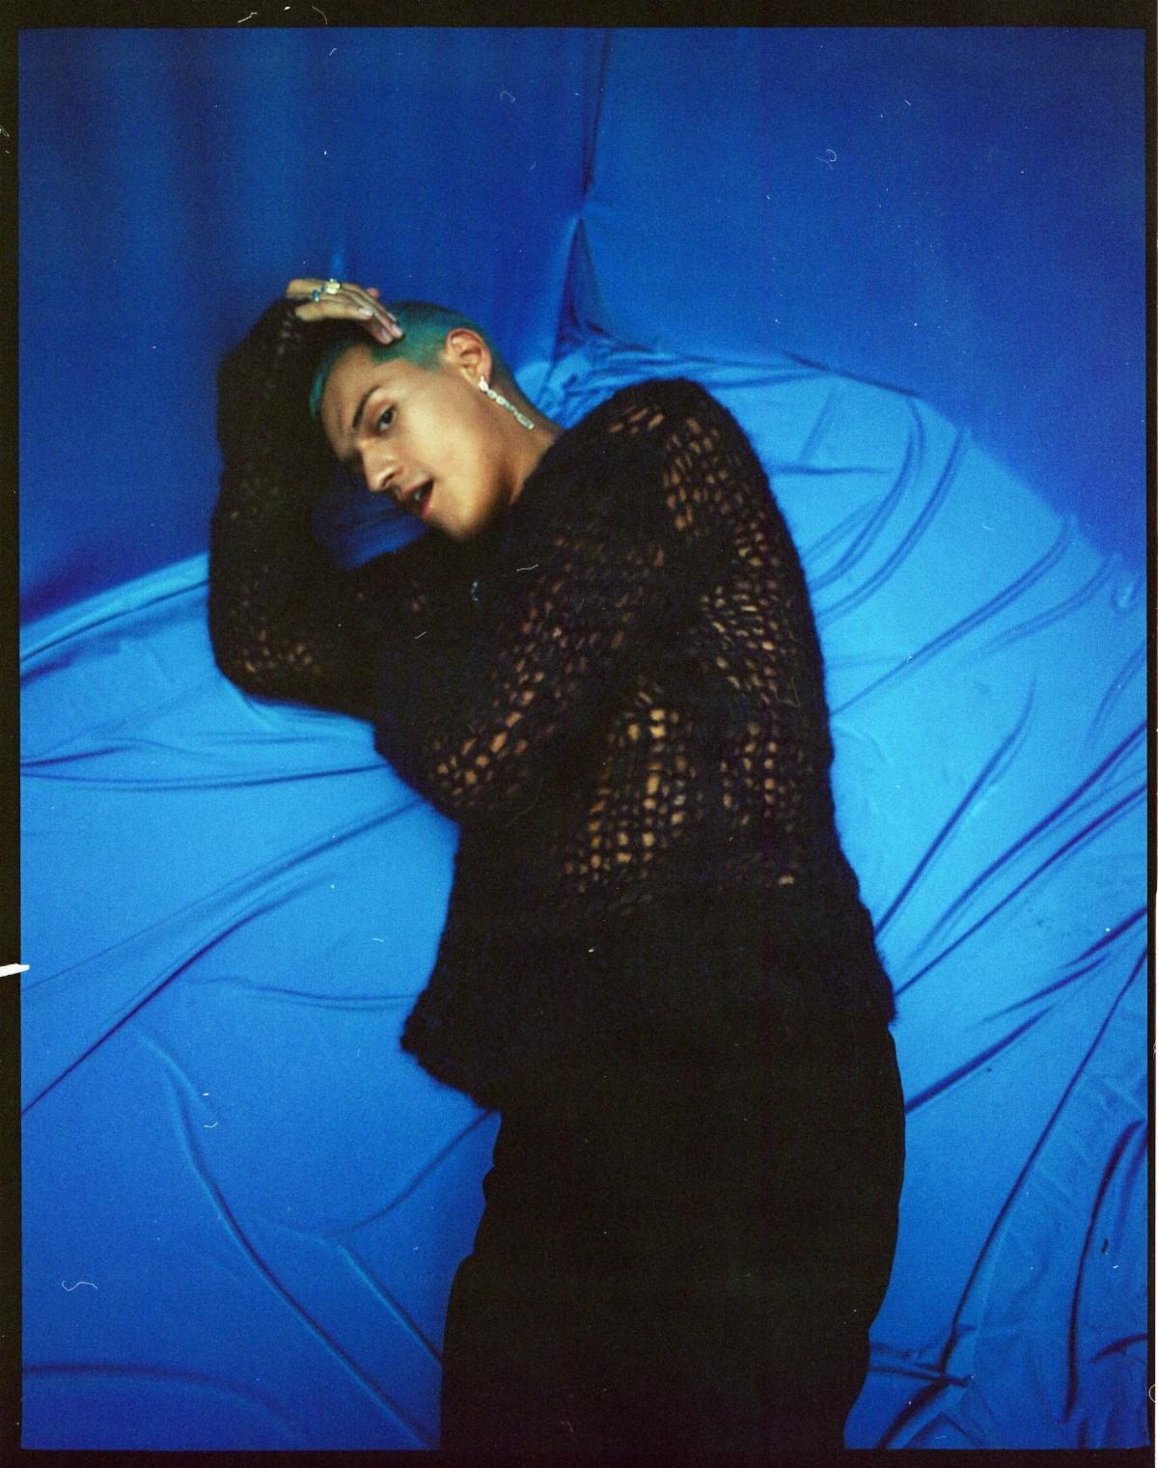
(Photo Credit: Julian Burgueño; Download Hi-Res assets HERE)

