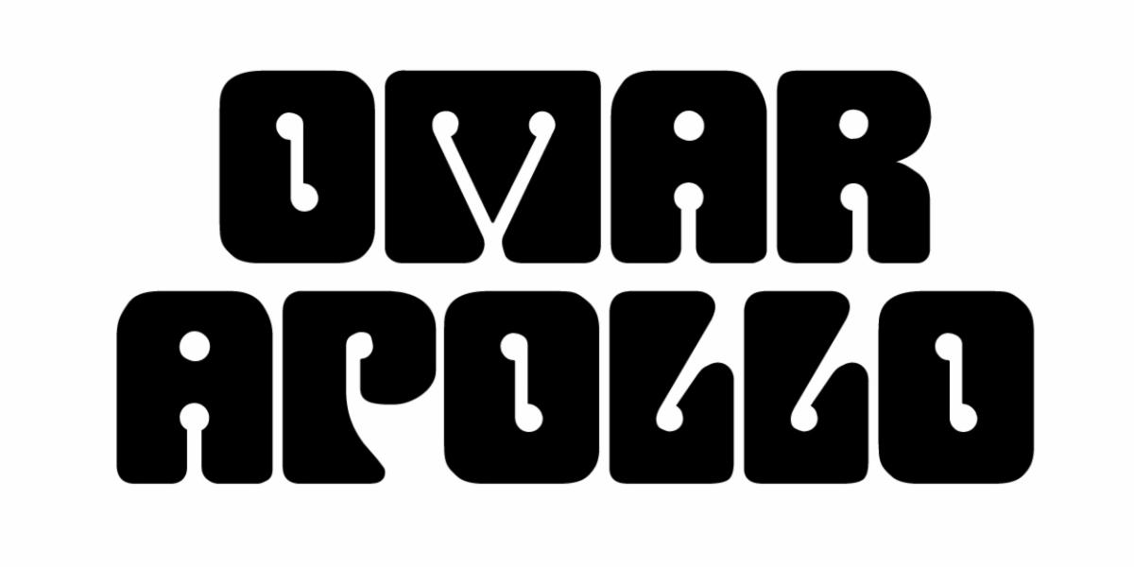
SHARES NEW SONG "WANT U AROUND" FEATURING RUEL – LISTEN HERE

DEBUT PROJECT APOLONIO OUT THIS FRIDAY, OCTOBER 16TH

SET TO PERFORM AT PRINCE'S PAISLEY PARK ON 10/28

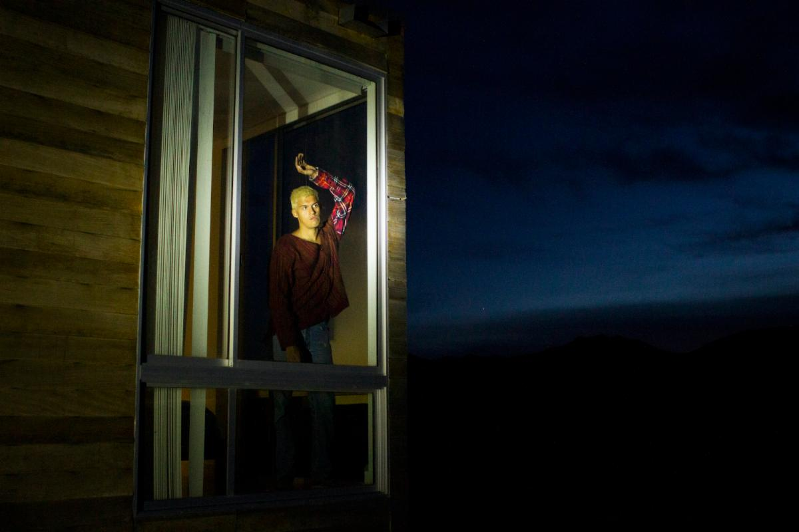
Photo Credit: Nate Guenther

"sleek, soulful, heartache-infused love songs" - NPR

"A triple threat of an artist with plenty to offer" - Pitchfork

"lovelorn songs that reconcile the sultry sounds of D'Angelo, Prince, and Frank Ocean with Mexican soul and traditional corridos" - Rolling Stone

October 12, 2020 (Los Angeles, CA) - Ahead of the release of Apolonio this Friday, Omar Apollo is sharing a new song from the project. "Want U Around" featuring Ruel is out now and follows the previously-released singles "Kamikaze," "Dos Uno Nueve," titled 219 after his area code in his home state of Indiana, and the self-written and self-produced "Stayback," which The FADER called "his downright funkiest work to date."

Speaking on "Want U Around," Apollo says: "'Want U Around' is about missing someone who doesn’t feel the same way. After you try everything and it’s still not enough, you know you should give up on that person— but something holds you back from giving up on the idea of being together one day."
Apolonio features guest appearances by Kali Uchis and the aforementioned Ruel alongside production collaborations with Albert Hammond Jr, Mk.gee, DJ Dahi, and Michael Uzowuru. The project is the follow-up to his 2019 EP Friends, which NPR called "a funky, fresh collection of straight jams."

"Want U Around" also arrives ahead of Apollo's one-of-a-kind concert documentary, live from Prince's Paisley Park. Airing October 28th, the documentary will feature behind-the-scenes footage of Apollo and his band as they record and rehearse around the legendary estate alongside their performance live from the Park. Tickets are on sale here.

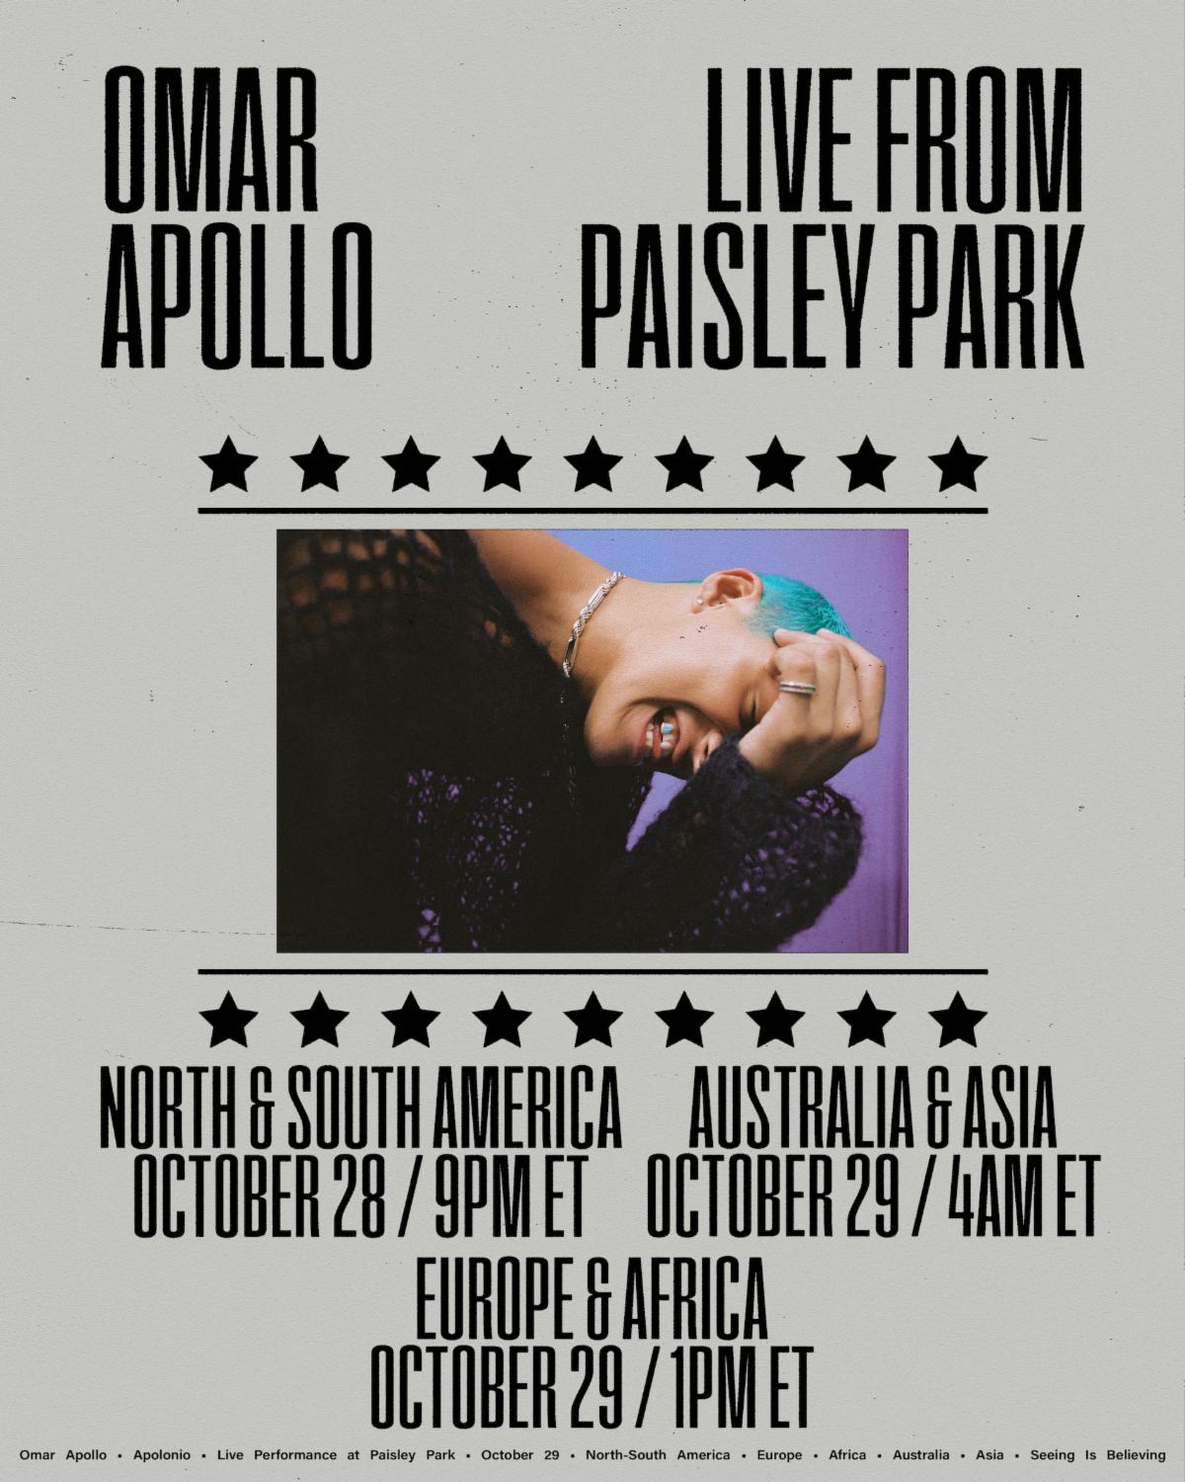

Since his 2018 critically-acclaimed debut EP Stereo, Omar Apollo has continued to ascend as an undeniable talent to watch, becoming one of today's brightest breakout stars and one of the most talked about new artists of the last couple of years. Last year he released his second EP Friends, and Rolling Stone named him an Artist You Need To Know, Pitchfork featured him as a Rising artist, he made his late-night television debut on Late Night with Seth Meyers, and he had two headlining North American tours which included stops at Tyler, The Creator's Camp Flog Gnaw Carnival and Tropicalía Festival. He was also part of YouTube's Foundry International artist development program, with past alumni including Cuco, ROSALÍA, Gunna, Chloe X Halle, and Dua Lipa. In late 2019, he released a pair of singles with Kenny Beats - "Frio" and "Hit Me Up" - the former showcasing Spanish lyrics and playing off of Dembow music, the latter of which featured Dominic Fike. More recently, he released "Imagine U" which was also co-produced by Kenny Beats and was described by Uproxx as "an alluring, melodic anthem about modern heartbreak."

Listen to "Want U Around" feat. Ruel and pre-order Apolonio above, see project details below and stay tuned for more from Omar Apollo coming soon.

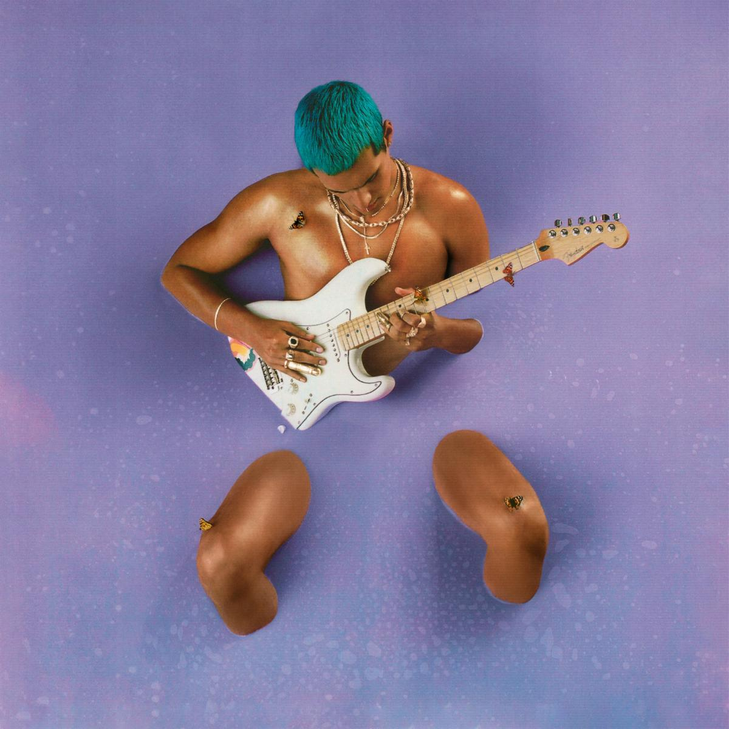

Apolonio Tracklisting:

1. I'm Amazing
2. Kamikaze
3. Want U Around (feat. Ruel)
4. Stayback
5. Hey Boy (feat. Kali Uchis)
6. Dos Uno Nueve (219)
7. Useless
8. Bi Fren
9. The Two Of Us

﻿(Download Hi-Res assets HERE)

Follow Omar Apollo
Official | Instagram | Twitter | YouTube | Press Materials

For more information, please contact:
Yash Zadeh | Warner Records
Yashar.Zadeh@warnerrecords.com

