OMAR APOLLO SHARES NEW SONG "KAMIKAZE"

LISTEN HERE
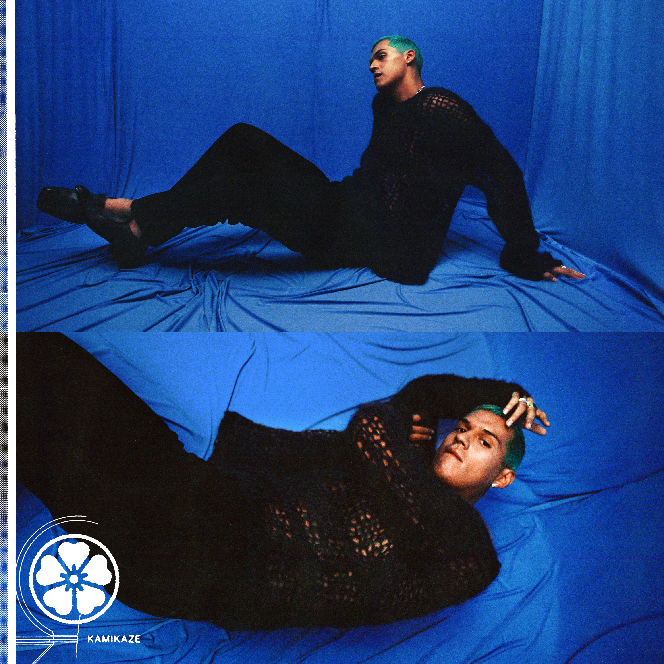

"sleek, soulful, heartache-infused love songs" - NPR

"A triple threat of an artist with plenty to offer" - Pitchfork

"lovelorn songs that reconcile the sultry sounds of D'Angelo, Prince, and Frank Ocean with Mexican soul and traditional corridos” - Rolling Stone

September 10, 2020 (Los Angeles, CA) - On the heels of his latest single "Stayback," Omar Apollo returns to share a new song. "Kamikaze" is his third release this Summer, following the aforementioned self-written and self-produced "Stayback," which The FADER called "his downright funkiest work to date," as well as the song's remix featuring Parliament-Funkadelic's Bootsy Collins.

Speaking on the inspiration behind "Kamikaze," Omar says: “’Kamikaze’ is a song that taps into my old emotions, taking it back to when I was younger. When I made ‘Kamikaze’ I was reminiscing on how I used to feel for someone and realizing those feelings are lost and we’re left with nothing. It feels good to hold on to the memories without the feelings it gave me.”

Since his 2018 critically-acclaimed debut EP Stereo, Omar Apollo has continued to ascend as an undeniable talent to watch, becoming one of today's brightest breakout stars and one of the most talked about new artists of the last couple of years. Last year he released his second EP Friends, and Rolling Stone named him an Artist You Need To Know, Pitchfork featured him as a Rising artist, he made his late-night television debut on Late Night with Seth Meyers, and he had two headlining North American tours which included stops at Tyler, The Creator's Camp Flog Gnaw Carnival and Tropicalía Festival. He was also part of YouTube's Foundry International artist development program, with past alumni including Cuco, ROSALÍA, Gunna, Chloe X Halle, and Dua Lipa. In late 2019, he released a pair of singles with Kenny Beats - "Frio" and "Hit Me Up" - the former showcasing Spanish lyrics and playing off of Dembow music, the latter of which featured Dominic Fike. More recently, he released "Imagine U" which was also co-produced by Kenny Beats and was described by Uproxx as "an alluring, melodic anthem about modern heartbreak."

Listen to "Kamikaze" above and stay tuned for more from Omar Apollo coming soon.

(Download Hi-Res assets HERE)

Follow Omar Apollo:
Instagram | Twitter | Website | Press Site

For more information, please contact:
Yash Zadeh | Warner Records
Yashar.Zadeh@warnerrecords.com

