AMY ALLEN RELEASES NEW SINGLE “A WOMAN’S WORLD” ON THE HEELS OF RECEIVING AN ICONIC IVOR NOVELLO AWARD FOR SONGWRITING

WATCH THE VIDEO HERE

AWW! EP OUT NOVEMBER 5TH
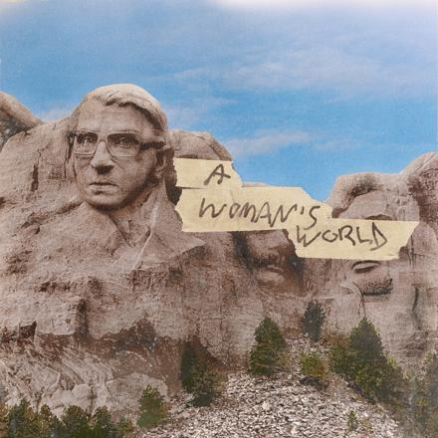

September 24, 2021 (Los Angeles, CA) – Critically acclaimed singer-songwriter Amy Allen has released the single “A Woman’s World” today – listen HERE. The track is the first from her debut EP AWW! due out November 5th via Warner Records. “A Woman’s World” is accompanied by a thought provoking visual co-directed by Amy and Jared Asher Harris – watch the video HERE.

“The moment I wrote ‘A Woman’s World,’ I was like, ‘All right, I know what this EP is,’” Amy says. “I was way zoomed out, and then the second I had the idea for this song, everything came into hyper-focus, and I could really see what the next body of work I wanted to make would be. When I wrote the line ‘I know you think you’re God’s gift to earth/But you’re living in a woman’s world,’ I was able to say what I had been feeling for a really long time.”

In the accompanying visual, Amy finds herself in a blank expanse, with menacing clouds hovering overhead. A force to be reckoned with, Amy surfaces from the haze and battles the elements until she emerges triumphantly at the top of a monument dedicated to the late Supreme Court Justice Ruth Bader Ginsburg. Through her symbolic trek and profound lyrics, Amy pays homage to the empowering women who have made her journey possible.

With her new EP, Amy has rediscovered her love for writing and performing songs that have big pop choruses and still carry messages that resonate to her and her fans. Inspired by the sounds of Amy’s favorite ‘90s female pop-rock icons, AWW! presents a bold, distinctive perspective on the rewards and challenges of living and creating in today’s world.

“AWW! is my coming-of-age EP about navigating all facets of life as a young woman,” says Amy. “Every lyric is a line in a story I’ve lived, about my fight for respect and acceptance in my profession, my love life, and in modern society. This collection of songs is about finding an inner confidence and not apologizing as I seek my earned space as an artist, friend, girlfriend and daughter.”

The hitmaker was recently honored at the 2021 Ivor Novello Awards, recognized as the pinnacle of creative musical achievement, where she, along with Tyler Johnson, Kid Harpoon and Harry Styles, took home the prestigious award for the GRAMMY-nominated song “Adore You.” Having written several multi-platinum hits, Amy has established herself as one of the top songwriters for pop artists including Harry Styles, Halsey, Selena Gomez, and Shawn Mendes. She has been named a “super-songwriter” by Billboard, featured as one of Variety’s “Hitmakers of the Month, and landed a coveted spot on Forbes’ 30 Under 30 list. Her previous solo releases have garnered support from the likes of People, Variety, and American Songwriter, who praised, “Allen comes into her own as a solo act.” Following her Life Is Beautiful festival performance, Amy will play Outside Lands and join JP Saxe and Alexander23 on tour this fall.

AWW! Tracklist:
- A Woman’s World
- R.I.P.
- Tom Brady
- Staircase
- Unsatisfied
- End of a Dark Age

Photo credit: Caity Krone

# # #

For further information, please contact:

Warner Records Publicity:
Darren Baber | Warner Records | Darren.Baber@warnerrecords.com
Ceri Roberts | Warner Records | Ceri.Roberts@warnerrecords.com

Permanent Press Media:
Kathy Reilly | Permanent Press | kathy@permanentpressmedia.com
Chloe Cardio | Permanent Press | chloe@permanentpressmedia.com
Grant Thompson | Permanent Press | grant@permanentpressmedia.com

Follow Amy Allen:
Official | Instagram | Twitter | Facebook | YouTube | Press Materials

