AMY ALLEN
RELEASES DEBUT EP AWW!

“RIP” SINGLE & MUSIC VIDEO OUT NOW – WATCH HERE

TICKETS ON SALE NOW FOR NOVEMBER 18TH
HEADLINING NYC SHOW

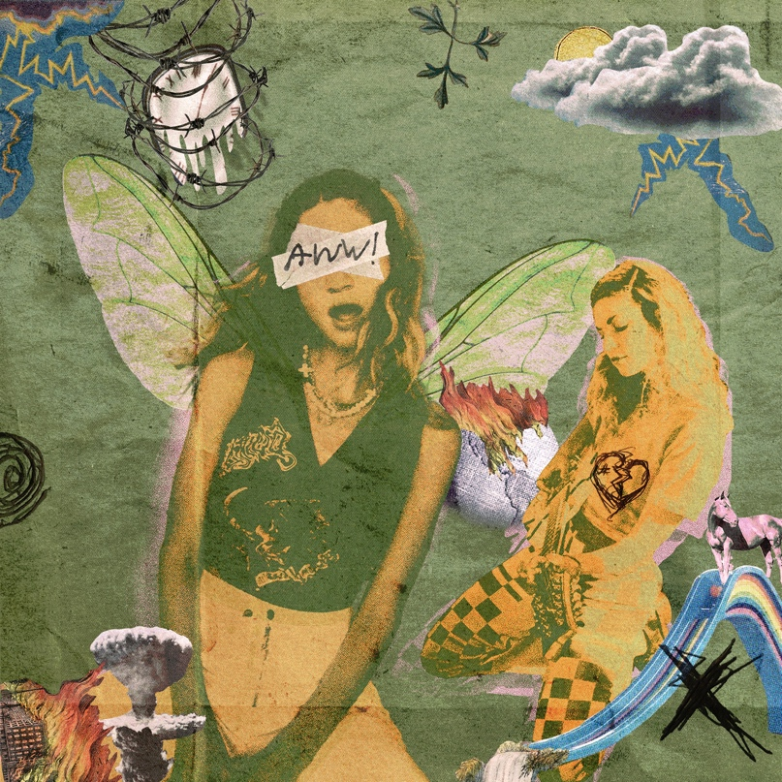

November 5, 2021 (Los Angeles, CA) – Critically acclaimed singer-songwriter Amy Allen released her debut EP AWW! today, which features six tracks illustrating her prowess for both writing and performing songs that are undeniably personal and powerful. The music video for standout single "RIP (Really Insecure Person)" also dropped today and includes a guest appearance from viral hyperpop sensation Rebecca Black. You can watch the “RIP” music video here and listen to the full EP here.

With the release of AWW!, Amy has established herself as an artist who is unafraid to challenge societal pressures through an honest and striking narrative. Drawing inspiration from her influences like Liz Phair and Pretenders, the EP is a coming-of-age record that explores the juxtaposition of the successes and hardships Amy has faced throughout various aspects of her life.

“This collection of songs isn’t about finding myself,” Amy says, “because we’re always changing, so I don’t know if we ever really do that. But it is about finding the confidence and power to be who I am as a woman, as an artist, as a friend, sister, girlfriend, daughter, and all the things I am.”

Songs like “RIP” paint a raw and blistering depiction of her experiences as a woman in the industry, but serve as a universal plea for listeners to advocate on their own behalf, whenever necessary. With the help of Rebecca Black and a karaoke-style performance, Amy brings "RIP" to life in the tongue-in-cheek visual.

“‘RIP’ is less of a song about resentment and anger,” says Amy, “and more of a song about finding your voice, standing up for yourself and not letting people get the best of you.”

AWW! features previous releases “A Woman’s World,” the dramatic title track that served as a turning point for the overall theme of the EP, and “End Of A Dark Age,” a love song about finding the person who makes you feel free to be your most vulnerable self.

Amy’s success over the last few years has led to her becoming one of the most in-demand songwriters in pop music having written several multi-platinum hits for artists including Harry Styles, Halsey, Selena Gomez, and Shawn Mendes. Already, she has landed a coveted spot on Forbes’ 30 Under 30 List and has been featured as one of Variety’s “Hitmakers of the Month.” Recently, Amy was honored at the 2021 Ivor Novello Awards, recognized as the pinnacle of creative musical achievement, where she, along with Tyler Johnson, Kid Harpoon and Harry Styles, took home the prestigious award for their GRAMMY-nominated song “Adore You.” Billboard has named her a “super-songwriter,” along with support from People, Variety, NYLON and American Songwriter, who praised, “Allen comes into her own as a solo act.”

In addition to joining both JP Saxe and Alexander23 on their respective tours this fall, Amy is set to perform “RIP” and the rest of AWW! at her headlining show on November 18th at the legendary Mercury Lounge in New York City. Tickets and show information can be found HERE.

AWW! Tracklist:
- RIP
- A Woman’s World
- Tom Brady
- Unsatisfied
- Staircase
- End Of A Dark Age

Listen to “RIP” here:
https://amyallen.lnk.to/ripvideo

Listen to AWW! here:
https://amyallen.lnk.to/AWW

Tickets for Mercury Lounge on sale now at:
https://www.ticketmaster.com/event/00005B48D9785E82

# # #

For further information, please contact:

Warner Records Publicity:
Darren Baber | Warner Records | Darren.Baber@warnerrecords.com
Ceri Roberts | Warner Records | Ceri.Roberts@warnerrecords.com

Permanent Press Media:
Kathy Reilly | Permanent Press | kathy@permanentpressmedia.com
Chloe Cardio | Permanent Press | chloe@permanentpressmedia.com
Grant Thompson | Permanent Press | grant@permanentpressmedia.com

Follow Amy Allen:
Official | Instagram | Twitter | Facebook | YouTube | Press Materials

