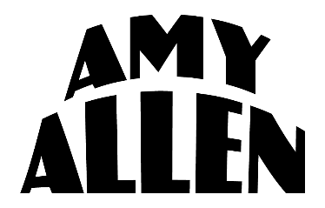

AMY ALLEN ANNOUNCES VIRTUAL EARTH DAY BENEFIT EVENT
AMY ALLEN & FRIENDS CELEBRATE EARTH DAY ON APRIL 22

Featuring Alexander23, Chelsea Cutler, Griff, Fletcher, Vance Joy & more!

Premiering on YouTube, April 22 at 9am PT / 12pm ET

In support of the Surfrider Foundation, Ecosia, Greenpeace, Parks Project & more!

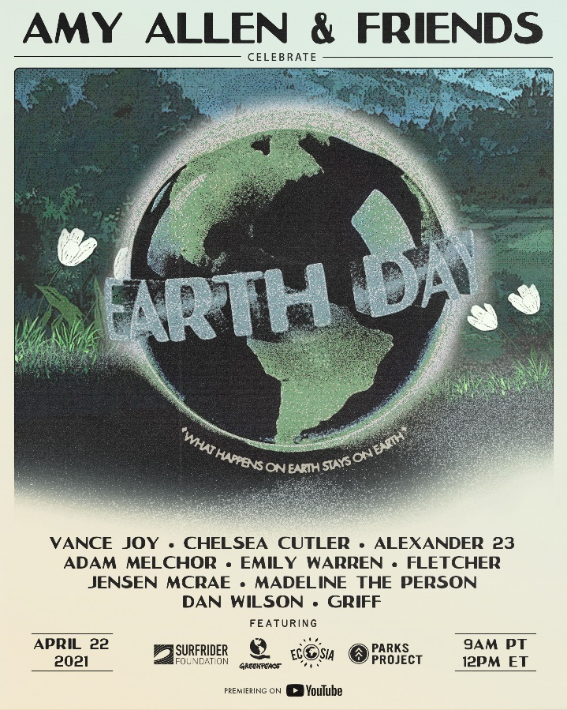

April 15, 2021 (Los Angeles, CA) – Raising awareness and fighting for the environment, singer, songwriter, producer and multi-instrumentalist Amy Allen proudly presents Amy Allen & Friends Celebrate Earth Day on April 22, 2021 (Earth Day) at 9am PT/12pm ET broadcast via YouTube Premiere. Be sure to tune in HERE. She notably joined forces with global environmental change agents the Surfrider Foundation, Ecosia, Greenpeace, and Parks Project for the hand-crafted event, and will release her new song “One” on the same day, as a direct reflection on the state of the world and environment.

Amy explains her inspiration for putting together this event: "I grew up on the ocean in Maine, so I’ve always felt the most at home when I’m outdoors. I’ve long been an advocate for protecting the environment we live in, so this Earth Day I wanted to put together an intimate virtual concert to fundraise for a few initiatives I support. I was speaking to some friends of mine who are also advocates for ending climate chaos, and they wanted to join me in support of such an important cause. I'm such a fan of everyone involved so it feels really special coming together this Earth Day, April 22."

Amy not only headlines and hosts the hour-long event, but she also curated the lineup. As an award-winning songwriter for some of the biggest names in music – just this week winning the ASCAP Pop Music Writer & Publisher Award for Harry Styles’ “Adore You,” and a nominee for the upcoming IHeartRadio Music Awards’ “Songwriter of the Year” and “Best Lyrics” – Amy was uniquely able to tap her incredibly talented network to perform. She recruited nine of her friends – Adam Melchor (with Emily Warren), Alexander23, Chelsea Cutler, Dan Wilson, Griff, Fletcher, Jensen McRae, Madeline The Person, and Vance Joy – each of whom has personally chosen an environmental organization to support. See below for the full confirmed lineup and organizations.

Additionally, the Surfrider Foundation, Ecosia, Greenpeace and Parks Project will share important information about their respective missions and offer up a call-to-action in between the performances. To conclude the proceedings, Amy will deliver a very special acoustic rendition of her single “What A Time To Be Alive,” which she wrote to urge humanity to leave the world a better place for future generations and was praised by Refinery29 as, “Thoughtful and timely, ‘What A Time To Be Alive’ issues a poignant challenge for listeners to do and be better for the sake of the next generation.”

Having spent the prior few years co-writing some of pop’s biggest hits (Harry Styles, Halsey, Selena
Gomez and more), “One” and “What A Time To Be Alive” are the latest in a string of debut solo releases that have introduced Amy Allen as a songwriter and artist for her generation, offering a birds-eye view of life as a young woman in 2020 America. Her incredibly personal and impactful songs “Queen of Silver Linings,” “Difficult,” and “Heaven” have earned critical acclaim from Flaunt, American Songwriter, WWD, Refinery29, People Magazine and more, while catching the attention of the likes of Elton John and Sam Smith.

Stay tuned for more from Amy Allen soon.

AMY ALLEN & FRIENDS CELEBRATE EARTH DAY LINEUP
- Adam Melchor (w/ Emily Warren) – Plastic Ocean Project (http://www.plasticoceanproject.org/)
- Chelsea Cutler – The Solutions Project (https://thesolutionsproject.org/)
- Dan Wilson – Oceana (https://oceana.org/)
- Griff - Amazon Conservation Team (https://www.amazonteam.org/)
- Alexander 23 - Fridays For Future (https://fridaysforfuture.org/)
- Jensen McRae - Rainforest Trust (https://www.rainforesttrust.org/)
- Madeline The Person - The Ocean Agency (https://theoceanagency.org/)
- Vance Joy – WWF (https://www.worldwildlife.org/)
- Fletcher – Greenpeace (https://www.greenpeace.org/usa/)
- Amy Allen

ABOUT AMY ALLEN:
There are two stories you can tell as a songwriter: yours or someone else’s. Amy Allen not only tells the stories of some of the biggest artists in the world as a songwriter, but she also shares her story as an artist. By 10-years-old, Amy began writing songs for herself and learned five instruments. After graduating from Berklee College of Music, she founded New York indie upstart band, Amy & The Engine. In 2018, she wrote “Back To You” by Selena Gomez and opened up the floodgates to collaborate with A-list talent, including Halsey, Camila Cabello, Shawn Mendes, Sam Smith, and Harry Styles. Forbes named her on the coveted “30 Under 30” list, while Variety dubbed her “Hitmaker of the Month.” Reclaiming her passion for performing in 2020, she introduced her sound as an artist on her first solo releases for Warner Records. All of her past experience has led her to this point, to creating a collection of personal and meaningful songs that are lived-in tales, reminiscent of the American troubadours that have come before her - heroes like Tom Petty or Sheryl Crow, Carole King or John Prine or Bruce Springsteen. Heralded by these initial song releases and a debut album to follow in 2021, Amy Allen tells her own story now.

ABOUT THE SURFRIDER FOUNDATION:
The Surfrider Foundation is a nonprofit grassroots organization dedicated to the protection and enjoyment of our world’s ocean, waves and beaches, for all people, through a powerful activist network. Founded in 1984 by a handful of visionary surfers in Malibu, California, the Surfrider Foundation now maintains over one million supporters, activists and members, with more than 170 volunteer-led chapters and student clubs in the U.S., and more than 700 victories protecting our coasts. Learn more at surfrider.org.

ABOUT ECOSIA:
Ecosia is the privacy-friendly search engine that plants trees to help fight climate change. Ecosia aims to plant and protect billions of trees by enabling people to channel their everyday actions into environmental good. When users search with Ecosia, 80% or more of profits are reinvested into tree planting projects around the world. With over 15 million users and 120 million trees already planted, Ecosia has enabled the planting of more native and biodiverse tree species globally than any other organization.

ABOUT GREENPEACE:
Greenpeace is a global, independent campaigning organization that uses peaceful protest and creative communication to expose global environmental problems and promote solutions that are essential to a green and peaceful future.

ABOUT PARKS PROJECT:
Our national parks are loved by millions, but they can’t be taken for granted; more visitors, less funding, and a changing climate threatens our wildlands. Whether it’s using a portion of every sale to support one of our conservancy partners or hosting volunteer days for our community, Parks Project is a brand that exists to transform park enthusiasts into park champions. Established in 2014, Parks Project has created dozens of apparel and home goods items over the last six years to bring the spirit of the National Parks into your home. They’ve partnered with more than 50 conservatories to ensure the conservation and education projects they’re committing to make the biggest impact. For more information, visit parksproject.us and @parksproject on Instagram.
# # #

For further information, please contact Warner Records Publicity:
Darren Baber / Ceri Roberts
Darren.Baber@warnerrecords.com / Ceri.Roberts@warnerrecords.com

Follow Amy Allen:
Official | Instagram | Twitter | Facebook | YouTube | Press Materials

