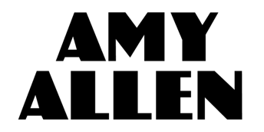

AMY ALLEN MAKES HER WARNER RECORDS DEBUT WITH
“QUEEN OF SILVER LININGS”

FIRST RELEASE FROM HIT SONGWRITER’S UPCOMING SOLO ALBUM
July 1, 2020 (Los Angeles, CA) - Today, singer, songwriter, producer and multi-instrumentalist Amy Allen releases her Warner Records debut “Queen of Silver Linings.” This marks Amy’s first release as a solo artist and return to the spotlight after spending the last two years co-writing some of pop music’s biggest hits with artists including Harry Styles (“Adore You”), Halsey (“Without Me”), Selena Gomez (“Back To You”) and more.

Get “Queen of Silver Linings” HERE. Watch the video HERE.

After years of writing and performing, Amy unveils “Queen of Silver Linings,” co-written and co-produced with Grammy-winning singer/songwriter/producer Dan Wilson.

“Dan Wilson and I wrote ‘Queen Of Silver Linings’ about an emotional experience I was going through. We thought of two characters – the Queen of Silver Linings, who holds onto love at all costs and wants to fix things, even if it’s not in her best interests to do so – and the King of Good Intentions, who means well but continues to let her down. As a Queen of Silver Linings myself, I realized that the message isn’t one of hopelessness – I believe there’s quite a power in having the guts to shamelessly fight for something you whole heartedly believe in.” – Amy Allen

The song represents the culmination of a lifelong journey for the Maine-born and Los Angeles-based artist. Penning songs since the age of ten, Amy Allen graduated from Berklee College of Music and cut her teeth on stage with endless gigs fronting indie pop-rock band Amy & The Engine around New York City before moving to LA to focus on songwriting in 2018. She has since experienced a meteoric rise to become one of the industry’s most in-demand songwriters.

“Queen Of Silver Linings” sets the stage for the release of her forthcoming full-length debut. Amy collaborated with a wide array of like-minded musicians to create a statement truly authentic to her, including Dan Wilson (Adele, Semisonic), Ethan Gruska (Phoebe Bridgers, Fiona Apple), Ian Fitchuk and Daniel Tashian (Kacey Musgraves), Jon Bellion (Rihanna, Halsey) Eg White (Adele, Florence and the Machine), Kid Harpoon (Harry Styles, Shawn Mendes) and Tyler Johnson (Ed Sheeran, Miley Cyrus).

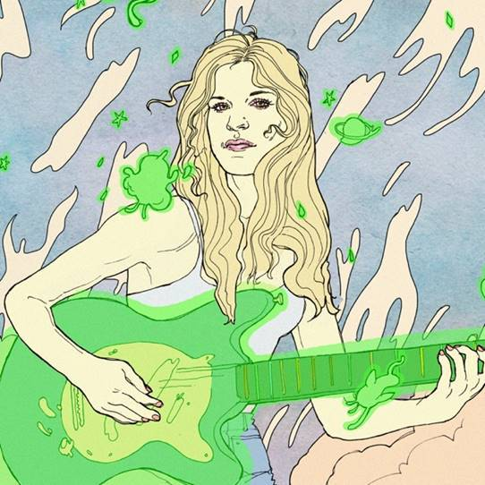

There are two stories you can tell as a songwriter: yours or someone else’s. Amy Allen not only tells the stories of some of the biggest artists in the world as a songwriter, but she also shares her story as an artist. By 10-years-old, Amy began writing songs for herself and learned five instruments. After graduating from Berklee College of Music, she founded New York indie upstart band, Amy & The Engine. In 2018, she wrote “Back To You” by Selena Gomez and opened up the floodgates to collaborate with A-list talent, including Halsey, Camila Cabello, Shawn Mendes, Sam Smith, and Harry Styles. Forbes named her on the coveted “30 Under 30” list, while Variety dubbed her “Hitmaker of the Month.” Reclaiming her passion for performing in 2020, she introduces her sound as an artist on her full-length debut for Warner Records. All of her past experience has led her to this point, to creating a collection of personal and meaningful songs that make up her debut album. Amy’s songs are lived-in tales, reminiscent of the American troubadours that have come before her - heroes like Tom Petty or Sheryl Crow, Carole King or John Prine, Bruce Springsteen or Freddie Mercury. Heralded by “Queen of Silver Linings” and much more to come, Amy Allen tells her own story now.
# # #

For further information, please contact Warner Records Publicity:
Darren Baber / Ceri Roberts
Darren.Baber@warnerrecords.com / Ceri.Roberts@warnerrecords.com

Follow Amy Allen:
Official | Instagram | Twitter | Facebook | YouTube | Press Materials

