For Immediate Release

ANDRA DAY RELEASES NEW SONG “AMEN”

“AMEN” FEATURED IN GENESIS G80 CAMPAIGN

GENESIS, WARNER BROS. RECORDS & DAY MAKE DONATION TO NONPROFIT UNLIKELY HEROES

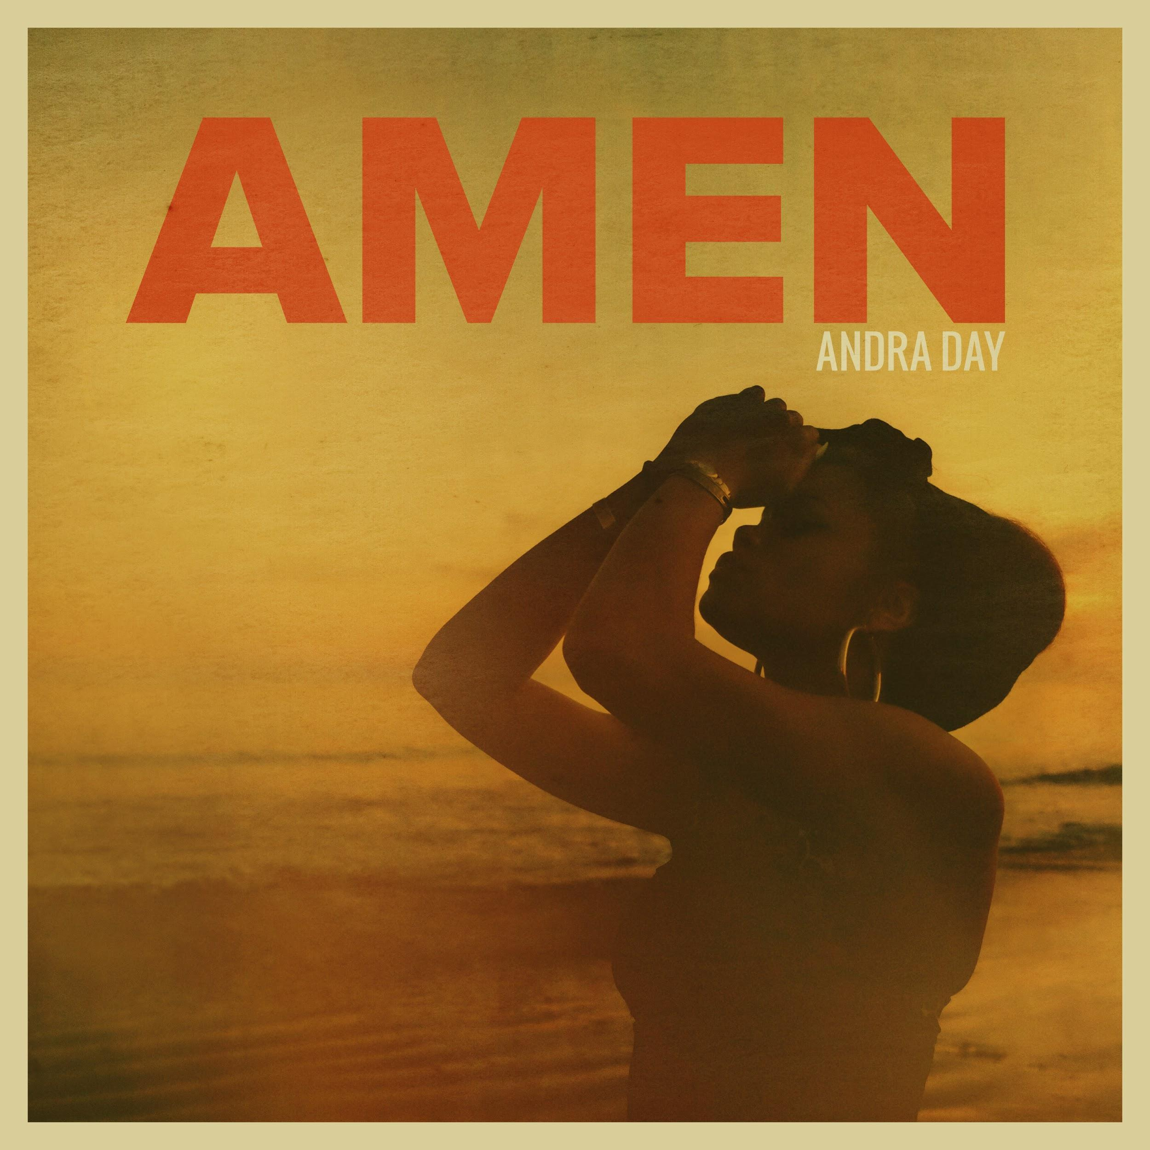

October 23, 2018 — (Los Angeles, CA) — GRAMMY® Award-nominated platinum soul powerhouse Andra Day has released her new song “Amen” via Warner Bros. Records. The song soundtracks a brand new campaign for Genesis G80. Get it HERE.

Lifted to the heavens by her unmistakable and undeniable voice, the song showcases the singer’s towering range and inimitable spirit over delicate piano chords. The lyrics immediately hit as she sings, “I’ll say amen to all the crazy things that happened that made me who I am.”

Thematically, it instantly spoke to Day with palpable significance.

Regarding “Amen,” she said, “I decided to sing the song because ‘Amen’ means ‘It is done’, and that for me means so much. To me, it lays to rest things in the past, things that have hurt, and things I can’t control. It reminds me that I’m not defined by those things, and though I can’t control them, that doesn’t mean they control me. It also gives me faith for my present and future, to go for the bigger dream, to take the harder road–the one that scares me–and to endure through trials, because nothing can take away my purpose. My greatness is already written. Everyone’s greatness is, and I hope this song helps them see that.”

Her knockout performance most definitely will illuminate this truth as well. Andra Day is currently hard at work on her much-anticipated new album.

Additionally, Genesis, Warner Bros. Records and Day have teamed up to make a collective donation to Unlikely Heroes, a 501 nonprofit organization that rescues, restores, and rehabilitates child victims of sex slavery around the world.

About Andra Day:
Carried by enough conviction to incite cultural change, Andra Day’s full-length debut Cheers to the Fall [Warner Bros. Records] garnered a 2016 GRAMMY® Award nomination in the category of “Best R&B Album,” while its ubiquitous lead single “Rise Up” achieved a nod for “Best R&B Performance” and earned an RIAA Platinum certification in addition to amassing over 37 million Spotify streams. Andra quite literally performed everywhere: The Late Show with Stephen Colbert, Ellen, Dancing with the Stars, The View, Hallmark’s National Christmas Tree Lighting, Audience TV, the CMA Country Christmas, and the America’s Got Talent Holiday Spectacular.

Quietly recognized amongst some of music’s most legendary names, the singer paid tribute to Ray Charles at The Smithsonian and shared the stage for performances with everyone from Chinese piano virtuoso Lang Lang, Bonnie Raitt, and Stevie Wonder to Ellie Goulding, Alicia Keys, and John Legend. Her voice abounded throughout the halls of the historic 2016 Democratic National Convention as well as the “International Day of the Girl” event at The White House. Along the way, she covered Essence Magazine and achieved the prestigious “Powerhouse Award” at the Billboard Women in Music event. Expanding its influence into different genres, the Mstr Rogers Remix of “Rise Up” would also soundtrack a Google Home campaign.

2017 kicked off with two show-stopping performances by the chanteuse at the 48th Annual NAACP Image Awards and a knockout Bee Gees tribute during the 59th Annual GRAMMYs®. Hyatt welcomed Andra as the voice of its “For A World Of Understanding” campaign, breathing new life into the Burt Bacharach and Hal David classic, “What The World Needs Now Is Love.” Moreover, she voiced Sweet Tea in the summer blockbuster Cars 3, covering Bruce Springsteen’s “Glory Days” during a standout sequence.

Closing out 2017, Andra released the moving anthem “Stand Up For Something” [feat. Common] from the Marshall Official Soundtrack Album and film. The movie also marks Andra’s on-screen debut. Andra Day and Common performed “Stand Up For Something” at the 60th Annual Academy Awards where the song was nominated for Best Original Song.

Genesis Motor America
Genesis Motor America, LLC is headquartered in Fountain Valley, Calif. Genesis is a global luxury automotive brand that delivers the highest standards of performance, design and innovation. All Genesis vehicles sold in the U.S. are covered by an industry-leading warranty with enhanced roadside assistance and concierge services. In just the first half of 2018, Genesis has won highest-ranked brand in the automotive industry awards for quality and owner satisfaction from industry experts such as JD Power, AutoPacific, and Strategic Vision.
For more information on Genesis, please visit www.genesis.com
Please visit our media site for the latest news at www.genesisnewsusa.com
Genesis Motor America on Twitter │ YouTube │ Facebook | Instagram

For more information on Andra Day, visit http://www.andraday.com

###

For press tools and assets: http://press.wbr.com/andraday

