Carlie Hanson Teams Up With iann dior for Politically-Charged New Track “Ego”

Announces New EP DestroyDestroyDestroyDestroy
Coming October 23

Listen to “Ego (feat. iann dior)” HERE

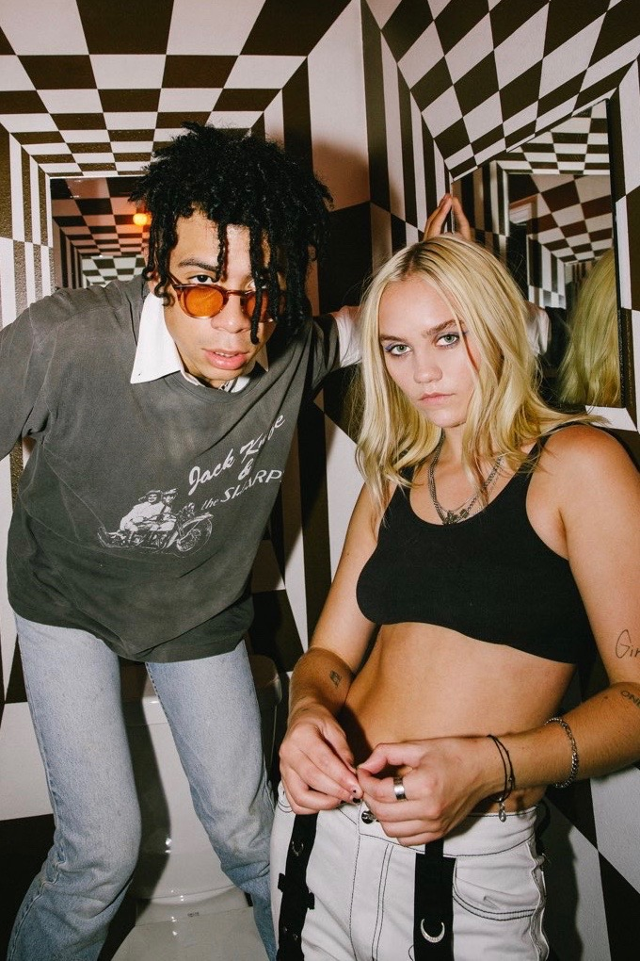
Photo Credit: Alice Baxley

September 25, 2020 (Los Angeles, CA) – Today, Carlie Hanson has teamed up with iann dior for her latest track “Ego.” It’s an edgy, politically charged anthem that sees the two young artists expressing their frustration with authority. The song comes as iann dior’s feature on 24kGoldn’s “Mood” reaches the No. 6 spot on the Billboard Hot 100. The release of “Ego” is paired with Carlie Hanson’s announce of her new EP DestroyDestroyDestroyDestroy, which will arrive October 23.

Listen to “Ego (feat. iann dior)” HERE.
Pre-save DestroyDestroyDestroyDestroy HERE.

"I hope that anybody who hears ‘Ego’ feels empowered. The line ‘10 11 13 FUCK COP’ comes from a place of anger towards authority. We, as a society, cannot ignore what is happening in our world every. single. day. From police brutality, to corrupt leaders, to the inequality that many people face in their everyday lives. We need to stand up for ourselves and for other people and be loud as f+++ as it seems to be the only thing that works! Sit down, so we can speak up for ourselves, so we can be heard,” said Carlie of the song. “I’m a massive fan of iann dior and felt that he would totally get this song and the energy. I’m so excited to finally release our baby - I hope we can inspire others to fight for the change they want to see in the world."

Carlie, who is the face of DC Shoes’ Summer 2020 women’s campaign, released her debut EP, JUNK, in June 2019. Before even turning 19, she had toured with TROYE SIVAN, Yungblud and others in the US, Europe and Australia, signed a deal with Warner Records and released JUNK. Named a VEVO DSCVR artist, Carlie also has fans in superstars like Taylor Swift and Demi Lovato. Carlie has passed 86 million total global streams with her music. Recently, Carlie’s last track of 2019, “Side Effects,” hit 11 million Spotify streams as her first track of 2020, “Daze Inn,” hit 4.6 million Spotify streams. Her latest release, “Good Enough” was heralded as a “heart-wrenchingly honest bout of self-doubt set to a beautifully satisfying backdrop of lush melody” by LA Weekly, while Alt Press said that “‘Good Enough’ is as relatable as it is memorable.”

DestroyDestroyDestroyDestroy Track List:

1) Fires ft. Lil West
2) Is That a Thing?
3) Ego ft. iann dior
4) Daze Inn
5) Stealing All My Friends
6) Side Effects
7) Good Enough

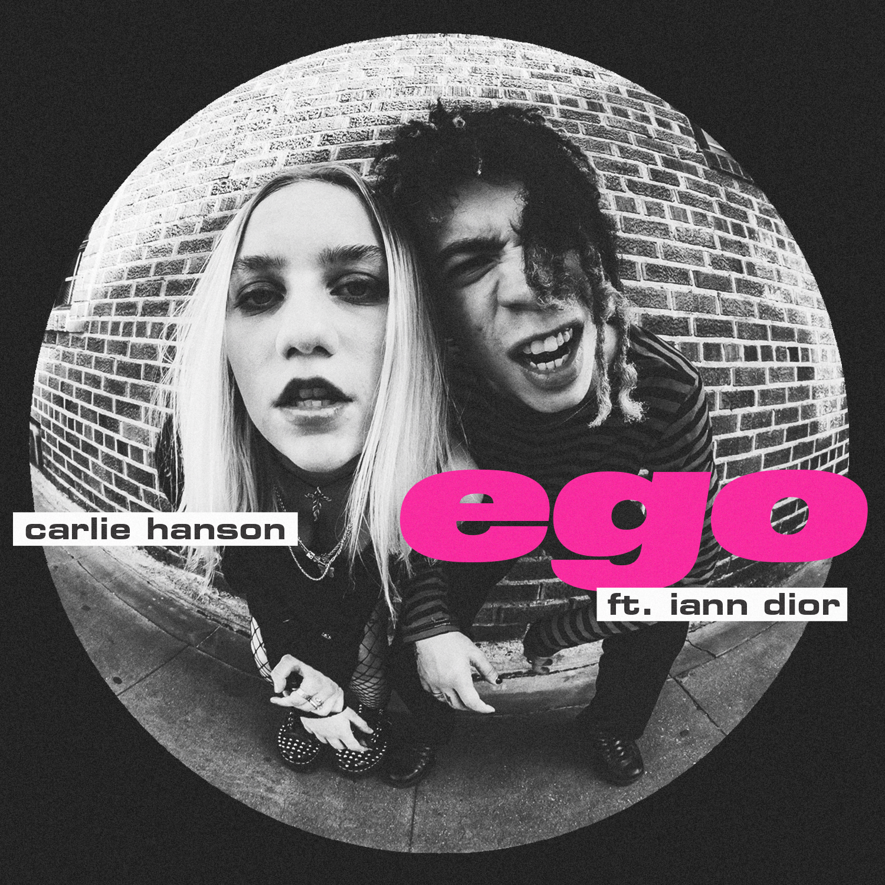

Follow Carlie Hanson
Official | Instagram | Twitter | Facebook | YouTube

For more information, contact:
Bobbie Gale at MixedMediaWorks
323-363-2171 | bobbie@mixedmediaworks.com

Darren Baber at Warner Records Publicity
Darren.baber@warnerrecords.com

