CARLIE HANSON TO RELEASE DEBUT EP JUNK ON JUNE 7

PREMIERES CINEMATIC MUSIC VIDEO FOR NEW SINGLE
“BACK IN MY ARMS”

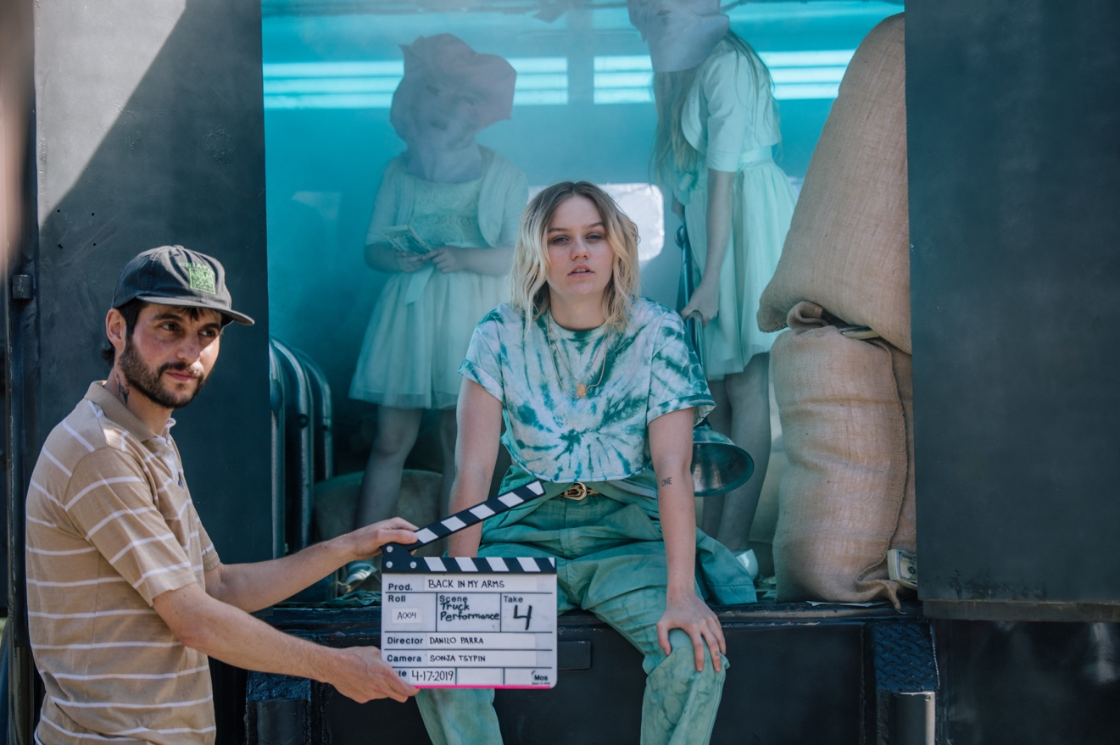

(May 3, 2019 – Los Angeles, CA) - Tastemaker-approved alt-pop maverick Carlie Hanson will release her debut EP, Junk via Warner Bros. Records on June 7. The pre-order just went live today and is available HERE.

In celebration of the news, Carlie shares her new music video for recently released track “Back In My Arms.” An emotionally charged armored truck heist in the heartland serves as the centerpiece for this video. In a bizarre turn of events ripe for a Harmony Korine flick, cops take away Carlie’s single father leaving Carlie and her sisters to fend for themselves. In an attempt to secure their father’s release from jail, Carlie and her two younger sisters pull off an armored truck heist thanks to an unlikely accomplice. The clip intercuts off-kilter vignettes of impoverished Americana with moments of familial fun despite it all. The visuals come to life via propulsive guitars, a heavenly stoned delivery, and chantable hooks.

Watch the music video for “Back In My Arms” HERE.

It’s no wonder Billboard described the track as “a pure-pop slow jam saturated with trap beats and instantly catchy melodies.” Meanwhile, Paper Mag named it among, “Bops Only: 10 Songs You Need to Start Your Weekend Right,” and Nylon touted it as “best thing they’d heard all week.” The song has quickly garnered over half a million total streams in a week.

Elsewhere on the forthcoming EP, “WYA” paints a portrait of escaping small-town malaise over a skittering beat with candid questions like, “Are you happy right now where you at, girl? Do you still get drunk when you’re sad, girl? Did you finally find love in this mad world?” Then, “Cigarettes” pairs a stark clean guitar with breathy nuanced vocals. All in all, this debut EP demonstrates Carlie’s astounding maturity as an artist. Junk is a snapshot of Carlie exposed, endearing, and engaging.

The full track listing is below.

With her unfiltered honesty and raw identifiability, Carlie Hanson turns pop into a four-letter word on Junk.

Toting a guitar and spinning, wise-beyond-her-years, stories of lost love through a cigarette-burned croon, 18-year-old Carlie Hanson turns suburban discord into confessional pop. As the story goes, she left a McDonalds drive thru gig in a tiny Wisconsin town in 2017 and quietly infiltrated the music mainstream. A series of independent singles clocked nearly 70 million streams as she garnered praise from CR Fashion Book, Nylon, L’Officiel, Relix, Hillydilly, and more. Paper Magazine included her in its “100 People Taking Over 2019,” and Taylor Swift handpicked her for a personal Apple Music Playlist. She has also enchanted crowds on tour with Troye Sivan, gnash., Yungblud, and others. Carlie is currently on tour with the Bad Suns, tour dates HERE. She will be on tour with Lauv this summer.

For some additional insta Carlie fun go here: https://giphy.com/carliehanson

TRACK LISTING:
- Bored With You
- Back In My Arms
- WYA
- Cigarettes
- Hazel

###
Press Contacts:
National: Bobbie Gale / Warner Bros. Records
(818) 953-3692 / Bobbie.Gale@wbr.com

Regional/Tour: Bre Flores / Warner Bros. Records
(818) 953-3638 / Breanne.Flores@wbr.com

Follow Carlie:
Instagram: @carliehanson
Twitter: @carliehanson
Facebook: https://www.facebook.com/carliehanson2000/

