CARLIE HANSON RELEASES DEBUT ALBUM TOUGH BOY

LISTEN HERE

DROPS VIDEO FOR “GIRLS IN LINE FOR THE BATHROOM”

WATCH HERE

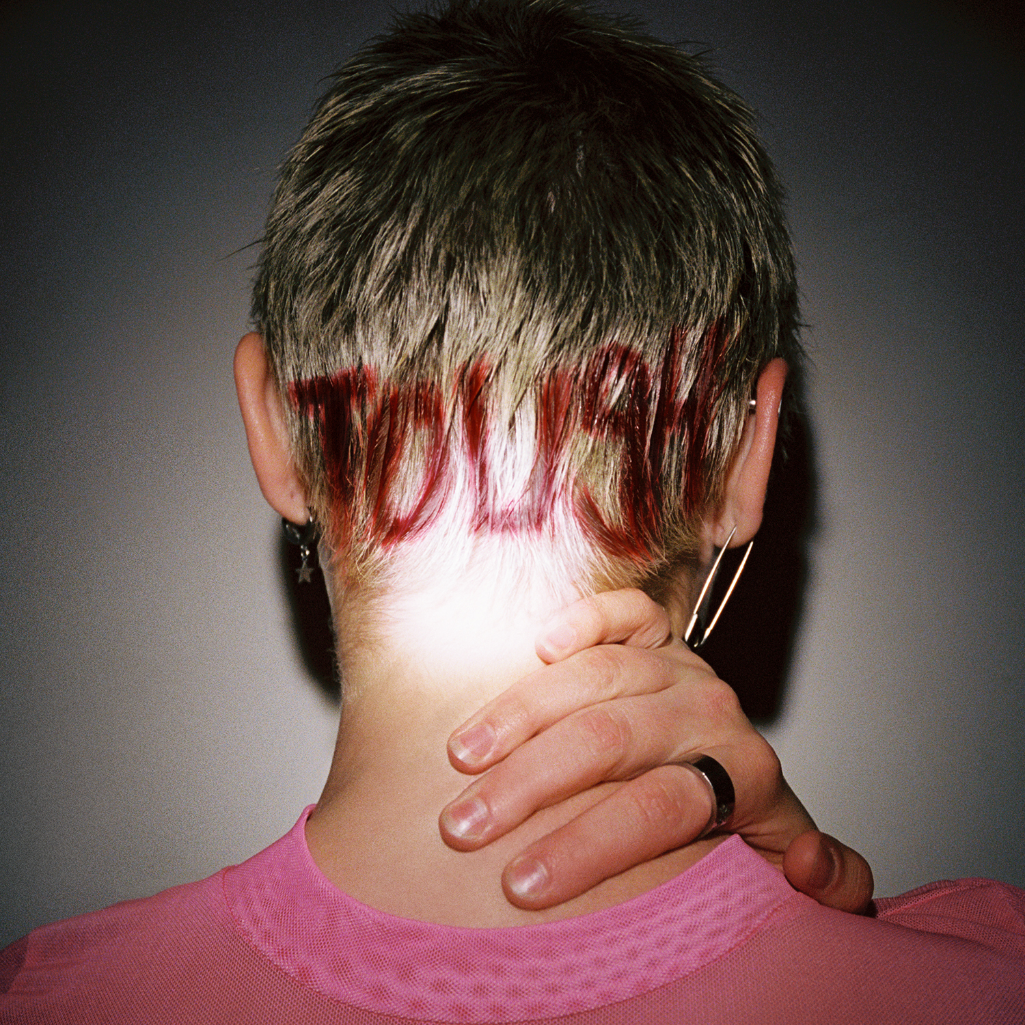
‘Tough Boy’ Cover Art

February 18, 2021 (Los Angeles, CA) – After 190 million streams and two EP releases, alt/pop singer Carlie Hanson has unleashed her debut album Tough Boy today. Paired with the 12-track album is a video for the focus track, “Girls In Line For The Bathroom.” She will be performing the track on The Late Late Show With James Corden on February 23, as well as on The Kelly Clarkson Show on February 28.

Listen to Tough Boy HERE.
Watch “Girls In Line For The Bathroom” Video HERE.

Of the album, Carlie said: "’Tough Boy’ embodies the tornado of feelings I’ve experienced in the last year and a half. It was a weird time to begin making an album. Obviously, the pandemic had just hit and I was freshly 20 years old. I spent a lotttttt of alone time during COVID, but because of this - I was able to discover parts of myself that I didn’t even know existed. I was stuck in my bedroom, playing guitar, analyzing myself and the world around me all day everyday, because - as everyone knows - there wasn’t much else to do. I shaved all of my hair off, I was doing mushrooms by myself, drinking at home every week, I went through a bad falling out with one of my best friends, I was on a rollercoaster ride with my girlfriend, and I was far away from my family. There is more, but at 20 there was a lot to navigate thru. The only thing that stopped me from going off the deep-end, was to WRITE about what I was going through. "Tough Boy" is all of the things that I was afraid to come to terms with. Guarding your emotions will only work for so long until you fuckin' break. Once I allowed myself to be more honest with who I am and what I was going through, I came out the other side seeing the good in all of my mess.”

Inspired by the music of Mac DeMarco, Jean Dawson, Alanis Morrissette, Lil Peep, Nirvana, Tough Boy unfolds over 13 tracks, taking listeners on a journey that entwines Hanson’s “pop bitch” goals with her sonic boundary-pushing ambition. Thematically, the album culls from Carlie’s full, vibrant spectrum of feelings, but with a confidence that seems new for this 21 year old.

Most recently, Carlie was featured on the cover of Alternative Press - check that out HERE as “An Artist to Watch for 2022.” She was also named to Billboard’s 21 Under 21 last year and has fans in artists like Taylor Swift and Demi Lovato. Her first EP, JUNK, was released in June 2019 while her sophomore EP, DestroyDestroyDestroyDestroy, was released in October 2020. Tough Boy tracks “Gucci Knife (feat. MASN),” “Off My Neck,” “Snot (feat. Deb Never),” and “Fuck Your Labels” were all released in advance over the past year.

She’ll be performing at Winston House on February 24th to celebrate the album’s release.

Follow Carlie Hanson
Official | Instagram | Twitter | Facebook | YouTube

For more information, contact:
Bobbie Gale/ MixedMediaWorks
323-363-2171 | bobbie@mixedmediaworks.com

Darren Baber/ Warner Records Publicity
Darren.baber@warnerrecords.com

