CHRISTIAN LEAVE RETURNS WITH DREAMY NEW SINGLE “MAYBE”
LISTEN HERE – WATCH HERE

NEW EP DAYS LIKE LOST DOGS OUT OCTOBER 29

U.S. TOUR WITH BEABADOODEE KICKS OFF NOV. 1ST

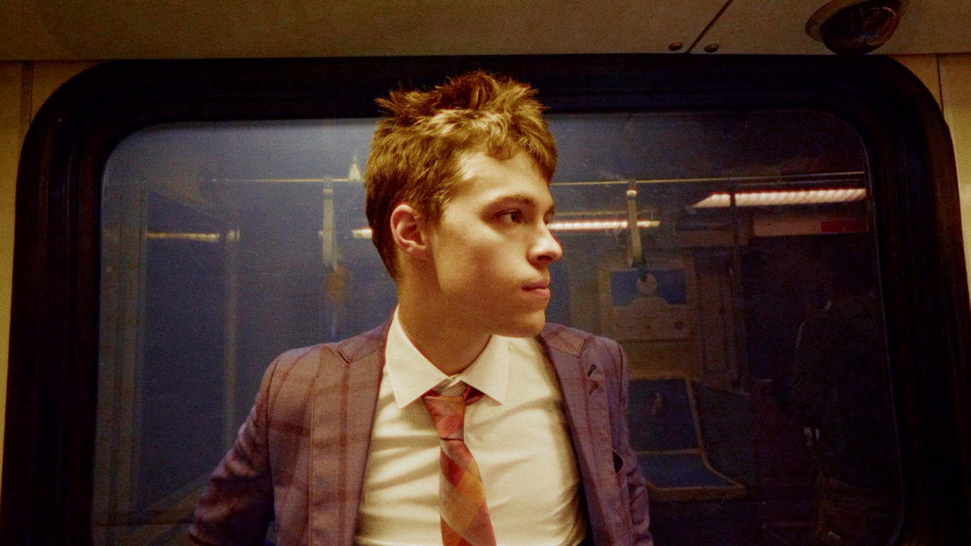

“Boy-next-door turned superstar” – VMAN

“One spin of Christian Leave’s music, and you’re immediately sucked in longing for more.” – FLAUNT

“Unique and infectious … a modern indie feel with a classic R&B sound.” – American Songwriter

“charismatic tone and soothing vocals” – Office Magazine

“Christian Leave just keeps rolling out great songs.” – The Interns

October 15, 2021 (Los Angeles, CA) – Today, critically-acclaimed alt-breakout Christian Leave shares dreamy new single “Maybe,” setting the stage for the arrival of his forthcoming EP, Days Like Lost Dogs, arriving October 29th on Warner Records. Listen to “Maybe” HERE and watch the live performance video HERE.

Practically floating out of the speakers, his heavenly harmonies wrap around a dreamy bass line as nostalgic lyrics and delicate instrumentation entwine. Barely above a whisper, he nostalgically yearns, “Maybe I miss your face,” only to admit, “Cause it can get hard, but we should move on.” In the accompanying live performance video, Christian lightly plucks at his bass guitar in front of a microphone outside. The grainy footage ultimately mirrors the warmth of the vocal delivery.

About the song, he commented, “There have been many different relationships in my life where i feel that a lack of communication has been the downfall, platonically or romantically. Whether it’s not being able to fully open up to someone due to embarrassment of my own feelings or not being able to be transparent with how I feel I’m being treated. This song is a letter to those situations and hopefully serves as reminder to myself that speaking as honestly as possible is always the leader to a better, healthier life.”

This fall, Christian will support beabadoobee on 25+ dates this fall alongside BLACKSTARKIDS, beginning November 1st in Washington, D.C. Tickets are available now at christianleave.world – see a full list of dates below.

Earlier this year, he garnered widespread critical acclaim for his Heavy Hitting Hurts My Head EP, featuring infectious standouts “Filth,” “Bedache,” and “Your Life Your Time,” which Billboard called a “catchy gem.” Beyond piling up 6 million total streams and counting, the record earned him the top spot on high-profile playlists, including Spotify’s Lorem, Amazon Music’s Breakthrough Indie and Fresh Indie, Apple Music’s INDIY, and Pandora’s New Music Now, just to name a few.

FALL 2021 TOUR DATES:
Nov. 1 Washington D.C. 9:30 Club
Nov. 2 Philadelphia, PA Union Transfer
Nov. 4 New York, NY Webster Hall
Nov. 5 Boston, MA Royale
Nov. 9 Carrboro, NC Cat's Cradle
Nov. 10 Charlotte, NC The Underground
Nov. 11 Atlanta, GA Buckhead Theatre
Nov. 13 Birmingham, AL Saturn
Nov. 15 Houston, TX White Oak Music Hall
Nov. 16 Austin, TX Emo's
Nov. 19 Phoenix, AZ The Van Buren
Nov. 20 San Diego, CA The Observatory North Park
Nov. 21 Los Angeles, CA The Fonda (Night 1)
Nov. 22 Los Angeles, CA The Fonda (Night 2)
Nov. 23 San Francisco, CA The Fillmore
Nov. 26 Portland, OR Crystal Ballroom
Nov. 27 Seattle, WA Neptune Theatre
Nov. 28 Vancouver, BC Rickshaw Theatre
Nov. 30 Salt Lake City, UT The Depot
Dec. 1 Denver, CO The Summit Music Hall
Dec. 4 Kansas City, MO The Truman
Dec. 6 Chicago, IL Metro
Dec. 8 Detroit, MI Majestic Theatre
Dec. 9 Toronto, ON Danforth Music Hall
Dec. 10 Columbus, OH Newport Music Hall
Dec. 11 Pittsburgh, PA Stage AE

ABOUT CHRISTIAN LEAVE:
Growing up in Texas, Christian Leave at 14 was just like any other teenager, wrestling with uncomfortable social dynamics that made it hard for him to balance who he was with who he wanted to be – and then he discovered Vine. The TikTok precursor ultimately let Christian understand himself better, leaning into his awkwardness, riffing on puns and injecting dad jokes with genuine humor. He branched off Vine to other platforms, racking up millions of followers in the process, but something felt off until he started writing his own songs in 2015. Now 21 years old, Christian has spent the past few years working out of his bedroom, writing, producing and creating this sound that is at once naive and wise, the product of teenage heartbreak as viewed through the eyes of a person who grew up just a little too fast. He strikes a balance between subversive vulnerability and catchy palatability, inspired by everyone from The Cure and My Bloody Valentine to Bon Iver. His encyclopedic musical knowledge translates into genre-hopping bops with all the charm of your favorite indie flick.

Follow Christian Leave:
Instagram | TikTok | YouTube | Twitter

For more information, please contact:
National: Ceri Roberts
Ceri.Roberts@warnerrecords.com

Tour Press: Patrice Compere
Patrice.Compere@warnerrecords.com

