**BEDROOM-POP WUNDERKIND CHRISTIAN LEAVE UNVEILS NEW SONG “NO USE” TO ADORING FANBASE**

**WATCH THE DREAMY VIDEO** [**HERE**](https://youtu.be/FtyqHtt_GWU)

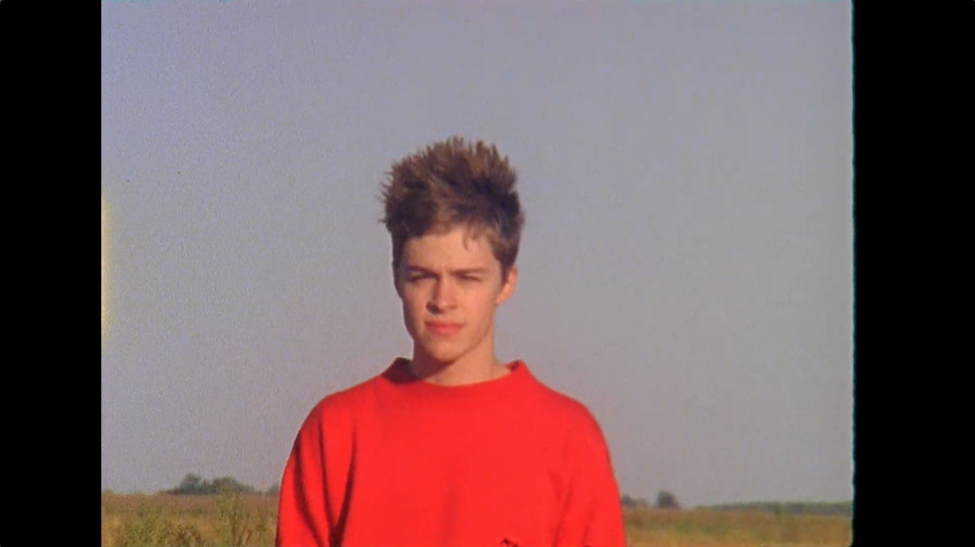

**May 29, 2020 (Los Angeles, CA)** – Bedroom-pop wunderkind Christian Leave shares his highly anticipated new song “No Use” and the accompanying dreamy music video, his first new music in over a year. The song introduces Christian’s idiosyncratic sound, at once naïve and wise, that he has been quietly cultivating while accruing millions of rabid followers. With “No Use,” Christian solidifies his status as a bona fide bedroom-pop artist, employing a tight, slick guitar loop and trunk-knocking drums, as he sings about the imbalance in his personal relationships and feeling unappreciated for who he is and what he has to offer. Though his experience is specific to his strange life, his heart is infinitely relatable – just a 20-year-old kid looking to find his place in an increasingly unstable world.

**Listen to “No Use” [HERE](http://christianleave.lnk.to/nouse)**



**Download hi-res photo** [**here**](https://press.warnerrecords.com/christianleave) **(Credit: Motoki Maxted)**

**ABOUT CHRISTIAN LEAVE:**

The son of pastors, growing up in Tennessee, Christian Leave at 14 was just like any other teenager, wrestling with uncomfortable social dynamics that made it hard for him to balance who he was with who he wanted to be – and then he discovered Vine. The TikTok precursor ultimately let Christian understand himself better, leaning into his awkwardness, riffing on puns and injecting dad jokes with genuine humor, and people loved him for it, including a young Tyler the Creator and Kevin Abstract. He branched off Vine to other platforms, racking up millions of followers in the process, but something felt off until he started writing his own songs in 2015. Now 20 years old, Christian has spent the past few years working out of his bedroom, writing, producing and creating this sound that is at once naive and wise, the product of teenage heartbreak as viewed through the eyes of a person who grew up just a little too fast. He strikes a balance between subversive vulnerability and catchy palatability, inspired by everyone from The Cure and My Bloody Valentine to Bon Iver. His encyclopedic musical knowledge translates into genre-hopping bops with all the charm of your favorite indie flick.

**Follow Christian Leave:**

[Instagram](https://www.instagram.com/christi2n/?hl=en) | [TikTok](https://vm.tiktok.com/wjj9kG/) | [YouTube](https://www.youtube.com/channel/UCW0RlqT2XzTpvZM6W-jJO0g) | [Twitter](https://twitter.com/ChristianLeave?ref_src=twsrc%5Egoogle%7Ctwcamp%5Eserp%7Ctwgr%5Eauthor)

**For more information, please contact:**

Ceri Roberts | Warner Records

[Ceri.Roberts@warnerrecords.com](mailto:Ceri.Roberts@warnerrecords.com)

**Press Materials:**

[press.warnerrecords.com/christianleave](https://press.warnerrecords.com/christianleave)

**cid:image004.jpg@01D5E66A.9F2C7370**