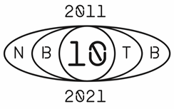

DAVID GUETTA SALUTES A DECADE OF HIS ALL-TIME SINGLE ‘TITANIUM’ RELEASING THE “FUTURE RAVE REMIX” W/ MORTEN

HONORING THE LEGENDARY ALBUM 10 YEAR ANNIVERSARY FOR “NOTHING BUT THE BEAT,” WITH MORE SURPRISES TO COME!

David Guetta & Sia “Titanium [David Guetta & MORTEN Future Rave Remix]”
// STREAM HERE //
// LYRIC VIDEO HERE //

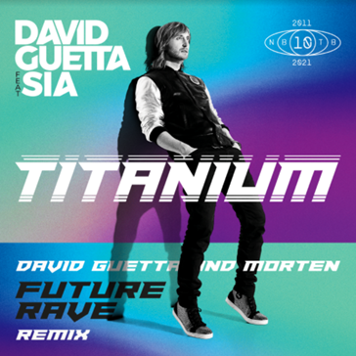
David Guetta photos, art and logo // download here //

Prime your ears for a special sonic salute! The ultimate hit-maker David Guetta celebrates the anniversary of the decade: 10 years of the Grammy award winning DJ and producer’s bulletproof and legendary album that changed music forever, “Nothing But The Beat” -- stream it here; and to continue his momentum as a melodious trailblazer, the international dance-floor dominator has re-invented his famed, anthemic all-time single “Titanium” featuring Siawith the release today of the David Guetta & MORTEN “Future Rave Remix” -- stream the remix here -- with more surprises to come!

“Titanium” is an influential self-power anthem that heals bleeding emotions beyond the lyrics itself. In 2020 alone, “Titanium” has accumulated 1.5 Billion streams, an additional 1.5 Billion streams on YouTube, and 500 Million views on TikTok.

"The anniversary of my album 'Nothing But The Beat' is a milestone in my career. In part because of my single ‘Titanium,' David Guetta shares. “It’s probably my favourite all time track I have ever created and the one I love playing live. Listening to seas of people singing so loudly together in unison at my shows around the world feels so surreal. I also love working with Sia so much. She is such an incredibly talented singer and songwriter with a phenomenally unique voice. It made me so happy over ten years ago when she accepted to keep her vocals on the track. I still feel it would not have been the same without her. We have always worked so well together and that’s why I find myself going back to her over and over to collaborate throughout the years. ‘Titanium' transcends across the globe and touches so many lives. I am so proud of this track and truly believe that this song forever changed my career.”

“It’s an honor to be a part of a remix for one of the greatest dance music records of all time,” Morten continues “This song has made the world dance for more than decade now! 'Titanium' is what shaped my commercial perception of dance music and it also influenced many others to become dance music producers."

The “Future Rave Remix,” which David first previewed at his ‘United At Home’ charity livestream in Dubai, is a callback to the classic big room sound of the 2010s, extending Sia's vocals to the forefront over a deliberate, haunting beat, offering a 2021 meaning to the historic “Titanium” lyrics, “I'm bulletproof, nothing to lose, fire away, fire away… ricochet, you take your aim, fire away, fire away… You shoot me down, but I won't fall, I am titanium...” With a prominent build-up and a modern underground tech-house break, the “Future Rave Remix” collaboration with Danish DJ and producer MORTEN brings present-day energy to the inescapably renowned massive hit.

Concepted from the musical genius of David Guetta and MORTEN, the ‘Future Rave’ movement delivers new energy to previously-favored tracks from artists across the globe. In the spirit of further pushing their sound and style to the masses, the powerhouse pair selected the most iconic tracks of the decade, “Titanium,” to recommence their unstoppable tear of ‘Future Rave’ music releases across the past 12 months, aligned with David’s 10-year anniversary of his album ‘Nothing But The Beat.’ David and MORTEN’s ‘Future Rave’ discography launched with their track-flip for ‘Never Be Alone ’ ft Aloe Blacc, and their recent collaborations have continued with ‘Impossible’ ft John Martin and their evolution of ‘Let’s Love’ by Sia into an intoxicating house smash.

Influential producer David Guetta’s timeless fifth studio album “Nothing But The Beat” spawned six Top 10 singles, from the #1 hit, “Titanium” featuring Sia to “Sweat,” “Where Them Girls At,” “Little Bad Girl,” “Without You” and “Turn Me On,” and nearing 2x platinum in the UK. The album features a triumphant cast of collaborators, including Sia, Nicki Minaj, Flo-Rida, will.i.am, Jennifer Hudson, Usher, Snoop Dogg, Akon, Taio Cruz, Ludacris, Timbaland, among others. The paramount release of the decade showcased David Guetta’s now infamous musical bridge between electronic dance music and urban culture, a pairing which became synonymous for his sound, and made popular among future contemporary pop records. To date, “Nothing But The Beat” has sold nearly 3 million albums and an astonishing 16 million singles world-wide.

##
David Guetta is one of the biggest figures in global music with 50 million record sales and more than 14 billion streams. Guetta continues to serve court as one of the defining influences in electronic music and dance culture since the beginning of the millennium, as both a game-changing recording artist and record-breaking live performer. He has worked with some of the biggest artists in the world, including Bruno Mars, Jason Derulo, J Balvin, Justin Bieber, Little Mix, Martin Garrix, Nicki Minaj, Rihanna, Saweetie, Sia, and many more. His award-winning career includes two prestigious Grammy Awards. As of today, Guetta is the tenth most streamed artist in the world on Spotify.
David Guetta has had an extraordinarily busy year, releasing eight new tracks, with two recent Top 10 hit singles around the world including ‘Bed’ with Joel Corry and Raye, and ‘Heartbreak Anthem’ with Galantis and Little Mix, and now his latest, ‘Shine Your Light’ with Master KG and Akon. Plus, his “United At Home” performances from Dubai, Miami, New York, and Paris were viewed by more than 125 million people across the globe and raised more than US$1.6 million for various charities.
Guetta’s debut album, “Just A Little More Love,” in 2002, followed his influential works “Guetta Blaster” (2004) and “Pop Life” (2007). His 2009 album, “One Love,” propelled the DJ and producer from the clubs to a mainstream audience, with its hit singles ‘When Love Takes Over’,‘Gettin’ Over You’,‘Sexy Bitch’, and ‘Memories’. His 2011 album, Nothing but The Beat, saw his commercial success reach new heights with the hit singles ‘Where Them Girls At’,‘Little Bad Girl’,‘Without You’,‘Titanium’, and ‘Turn Me On’. This was followed by “Listen” (2014) and “7”(2018).
In November 2020, Guetta was voted No. 1 in DJ Magazine’s annual Top 100 DJs poll for the second time, almost a decade after he took the top spot for the first time in 2011.

Throwback assets:

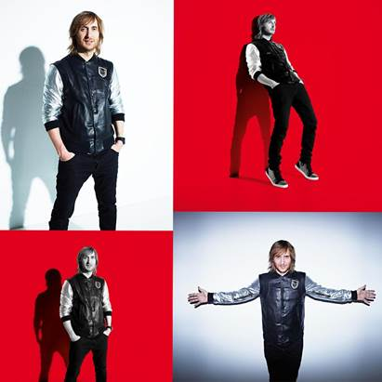

David Guetta photos, art and logo // download here //

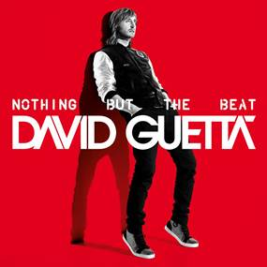

Connect with David Guetta online:
www.davidguetta.com
www.youtube.com/davidguetta
https://www.instagram.com/davidguetta/
www.facebook.com/davidguetta
www.twitter.com/davidguetta
https://www.tiktok.com/@davidguetta

