DAVID GUETTA TEAMS UP WITH UK DJ MISTAJAM AND
POP-SOUL SINGER JOHN NEWMAN ON 2021 SUMMER ANTHEM
“IF YOU REALLY LOVE ME (HOW WILL I KNOW)”

LISTEN HERE

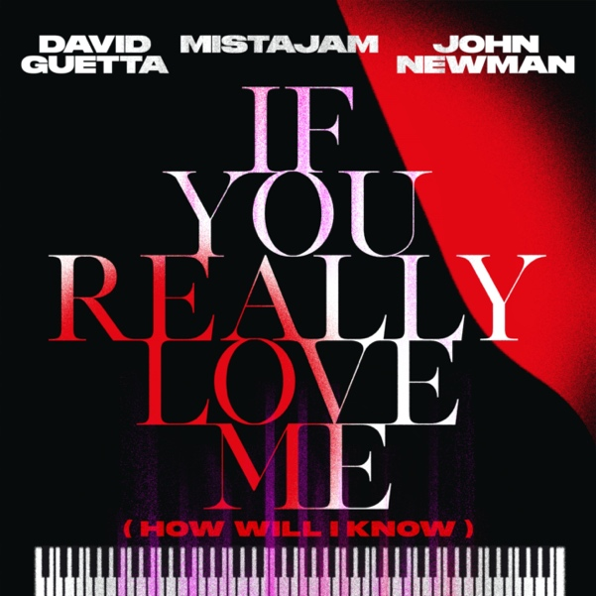

July 2, 2021 (Los Angeles, CA) - Continuing his incredible hot streak, multiple Grammy award-winning DJ & producer David Guetta teams up with UK DJ and tastemaker MistaJam and pop-soul sensation John Newman on new collaboration “If You Really Love Me (How Will I Know)” out today via Warner Records. Listen to the summer anthem HERE.

The new song follows Guetta’s recent hit collabs “Bed” Joel Corry and Raye and “Heartbreak Anthem” with Galantis and Little Mix. The release is co-produced by radio DJ MistaJam who is one of the UK’s most prominent music tastemakers and has been at forefront of breaking new records in the UK across multiple radio stations including BBC Radio 1 and now Capital & Capital Dance. The song is complete with vocals by Brit Award-nominated artist John Newman who is one of the of the UK’s best recognized voices for his is unique blend of pop, R&B and soul. He as an incredible three UK #1 singles with “Love Me Again” and collaborations with Calvin Harris and Rudimental and has amassed over 1 billion streams. With feel good piano tones intertwined with Newman’s smooth vocals, the trio inject an infectious and euphoria driven sound and breathe new life into the Whitney Houston classic. With an official video coming soon, this release will be at the top of summer playlists for the rest of the year and beyond.

About “If You Really Love Me (How Will I Know),” David Guetta said, “Who can resist the chorus from such a classic record as “How Will I Know!” Full of old school Piano House grooves, this has sunshine all the way through it. Working with MistaJam and John Newman together has made it my 2021 song of the summer.”

MistaJam added, “The first Whitney Houston album that the original “How Will I Know” appeared on was always playing in my house growing up. I’ve still got the vinyl! So, it was really cool to flip that meaning of that song into “If You Really Love Me (How Will I Know)” from something about the start of a relationship to something about the end of one. As an artist I’ve admired for years, it was amazing to finally get to work with David Guetta, especially alongside John Newman who I’ve had the pleasure of supporting since the start of his career.”

In addition, John Newman commented, “I’ve had the idea to remake this classic Whitney tune for so long as it’s a song that’s so special to me and my wife. It felt so natural to bring a new story and emotion of my own to the already incredible song and brought this new version of the song to life. When the opportunity came to do this song with David Guetta, someone who I’ve always wanted to work with - it was complete a no brainer for me.”

David Guetta is one of the world’s most recognized DJ & producers and remains one of music’s celebrated artists. He has won two Grammy Awards and has collaborated the biggest names in music with everyone from Justin Bieber to Rihanna and Avicii. He has delivered a succession of global hits including “Titanium” featuring Sia, “Hey Mama” featuring Nicki Minaj, Bebe Rexha & Afrojack, and “Sexy Chick” featuring Akon. “Titanium” alone has exceeded a billion streams. Guetta stands out as one of the 10th most-streamed artists on Spotify of all time, averaging over 54 million monthly listeners. He has an astonishing 14 billion streams to date and 50 million records sold. Guetta was voted the 2020 #1 DJ in the world by DJ Mag and won Best Electronic Act at the MTV EMAs. In 2020, David Guetta hosted a series of livestreams “United At Home,” which saw him raise over $1.6 million in COVID-19 relief, while breaking a Guinness World Record for the most watched DJ set on Facebook.

Not only prolific in the world of pop music, David Guetta remains a spearhead of the electronic dance community. In 2019, he started the new Future Rave sound movement in which DJs and fans alike call “the future of EDM.” He also continues to reserve his darkest and deepest tracks for his underground alias Jack Back which represents David’s roots in the club scene. For over 20 years, the DJ has managed to stay on top of the game and not slowing down anytime soon. It is safe to say that at this stage in his career, David knows exactly where to take it next.
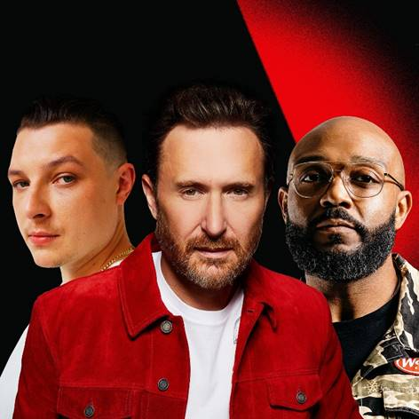

Follow David Guetta:
Official | Twitter | Instagram | Facebook | TikTok | Press Materials

For all media inquiries, please contact:
Darren Baber / Warner Records
darren.baber@warnerrecords.com

