Share the stunningly choreographed new video
for “in the wake of your leave” – watch it here

New album angel in realtime. out February 25th, 2022

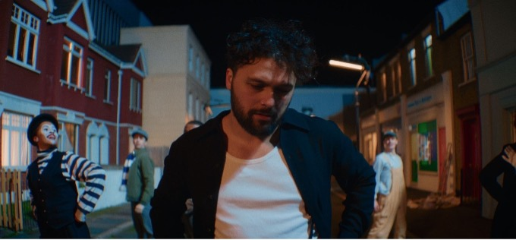

January 19, 2022 – (Los Angeles, CA) – Having won critical adoration for their emotionally transcendent current single “in the wake of your leave,” Gang of Youths give the song another moment in the spotlight by sharing its brand new video. The track is a highlight of their eagerly anticipated new album angel in realtime., which follows on February 25th.

<iframe width="560" height="315" src="https://www.youtube.com/embed/L5Py3TP9kgU" title="YouTube video player" frameborder="0" allow="accelerometer; autoplay; clipboard-write; encrypted-media; gyroscope; picture-in-picture" allowfullscreen></iframe>
The video is the latest creative collaboration between the band’s frontman Dave Le’aupepe and director Joel Barney. In contrast to its lyrical concept of channeling grief into creativity, the video gleams with joyousness and escapism. With exuberant character, a Technicolor palette, and a hyperreal representation of London, it presents a new twist on the golden age of the musical.

The stars of the show, however, are Le’aupepe and the accompanying team of dancers. Consisting of just three extended takes, it culminates with a dazzling two-minute group routine.

Joel Barney says, “When I first heard the track, I knew the video had to be larger-than-life. Dave came to me with a ‘Singing in the Rain’ meets ‘Top Hat’ concept that paid homage to the great musicals of the ‘50s and ‘60s. We wanted to merge elements of old school Hollywood with a modern edge.

Using three long takes and the musical-like choreography gave the video a real theatrical feel. I knew Dave was a brilliant performer from working together previously, but we wanted to push him even further outside of his comfort zone. Of course, he nailed it.”

The “in the wake of your leave” video extends the momentum that Gang of Youths have established in recent weeks. The band have also toured arenas as special guests to Sam Fender, played a selection of rapidly sold-out headline shows, and delivered an unforgettable performance of “the angel of 8th ave.” on The Late Show with Stephen Colbert.

angel in realtime. charts the waves of emotions that flooded over Dave Le’aupepe following the loss of his father. Those themes are amplified by Gang of Youths’ ever more ambitious musical approach, which draws upon the alternative and indie scenes of their new home in the UK, as well as indigenous sounds that reflect Le’aupepe’s Polynesian heritage. angel in realtime. is available to pre-order here.

Gang of Youths will commence a major North American tour in April. Tickets are on sale now and a full rundown of dates can be found below.

Praise for “in the wake of your leave”:

“"Gang of Youths keep surprising with off-kilter singles from their upcoming record, the man himself, and “In The Wake Of Your Leave” is no exception, its strangely percussive heart clashing perfectly with its anthemic verve." – PAPER

“The song explodes into blissful harmonies and thrilling highs despite the sombre subject matter, as if Le’aupepe is sending the song into heaven.” – Paste

“Propulsive drums, beautiful strings and Le’aupepe’s forceful delivery showcase the sound of a killer band that’s firing on all cylinders.” - UPROXX

angel in realtime. tracklist:

- you in everything
- in the wake of your leave
- the angel of 8th ave.
- returner
- unison
- tend the garden
- the kingdom is within you
- spirit boy
- brothers
- forbearance
- the man himself
- hand of god
- goal of the century

2022 North American tour dates:
Apr 21: Madison, WI Majestic Theatre
Apr 22: Indianapolis, IN The Vogue
Apr 24: Columbus, OH Newport Music Hall
Apr 25: Louisville, KY Mercury Ballroom
Apr 27: Carrboro, NC Cat’s Cradle
Apr 28: Charlotte, NC The Underground
May 1: Nashville, TN The Basement East
May 3: Chicago, IL Metro
May 4: Detroit, MI Shelter
May 6: Toronto, ON Danforth Music Hall
May 7: Montreal, QC L’Astral
May 9: Boston, MA Paradise Rock Club
May 10: Brooklyn, NY Brooklyn Steel
May 12: Philadelphia, PA Theatre of the Living Arts
May 13: Washington, DC Union Stage SOLD OUT
May 16: San Francisco, CA The Fillmore
May 18: Los Angeles, CA Belasco Theater
May 20: Las Vegas, NV 24 Oxford
May 21: Phoenix, AZ Crescent Ballroom
May 23: Austin, TX Scoot Inn
May 24: Dallas, TX The Echo Lounge & Music Hall
May 26: Tulsa, OK Cain’s Ballroom

Sep 13: Milwaukee, WI The Rave II
Sep 14: Minneapolis, MN First Avenue - Mainroom
Sep 16: St. Louis, MO Delmar Hall
Sep 17: Lawrence, KS The Bottleneck
Sep 19: Englewood, CO Gothic Theatre
Sep 20: Salt Lake City, UT Urban Lounge
Sep 22: Portland, OR Revolution Hall
Sep 23: Vancouver, BC Rickshaw Theatre
Sep 25: Seattle, WA Neumos
Sep 27: Sacramento, CA Ace of Spades

Contacts:

Grandstand Media
Kate Jackson katej@grandstandhq.com
Katie Nelson katien@grandstandhq.com

Warner Records
Rick Gershon Rick.Gershon@warnerrecords.com
Jenny Huynh Jenny.Huynh@warnerrecords.com

Follow Gang of Youths:
Official website | Instagram | Facebook | Twitter | Spotify | Apple Music | YouTube | Tik Tok
Press Materials

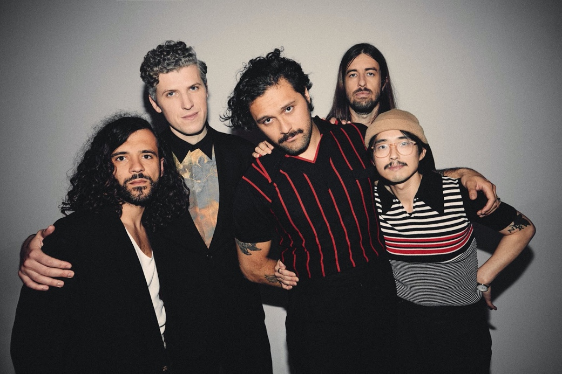
Download high-res photo by Edward Cooke HERE

