ZEDD UNVEILS NEW SINGLE “INSIDE OUT” WITH GRIFF TODAY
CLICK HERE TO WATCH THE LYRIC VIDEO

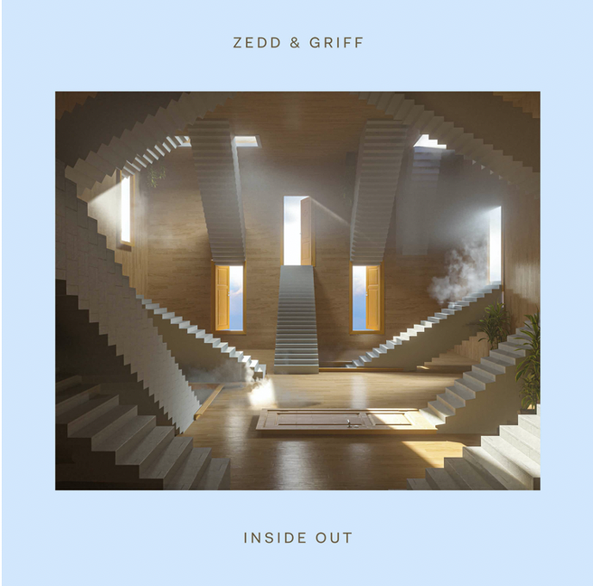

October 23, 2020 (Los Angeles, CA) —Today, GRAMMY® award-winning global superstar Zedd releases his brand-new single entitled “Inside Out” featuring rising U.K. singer-songwriter, Griff. The upbeat, feel-good track, features Zedd’s signature style that has made him the critically acclaimed artist/DJ/producer he is today. Paired with Griff’s incredible vocals, “Inside Out” is poised to be another one of Zedd’s standout tracks. The song is available now at all digital retail providers via Interscope Records.

Zedd says about “Inside Out”, “I started working on ‘Inside Out’ roughly a year and a half ago and I’m incredibly proud for it to finally see the light of day. We are in such a tense state of the world right now; I feel like this song can provide people with a much-needed sense of hope. I always strive to push myself to try new things, musically. With that in mind, this song feels very new but also familiar at the same time. A huge thank you to Griff for bringing such an intense level of emotion to ‘Inside Out’ with her beautiful voice!!”

Griff also notes, “This song for me is about any relationship in your life that’s worth holding onto, whether its platonic or romantic. I feel like these days everything is about how things look on the outside, and so the idea of loving someone from the inside first, feels like quite an important thing to say right now. It’s so surreal for Zedd to want a new artist like me to sing on this track, and I’m just super grateful and excited to be involved in this.”

Click HERE to watch the lyric video.

In addition to the release of “Inside Out,” Zedd will also be participating in The MDA Kevin Hart Kids Telethon, an event benefitting the Muscular Dystrophy Association and Help From the Hart Charity. The event will be streamed live on October 24 at 8pm ET on LOL Network platforms including YouTube and Pluto TV, plus Facebook, TikTok, Triller, and Twitch. The event will feature entertainment, comedy, musical performances, and MDA’s Let's Play For A Cure gaming elements. MDA’s Let's Play For A Cure consists of seven weeks of live gaming and Esports events produced and livestreamed by MDA, culminating in the final marathon stream headlined by Zedd. The marathon stream will kick off at 4pm ET on October 24 with Zedd going live at 7PM ET on his Twitch channel. This will run simultaneously with The MDA Kevin Hart Kids Telethon.

About Zedd
Multi-platinum, GRAMMY® Award-winning artist/DJ/producer Zedd made his debut with “Clarity” after signing with Interscope in 2012 and has been breaking down barriers surrounding music genres ever since. Throughout his career, Zedd has worked with a diverse range of artists to create hits, including Foxes on “Clarity” (which earned Zedd a 2014 GRAMMY® “Best Dance Recording”), Hayley Williams on RIAA platinum-certified hit, “Stay The Night” (which racked up more than 400 million streams), and Selena Gomez on the platinum-certified track, “I Want You To Know,” which spent four weeks at #1 on Billboard’s “Hot Dance/Electronic Songs” chart. He’s also collaborated with Alessia Cara on their hit single “Stay” which held the #1 spot at Top 40 radio for six consecutive weeks and earned Zedd his second GRAMMY® Award nomination, and with Maren Morris and Grey on the monster hit “The Middle,” which earned Zedd is second #1 at Top 40 radio. Digitally, the song has amassed over 1 billion streams and earned Zedd three GRAMMY® nominations including “Record Of The Year,” “Song Of The Year,” and “Best Pop Duo or Group Performance.”

About Griff
Griff is well on her way to becoming the next face of British Pop—and a next-generation type of pop star, at that. Born to Chinese and Jamaican parents just out of Watford, U.K., Griff began making music by borrowing her brother’s logic: teaching herself how to produce songs secretly from her classmates (many of whom only found out what Griff was up to when they heard her on Annie Mac). Hailed by Vogue as a “multicultural, multi-hyphenated, and multi-talented…utterly unique teenager” and by NME who called her “A phenomenon…the teenage boss about to take charge of pop,” Griff’s musical creativity draws no boundaries. Aside from making her own beats, sewing her own clothes, and shooting a music video on her iPhone under lockdown, Griff’s raw and vulnerable lyrics also prove she is mature beyond her years. With songs about friendship. (“1,000,000 X Better”), mental health (“Say It Again”), those stinging formative breakups (“Forgive Myself”) and the importance of family (“Good Stuff,” a moving account of Griff’s family fostering children), Griff manages to draw from her own difficult experiences and turn them into something uniformly positive making her particular model of bedroom-pop fitting for a legion of young girls to follow.

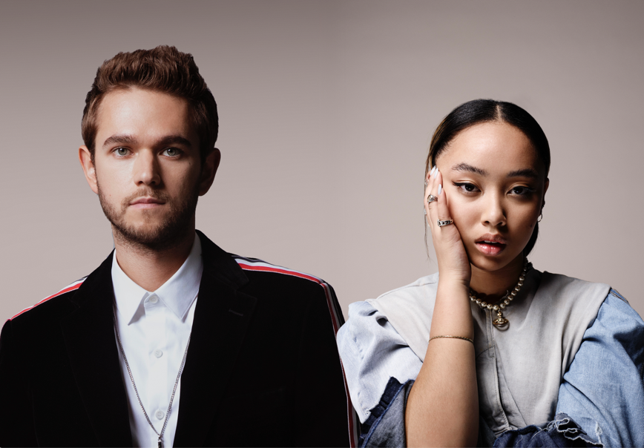
Download Press Photo HERE.

# # #

Follow Zedd:
WEBSITE | INSTAGRAM | FACEBOOK | TWITTER

Follow Griff:
INSTAGRAM | FACEBOOK | TWITTER

Zedd Press Contacts:
Michelle Nemeroff
Interscope Records
Michelle.nemeroff@umusic.com

Noelle Accardi
Interscope Records
Noelle.Accardi@umusic.com

Ariel Thompson
Interscope Records
Ariel.Thompson@umusic.com

Griff Press Contacts:
Darren Baber
Warner Records
Darren.Baber@warnerrecords.com

Rob Chute
Toast Press
rob@toastpress.com

Ruth Drake
Toast Press
ruth@toastpress.com

