UK POP SENSATION GRIFF & SIGRID HEAT UP THE NEW YEAR WITH “HEAD ON FIRE” – WATCH HERE

U.S. HEADLINE TOUR STARTS NEXT WEEK IN NYC

SET TO JOIN DUA LIPA IN APRIL ON HER UK/EUROPE FUTURE NOSTALGIA TOUR

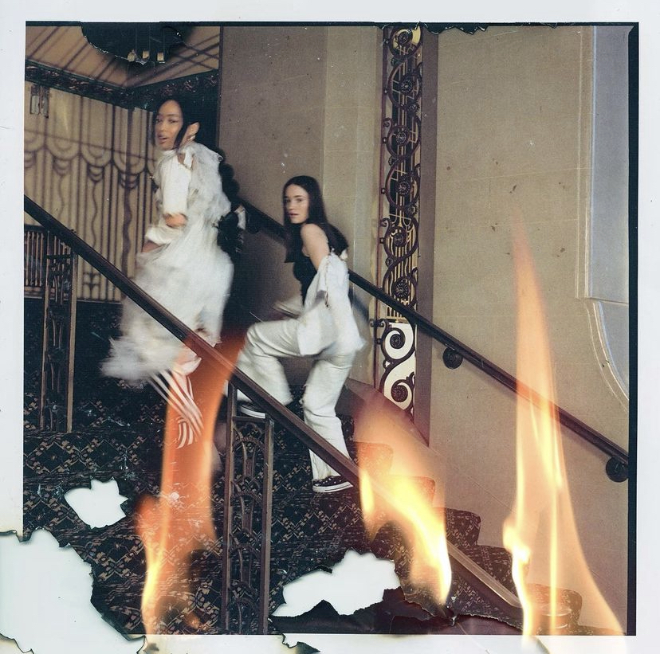

“Griff is Pop’s Next Powerhouse” - Vogue

"GRIFF is the hottest new artist to come out of the UK since Dua Lipa." - V Mag

“…the hottest thing out of the UK since beans on toast.”- Flaunt

January 19, 2022 (Los Angeles, CA) – Rising star BRIT-award winner Griff kicks off 2022 with a new single “Head On Fire” featuring Norwegian singer-songwriter Sigrid – out today via Warner Records. Listen to “Head On Fire” HERE and watch the video HERE.

About the duet, Griff shared, “I’ve looked up to Sigrid so much, especially as a young girl who broke through making powerful, credible pop music. So I was excited to hear she wanted to write. We hung out and made ‘Head On Fire,’ this really fun, feel-good song, and I’m excited for the world to finally hear us on a track together.”

Sigrid added, “Griff and I met sharing a pizza at the Rueben Selby show at Fashion Week in London, haha. We went to the studio a while later and just had a day of talking about life, before writing ‘Head On Fire.’ It’s about that feeling when you meet someone who just flips everything upside down and you can’t focus on anything else but that person. Sarah’s just lovely, and it’s been so much fun working with her.”

Griff will embark on a sold-out U.S. headline tour later this month and is set to open for Dua Lipa on her 2022 Future Nostalgia European tour. For more tour information, go here.

2021 was a huge year for Griff; She released her critically acclaimed mixtape One Foot In Front Of The Other, won the coveted ‘Rising Star’ Award at the BRIT Awards – following in the footsteps of previous winners Adele, Sam Smith, Florence and the Machine, Ellie Goulding, Jorja Smith, and more. Last summer, Spotify handpicked Griff as their first global RADAR emerging artist, check out her official RADAR documentary HERE. Additionally, Griff was selected MTV’s PUSH Artist of the Month in September and was a YouTube Music’s Artist On The Rise. Griff capped off 2021 being named one of Billboard’s 21 Under 21.

On top of all accomplishments, Griff made her TV debut in the U.S. on Late Night With Seth Meyers and in the UK on Later...With Jools Holland. She also performed “Black Hole” on The Late Show With Stephen Colbert and at The BRIT Awards. Watch her stunning post-apocalyptic performance HERE. Griff was recently announced as a 2022 BRIT Awards nominee for Best New Artist and Best Pop/R&B.

Look out for much more coming soon from Griff!

2022 TOUR DATES
Jan 24 – New York, NY – The Bowery Ballroom
Jan 25 - Washington, DC - Songbyrd DC SOLD OUT
Jan 26 - New York, NY - The Bowery Ballroom SOLD OUT
Jan 28 - Boston, MA - The Sinclair SOLD OUT
Jan 29 - Philadelphia, PA - The Foundry at The Fillmore SOLD OUT
Jan 30 - Toronto, ON – Opera House
Feb 01 - Chicago, IL – Lincoln Hall
Feb 04 - San Francisco, CA - Rickshaw Stop (Popscene) SOLD OUT
Feb 05 - San Francisco, CA - Rickshaw Stop (Popscene) SOLD OUT
Feb 06 - Los Angeles, CA – Fonda Theatre

FOLLOW GRIFF:
Instagram | Twitter | Facebook | YouTube | TikTok | Press Materials

For more information, please contact:
Darren Baber | Warner Records
Darren.Baber@warnerrecords.com

Regional: Jenny Huynh | Warner Records
Jenny.Huynh@warnerrecords.com
