GRIFF UNVEILS BRAND NEW SINGLE “ONE NIGHT” – LISTEN HERE

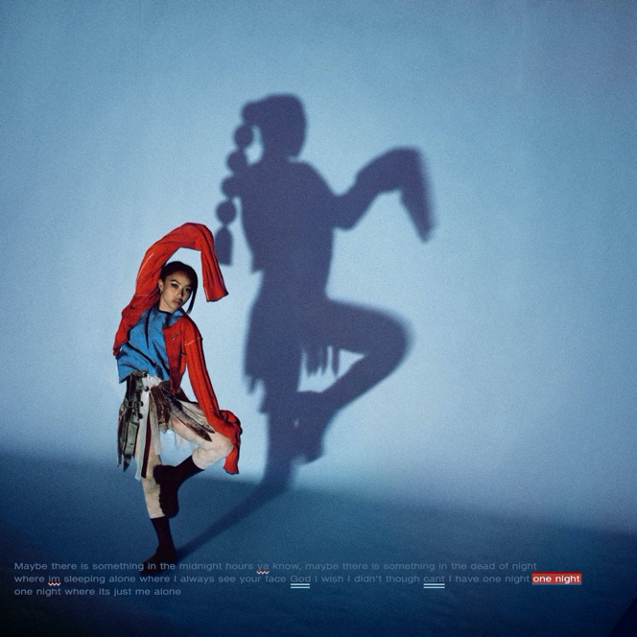

“Griff is Pop’s Next Powerhouse” - Vogue

"GRIFF is the hottest new artist to come out of the UK since Dua Lipa." - V Mag

“…the hottest thing out of the UK since beans on toast.”- Flaunt

August 26, 2021 (Los Angeles, CA) – Rising star BRIT-award winner Griff releases new single “One Night” today via Warner Records – listen HERE. Influenced by her love of Whitney Houston and The Weeknd, “One Night” is a vulnerable anthem that highlights Griff’s gift for storytelling.

About the single, Griff shared, “One Night’ is about feeling like you’re always carrying this darkness or burden. I think in the daytime we can feel distracted because we’re around people and we’re busy, but that moment between going to bed and falling asleep, there’s just enough silence for those burdens to get louder. Essentially this song is trying to understand why I can’t shake it, and the chorus comes to this breaking point of desperately wanting at least ‘One Night’ alone.”

The video for “One Night” made its broadcast premiere today on MTV Live, MTVU, and on the ViacomCBS Times Square billboard. It will premiere online next week. Griff was selected by MTV to be their Global Push Artist through the month of September.

Born to Chinese and Jamaican parents just outside of Watford, England, Griff began making music by borrowing her brother’s Logic: teaching herself how to produce songs in secret from her classmates, many of whom didn’t find out until she released her 2019 debut EP The Mirror Talk. The singer, songwriter, producer and DIY fashion designer has shown the type of creativity and curiosity that can still flourish even under challenging circumstances. In 2020, during the pandemic, she released multiple singles, collaborated with electronic duo Honne and superstar producer/DJ Zedd, led her voice to the Disney and Make a Wish annual holiday campaign, took over London’s Tate Modern for her first ever livestream, and founded her own popular ‘Against the Clock’ video series.

Griff has not slowed down in 2021. She began the year shortlisted for the BBC’s Sound of 2021 poll, she made her TV debut in the U.S. on Late Night With Seth Meyers and in the UK on Later...With Jools Holland, before gracing all new heights at the BRIT Awards – where she won the coveted ‘Rising Star’ Award, following in the footsteps of Adele, Sam Smith, Florence and the Machine, Ellie Goulding, Jorja Smith, and more. Watch her stunning post-apocalyptic performance HERE.

Earlier this month, GQ launched their global artist Voices of the Future campaign with Griff representing the UK as the local artist “who’s shaping the zeitgeist and defining the sounds of tomorrow.” She also performed at the Great Britain Olympic Homecoming event, dressed in Tom Daley’s signature cardigan. Additionally, Spotify handpicked Griff as their RADAR emerging artist in June and she was the first to be featured with the support across the UK and the U.S. Check out Griff’s official RADAR documentary HERE.

###
For more information, please contact:
Darren Baber | Darren.baber@warnerrecords.com

Follow GRIFF
Press Materials | YouTube | Instagram | Twitter | Facebook

